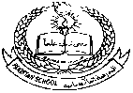**Pakistan School, Kingdom of Bahrain**

**E- Support and Learning Material**

**Subject: English Grade : HKG**

**Topic #2: Reading and Writing Two Letter Words (on, or, of, ox)**

|  |  |
| --- | --- |
|  |  |
| **Student’s Name: _________________________________________________** | |
|  | |

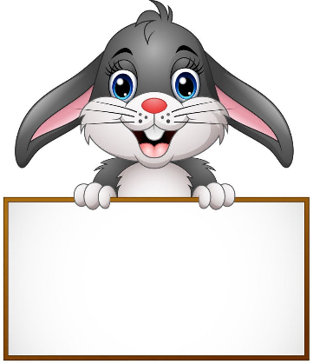**Q.1: Write the following words:**

on

or



of

ox

**Q.2: Match the same words by drawing a line:**

**ox**

**on**

**on**

**or**

**or**

**of**

**of**

**ox**

**Q. 3: Complete two letter words:**

|  |  |  |
| --- | --- | --- |
|  | **__n** |  |
|  |  |  |
|  | **__r** |  |
|  |  |  |
|  | **__x** |  |
|  |  |  |
|  | **__f** |  |

**Q.4: Read and practice book page numbers 17, 18, 19 and 20.**

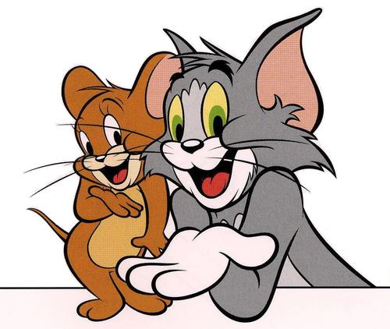

**Pakistan School, Kingdom of Bahrain**

**E- Support and Learning Material**

**Subject: English Grade : HKG**

**Topic #2: Reading and Writing Two Letter Words (by, my, up, us)**

|  |  |
| --- | --- |
|  |  |
| **Student’s Name: _________________________________________________** | |
|  | |

**Q.1: Write the following words:**



by

up



us

my



to do

**Q.2: Match the same words by drawing a line:**

**up**

**by**

**us**

**my**

**my**

**up**

**by**

**us**

**Q. 3: Complete two letter words:**

|  |
| --- |
| **__y** |
|  |
| **__y** |
|  |
| **__p** |
|  |
| **__s** |
|  |
| **__ o** |
|  |
| **__ o** |

**Q.4: Read and practice book page numbers 21, 22, 23 and 24.**