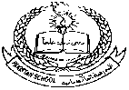**Pakistan School, Kingdom of Bahrain ( Junior Section)**

**E- Support and Learning Material / Session 2020-2021**

**Subject: English Grade: LKG**

**FIRST TERM**

**NAME**____________________________ **SUBJECT: English DATE**_______________

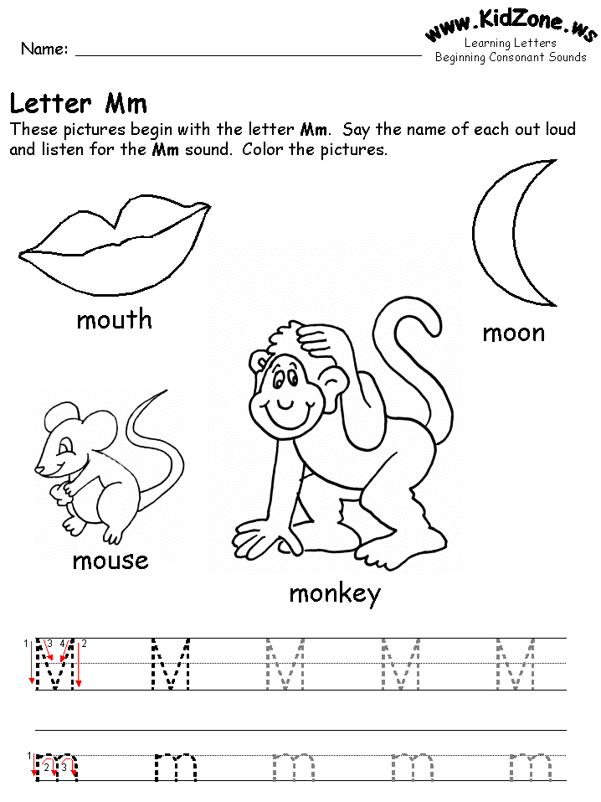Color the friends of letter M:

 **Trace the letter M:**

Circle letter M:

H M B N H M H T M

M B N M H B M I H



**Pakistan School, Kingdom of Bahrain ( Junior Section)**

**E- Support and Learning Material / Session 2020-2021**

**Subject: English Grade: LKG**

**FIRST TERM**

**NAME**____________________________  **DATE**_______________

* Color the friends of letter N:

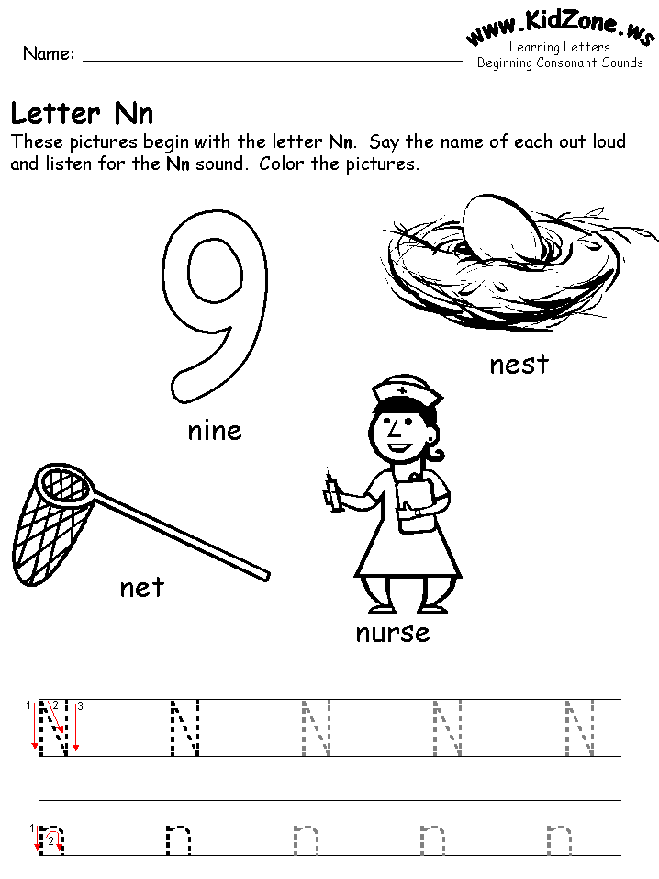

**Trace the letter N:**



Circle letter N:

N M B N H N H T N

N B N M H B N I H

**Pakistan School, Kingdom of Bahrain ( Junior Section)**

**E- Support and Learning Material / Session 2020-2021**

**Subject: English Grade: LKG**

**FIRST TERM**

**NAME**____________________________  **DATE**_______________

Color the friends of letter V:

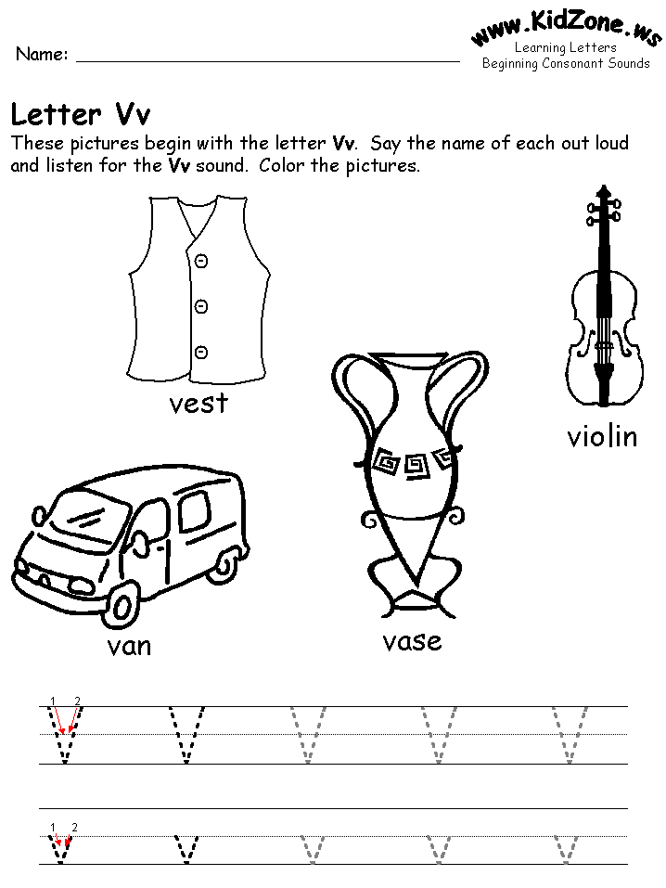

**Trace the letter V:**



Circle letter V:

V U B V R V U S V

T V R V U N V S



**Pakistan School, Kingdom of Bahrain ( Junior Section)**

**E- Support and Learning Material / Session 2020-2021**

**Subject: English Grade: LKG**

**FIRST TERM**

**NAME**____________________________  **DATE**_______________

Color the friends of letter W:

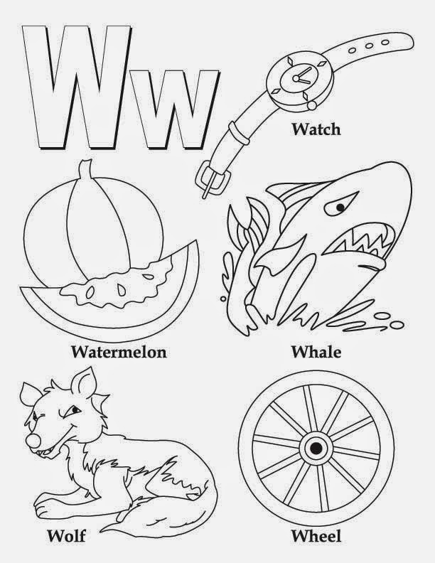

**Trace the letter W:**

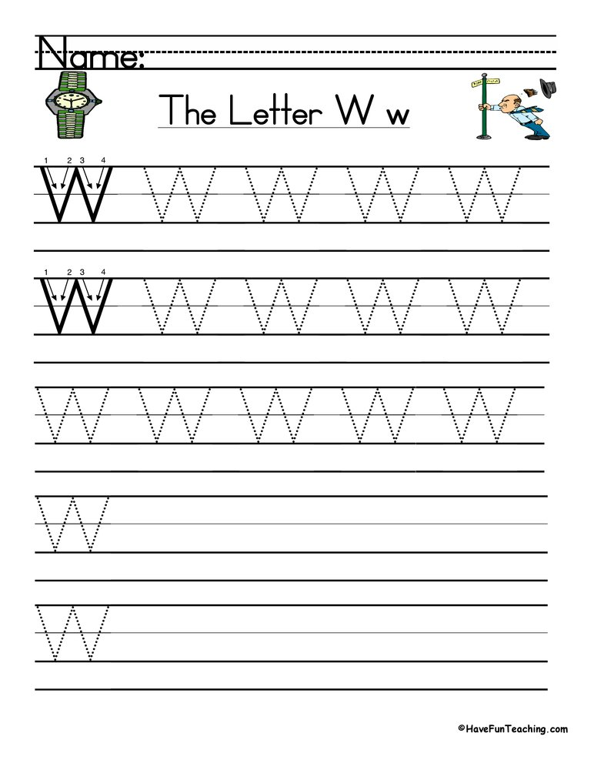

Circle letter W:

W U B W R W U S W

T W R W U N W S Q

**Pakistan School, Kingdom of Bahrain ( Junior Section)**

**E- Support and Learning Material / Session 2020-2021**

**Subject: English Grade: LKG**

**FIRST TERM**

**NAME**____________________________  **DATE**_______________

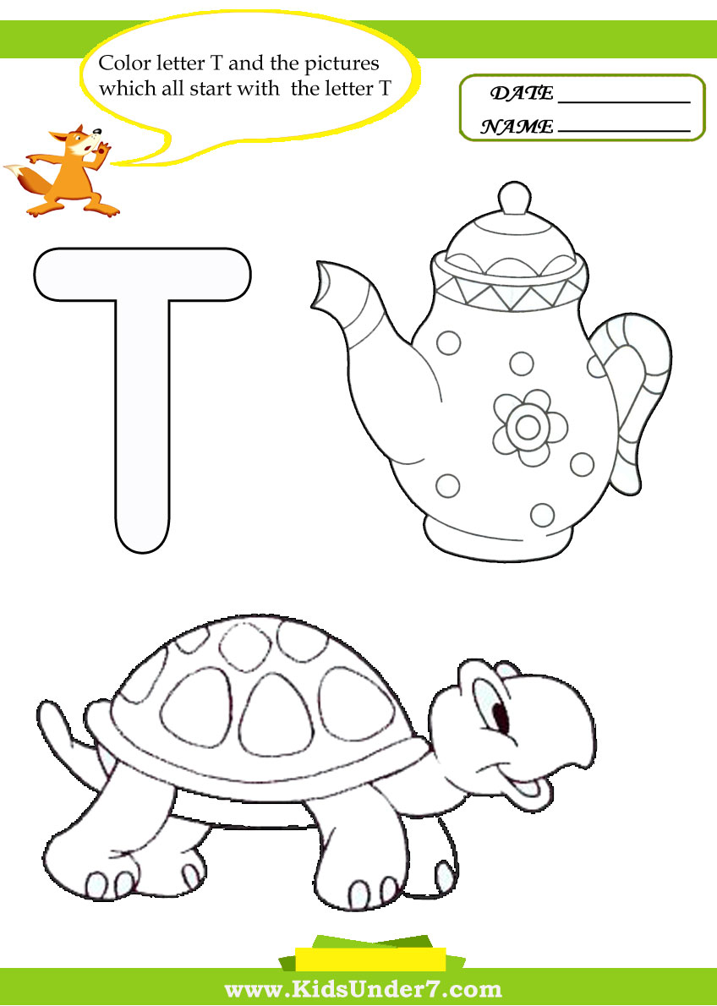Color the friends of letter T

**Trace the letter T:**

