**Pakistan School , Kingdom of Bahrain**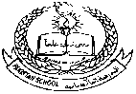

**E- Support and Learning Material / Session 2020-2021**

**Subject: General Science Grade : 8th**

**Book: Oxford Secondary Science 3 FIRST TERM**

**Unit 2: Pg. No: 11, 12 WEEK 2ND: DAY 1**

**Kidneys and excretion: Lesson 1**

**Topic: The Kidneys**

**MCQs**

1) When cells respire to produce energy, the waste product is

1. oxygen
2. carbon dioxide
3. methane
4. all of the above

2) Carbon dioxide is excreted from

1. skin
2. kidneys
3. lungs
4. liver

3) The tiny tubes present in the kidney which filter the blood are

1. capillaries
2. veins
3. nephrons
4. arteries

4) The outer part of the kidney is called the

1. capsule
2. medulla
3. cortex
4. ureter

5) During the course of a day, the kidneys remove over

1. 100 litres of liquid
2. 200 litres of liquid
3. 300 litres of liquid
4. 400 litres of liquid

**Answers to MCQs**

1) b 2) c 3) c 4) c 5) b

**Questions & Answers**

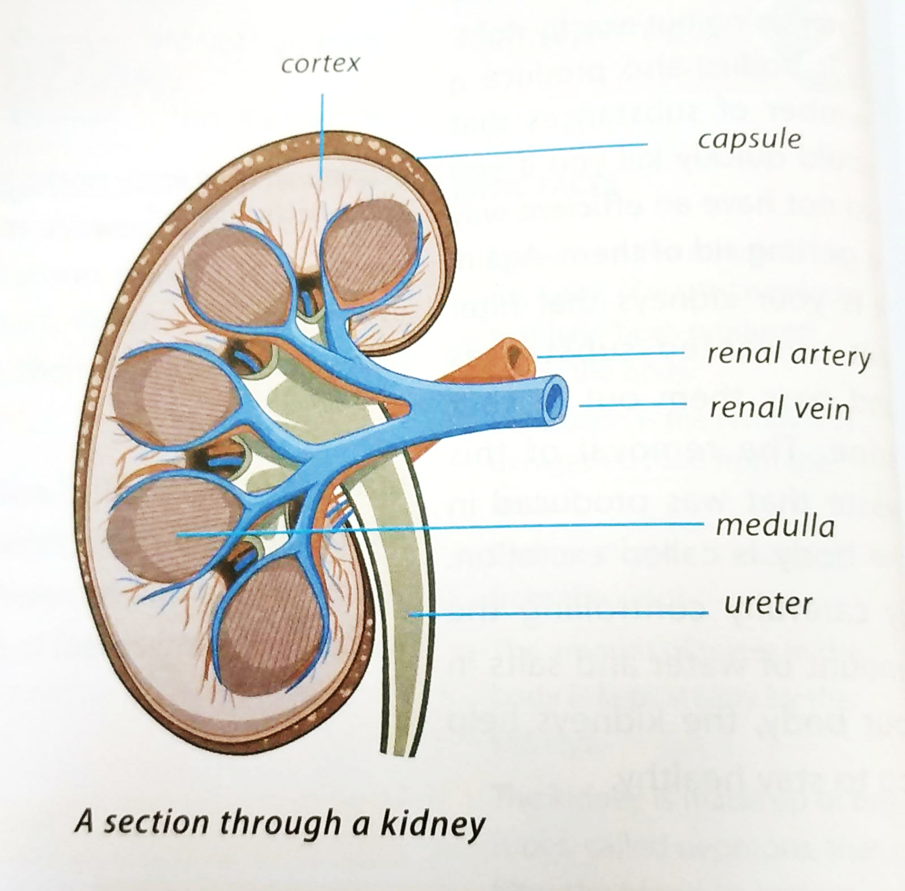

**Q1)** Describe the structure of the kidney.

**A:** Structure of the kidney:

1. Location:

In our body, there are two kidneys present, which are situated just under our ribs at the back of our body.

1. Size:

Each kidney is about 11.5 cm long, 6 cm wide and 3.5 cm thick. Its weight is about 140 grams.

1. Capsule:

It is the fatty case which surrounds both kidneys.

1. Cortex:

It is the outer part of the kidney.

1. Glomerulus:

Cortex consists of many tiny knots of thin blood capillaries known as glomerulus.

1. Medulla:

It is the inner part of the kidney and has over a million tiny tubules called nephrons.

1. Nephrons:

These are present in the medulla of the kidney. These nephrons make up most of the kidney tissue. If straightened out, they would measure more than 300 km!

1. Ureter:

These kidney nephrons link up to form larger collecting tubes, which join to form the ureter.

**Homework:**

Do anyone.

1. Make a labelled diagram of the human excretory system.
2. Make a model of the section through the kidney by using clay and label it.

**Pakistan School , Kingdom of Bahrain**

**E- Support and Learning Material / Session 2020-2021**

**Subject: General Science Grade : 8th**

**Book: Oxford Secondary Science 3 FIRST TERM**

**Unit 2: Pg. No: 11, 12 WEEK 2ND: DAY 2**

**Kidneys and excretion: Lesson 1**

**Topic: The Kidneys**

**Question & Answer**

**Q)** Describe urinary bladder, ureters and urethra.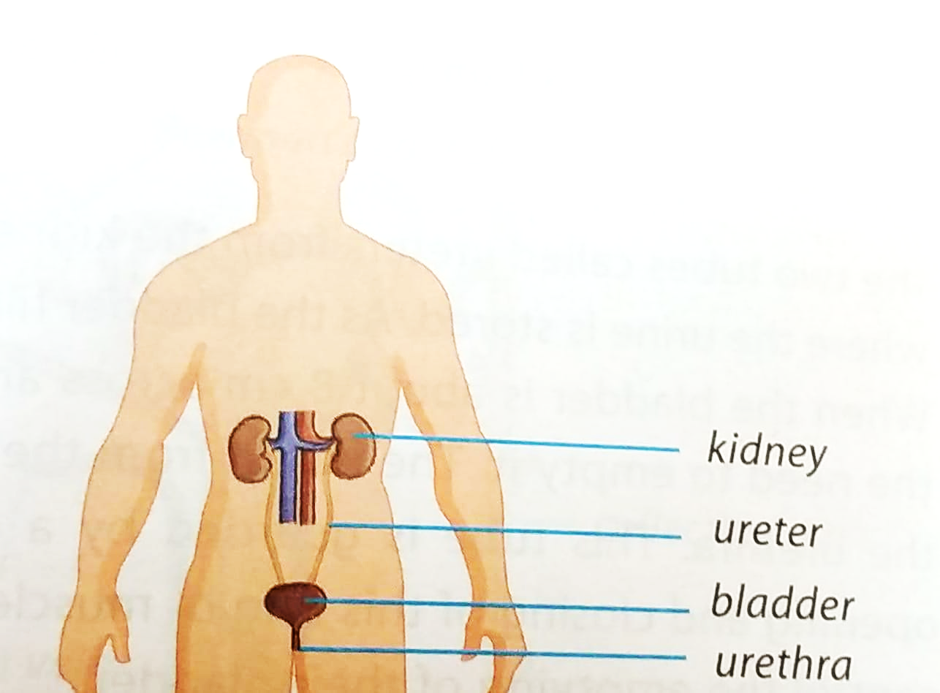

**A:** Urinary bladder:

Below and between the two kidneys is the urinary bladder. It is a stretchable bag where urine is stored. When the bladder is filled with urine, it is 8 cm wide, and has 0.5 litre of urine. As such, it expands into a balloon shape.

Urine is 96% water and 4% salts and urea.

Ureters:

The kidney nephrons link up to form collecting tubes or ducts which join to form the ureter. Urine runs down the tube known as ureter, which extends from the kidney into the bladder. Since there are two kidneys in our body, there are also two ureters to carry the urine to the bladder.

Urethra:

The outlet from the urinary bladder to the outside of the body is called the urethra. This tube is guarded by a ring of muscles which controls the emptying of the bladder.

**Worksheet:**

Fill in the blanks.

1. The liquid which leaves the kidneys is ____________.
2. The composition of urine is _________ water and _________ salts and urea.
3. Kidneys _________ _________ unwanted substances.
4. Excretion is the removal of waste products made ________ the body.
5. We lose water when we ___________, ___________ and sweat.

Mark True / False.

1. Urinary bladder is a stretchable bag present between two kidneys. ______
2. Carbon dioxide is the only harmful waste product made inside the body. ______
3. We do not need all the proteins and amino acids that we consume in our diet. _____
4. Urethra is guarded by a ring of muscles. _____
5. The outer part of the kidney is called the capsule. ______

Answer anyone.

**Q1)** What is the difference between the ureter and urethra.

**A:**

**Q2)** What are two functions of the kidney.

**A:**