**Pakistan School , Kingdom of Bahrain**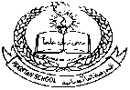

**E- Support and Learning Material / Session 2020-2021**

**Subject: General Science Grade : 10**

**Activity-1**

**ASSESSMENT**

**Choose the correct option:**

1. **Carbohydrate is broken down by the enzyme into ………………….**
2. **Glucose b. amino acid c. fatty acid d. glycerol**
3. **Base unit of Proteins is ……………………….**
4. **Glucose b. amino acid c. fatty acid d. glycerol**
5. **The growth of the cell and the body is the result of …………………….**
6. **Assimilation b. Digestion c. Absorption d. diffusion**
7. **Fats can be found in …………………………**
8. **Chicken b. potato c. ghee d. pulses**
9. **The sum of all constructive and destructive activities done in living organism is called ………………….**
10. **Metabolism b. assimilation c. catabolism d. anabolism**

**Q. Short Question:**

**i. Enlist the smaller units that make these large molecules**

**a. Carbohydrates b. Proteins c. Fats**

**ii. Describe the digestion of Proteins in human body.**

1. **Define Metabolism.**

**Detail Question:**

**Write a note on Digestion of Food.**

**Pakistan School , Kingdom of Bahrain**

**E- Support and Learning Material / Session 2020-2021**

**Subject: General Science Grade : 10**

**Book: General Science FIRST TERM**

**Unit 3: Biochemistry and Biotechnology:**

**Week-1 Pg. No: _29-- 31**

**Question:**

1. **What is meant by biochemistry?**

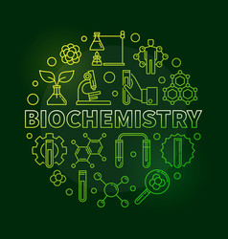**Ans: Biochemistry is involved in different biological activities of human such as digestion, enzymes and their role etc.**

1. **Name and define the chemical activities done in living organisms?**

**Ans: There are two main chemical activities done in living organisms**

**i.e.**

**i. Anabolic activities: The process of using digested food for the growth of living organism is called anabolic activities.**

**ii. Catabolic activities: Every cell of organ performs its own function in a body. Different activities performed by different cells will be called metabolism activities.**

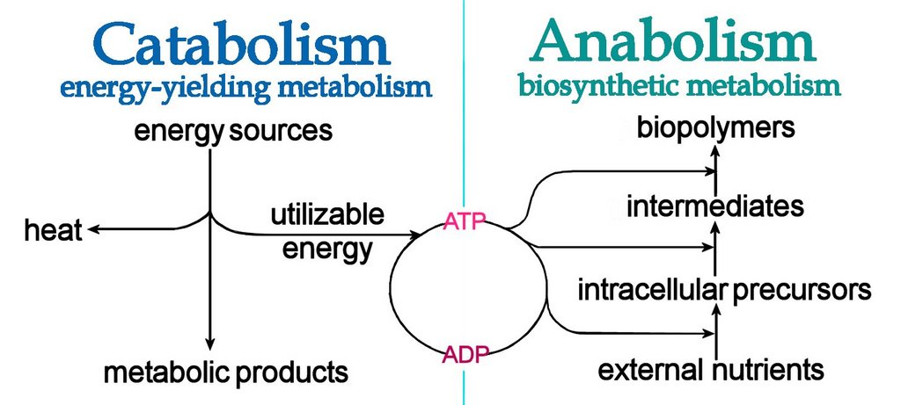

1. **Define metabolism. Describe its types.**

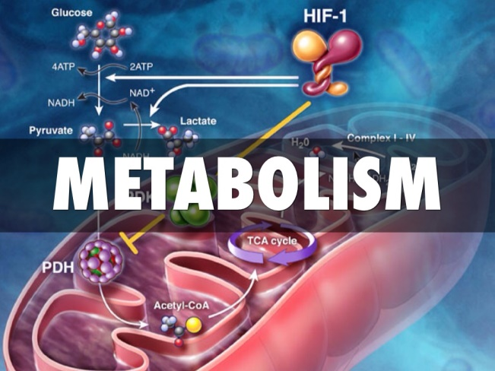**Ans: The process of repair and growth of cell, constructive and destructive to get energy is called metabolism. These are the chemical activities done in living organisms.**

**There are two types of metabolism:**

1. **Anabolism**
2. **Catabolism**

**i. Anabolic activities: The process of using digested food for the growth of living organism is called anabolic activities.**

**ii. Catabolic activities: Every cell of organ performs its own function in a body. Different activities performed by different cells will be called metabolism activities.**

1. **What is meant by digestion of food?**

**Ans: Breaking down of food into small units in the presence of enzymes so that they can diffuse into cells of organisms is known as digestion of food.**

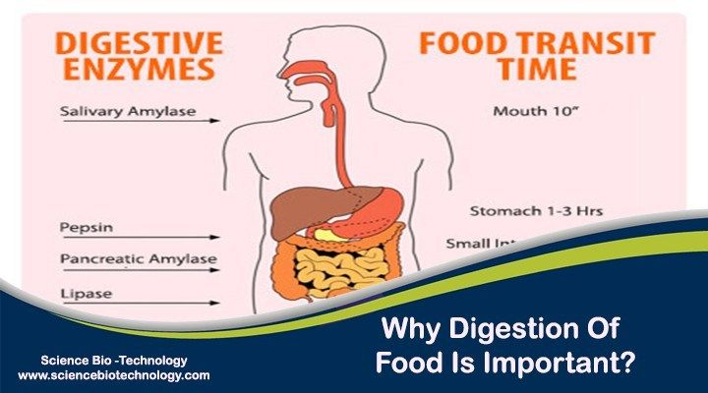

1. **Give examples of some smaller units that make these large molecules of food.**

**Ans: Some examples of food molecules are given below:**

**i. Carbohydrates $→$ Glucose Molecules**

**ii. Proteins $→$ Amino Acids**

1. **Fats $→$ Fatty Acids & Glycerol**

**Example of Starch and Glycogen:**

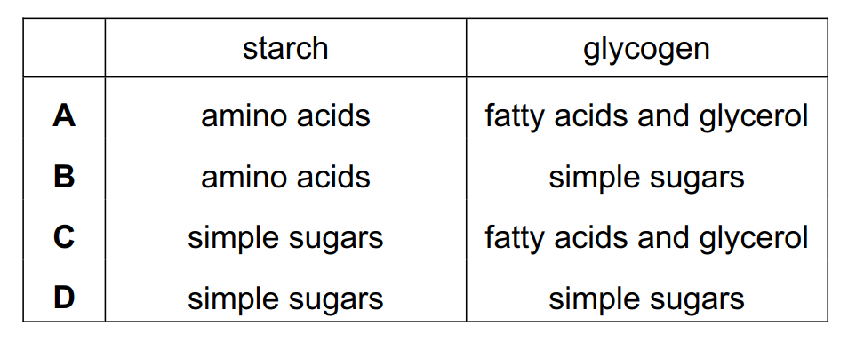

1. **What is meant by biotechnology?**

**Ans: It is a technology that involves the use of living organism to make useful chemicals and products mainly used in agriculture food science and medicines or to perform industrial tasks.**

**Q. Explain the digestion of Carbohydrates in the human body?**

**Ans: Carbohydrates:**

**Definition: They are energy rich compounds of carbon hydrogen and oxygen.**

**Sources: They are available in the form of sugar starch and glycogen.**

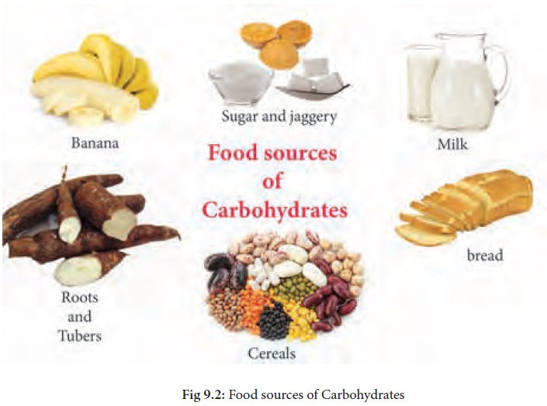

**a. Sugar: It is digested and changed into glucose, which is highly diffusible and absorb into the blood and supplied to all cells of the body.**

**b. Starch: It is available in the form of wheat rice potato sweet potato etc.**

**c. Glycogen: It is also called animal starts and is found in liver and meat.**

**Digestion: Starch and glycogen are digested in the alimentary canal in the presence of enzymes and converted into glucose.**

**Digestion equation:**

**Enzymes**

**i. Starch                      Glucose**

**Enzymes**

**ii. Glycogen                    Glucose**

**Note: Inside a cell glucose is broken down to give energy during respiration.**

**Equation:**

**Glucose + Oxygen               Carbon dioxide + Water + Energy**

**Symbolically:**

**C6 H12 O6 + 6O2 6 C O2 + 6H 2O + Energy**

**Example of base unit of Starch and Glycogen:**



**Q. Describe the digestion of proteins in the human body.**

**Composition:  They are energy rich Complex molecule made of carbon hydrogen Oxygen and nitrogen.**

**Functions:  They provide energy as well as raw material for repair and growth.**

**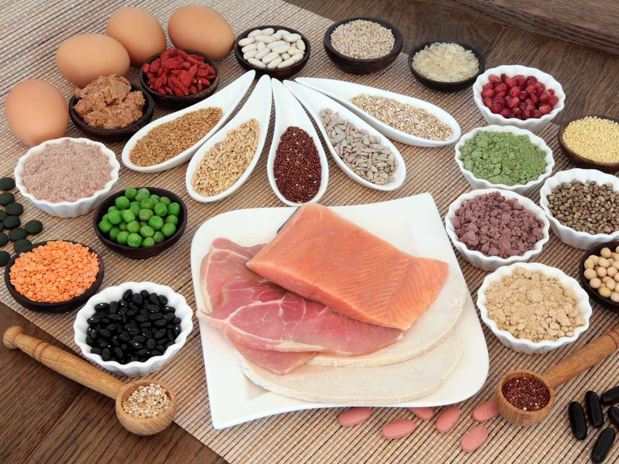 Resources:  Proteins are present in meat egg chicken fish and pulses.**

**Digestion: Proteins are broken down into amino acid during digestion.**

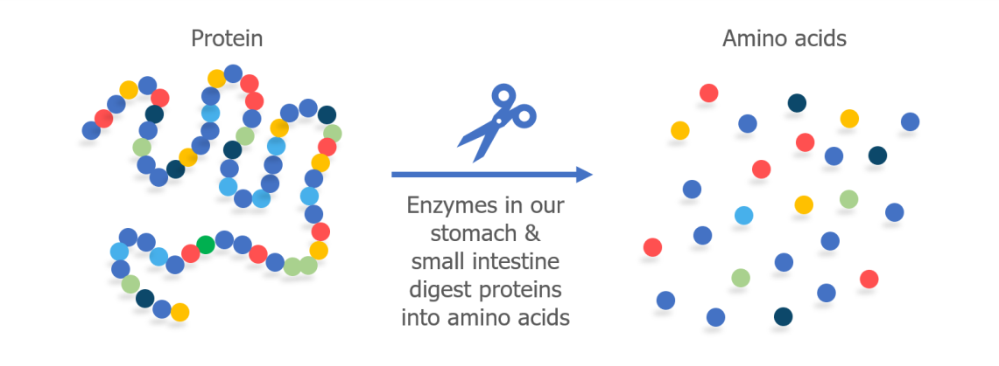

**Equation:**

**Proteolytic**

**Proteins                              amino acid**

**Enzymes**

**Functions of amino acid:  Amino acids are used to make various proteins needed by the cells and rest of amino acid is further broken down to release energy.**

**Q.  How are fats digested in the human body?**

**Fats: Description of fats is given below:**

**Composition:  They are energy compound made of Carbon, Hydrogen and Oxygen.**

**Resources: Fats are available in the form of ghee, butter and oils.**

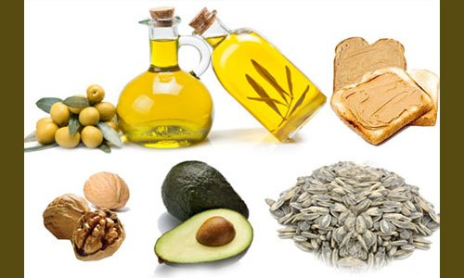

**Digestion:  During digestion fats are broken down into glycerol and fatty acid.**

**Equation:**

**Lipases**

**Fats                                  fatty acid + glycerol**

**Enzymes**

**Functions of fatty acids and glycerol:**

1. **They are small molecules and diffuse into blood and taken to all parts of the body.**
2. **They are either used to make structures of the cell or broken down to give energy.**

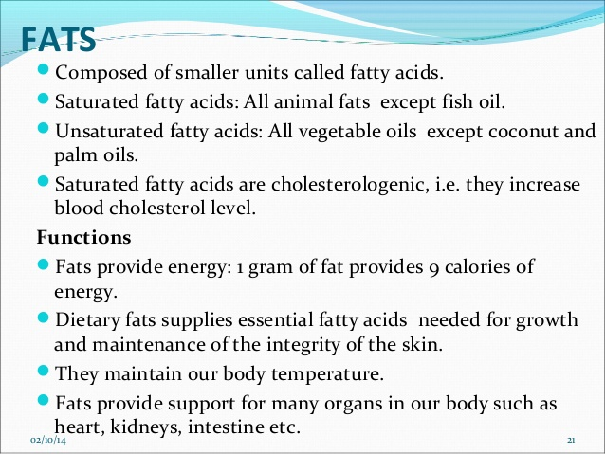

**Q. Define assimilation.**

**Assimilation:  Amino acids, fatty acids and glycerol are also used to make various structures of the cell. This phenomenon is called assimilation.**

**Note: The growth of the cell and of the body is the result of assimilation.**