**Pakistan School , Kingdom of Bahrain**

**E- Support and Learning Material / Session 2020-2021**

**Subject: General knowledge Grade :HKG Sec: _____**

**Name: ____________________________ Isa Town / Manama**

**Unit 2:Domestic Animals**

**Learn the names of Domestic Animals:**

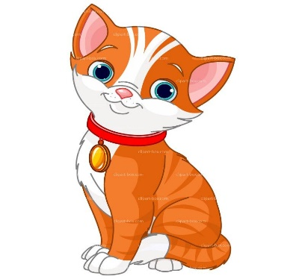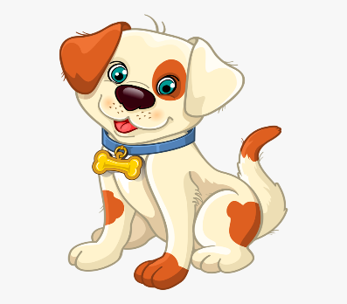

**Cat Dog**

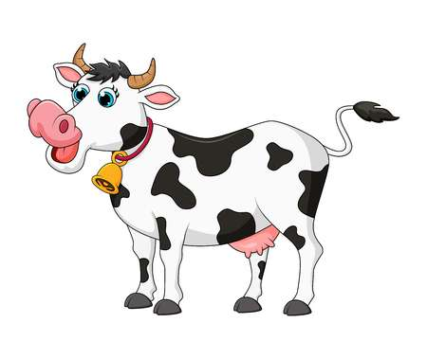

**Cow**

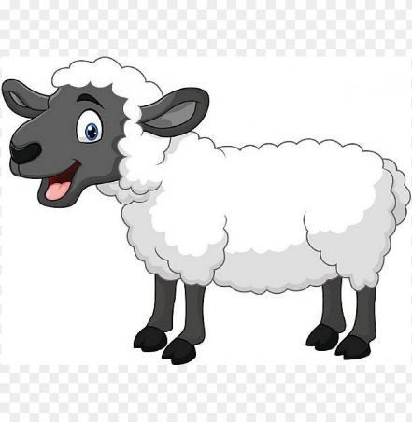 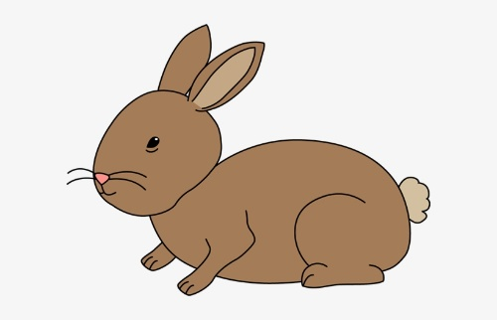

**Sheep Rabbit**

**Write and learn the spellings of these Domestic Animals:**

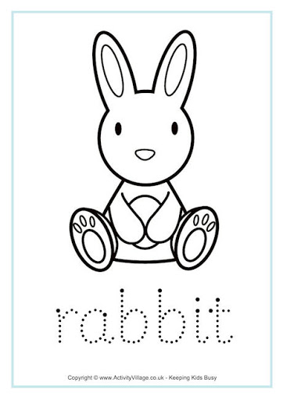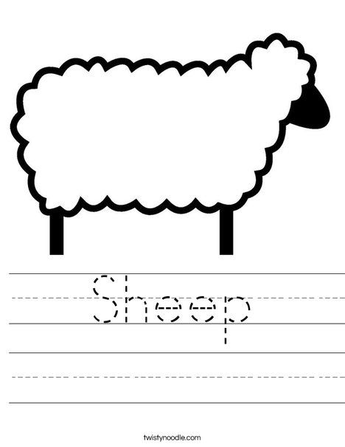

**--------------------------------------------------------------------------------------------------------------------------------------------------------------------------------------------------------------------------------------------------------------------------------------------------------------------------------------------------------------------------------------------------------------------------------------------------------------------**

**--------------------------------------------------------------------------------------------------------------------------------------------------------------------------------------------------------------------------------------------------------------------------------------------------------------------------------------------------------------------------------------------------------------------------------------------------------------------**

**--------------------------------------------------------------------------------------------------------------------------------------------------------------------------------------------------------------------------------------------------------------------------------------------------------------------------------------------------------------------------------------------------------------------------------------------------------------------**

**--------------------------------------------------------------------------------------------------------------------------------------------------------------------------------------------------------------------------------------------------------------------------------------------------------------------------------------------------------------------------------------------------------------------------------------------------------------------**

**------------------------------------------------------------------------------------------------------------------------------------------------------------------------------------------------------------------------------------------------------------------------------------------------------------------------------------------------------------------------------------------------------------------------------------------------------------------**

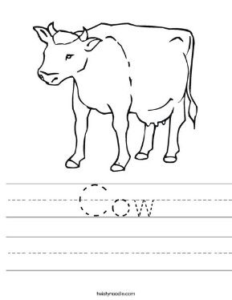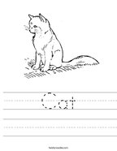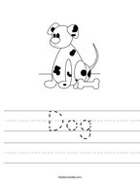

**-------------------------------------------------------------------------------------------------------------------------------------------------------------------------------------------------------------------------------------------------------------------------------------------------------------------------------------------------------------------------------------------------------------------------------------------------------------------**

**--------------------------------------------------------------------------------------------------------------------------------------------------------------------------------------------------------------------------------------------------------------------------------------------------------------------------------------------------------------------------------------------------------------------------------------------------------------------**

**--------------------------------------------------------------------------------------------------------------------------------------------------------------------------------------------------------------------------------------------------------------------------------------------------------------------------------------------------------------------------------------------------------------------------------------------------------------------**

**--------------------------------------------------------------------------------------------------------------------------------------------------------------------------------------------------------------------------------------------------------------------------------------------------------------------------------------------------------------------------------------------------------------------------------------------------------------------**

**--------------------------------------------------------------------------------------------------------------------------------------------------------------------------------------------------------------------------------------------------------------------------------------------------------------------------------------------------------------------------------------------------------------------------------------------------------------------**

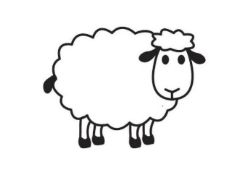**Match the names of domestic animals with the pictures:**

**Rabbit**

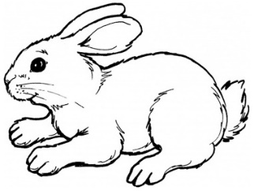

**Cow**

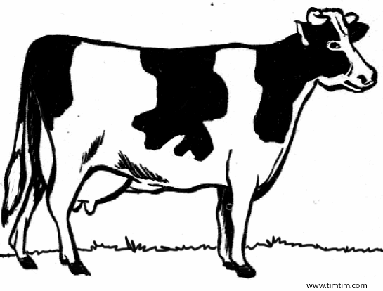

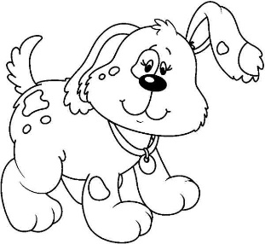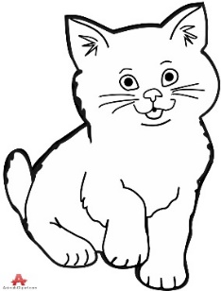

**Sheep**

**Dog**

**Cat**