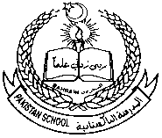 **Pakistan School, Kingdom of Bahrain**

**Subject: GK E- Support and Learning Material**

**Class : LKG( ) Name:___________________**

**Isa Town / Manama**

Parts of body. (Oral)

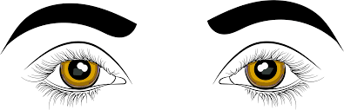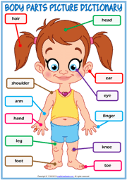

**EYES**

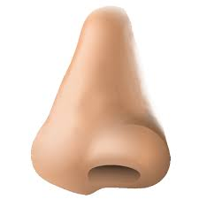

**NOSE**

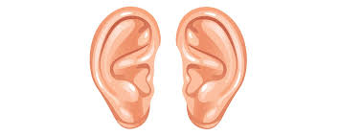

**EARS**

  **HEAD**

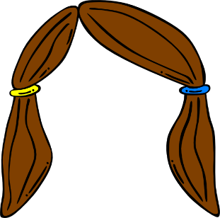 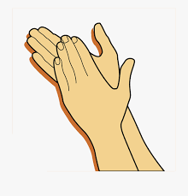 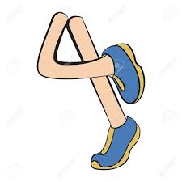

**HAIR HANDS LEGS LIPS**

**Q2. Tell the names of these body parts:**









