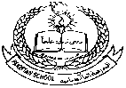**Pakistan School , Kingdom of Bahrain**

**E- Support and Learning Material / Session 2020-2021**

**Subject:General Knowledge Grade:HKG Sec: _____**

**Name: ________________________________ Isa Town / Manama**

**Common Flowers**

**Read and Learn**

**Some common flowers are:**

 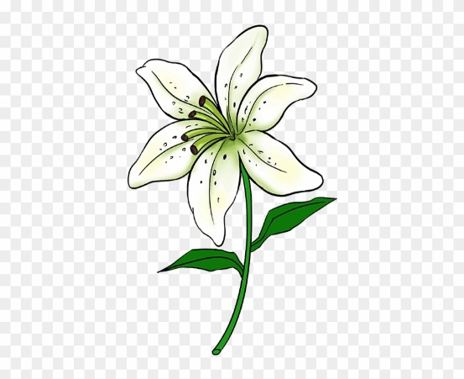 

**Rose Lily Sunflower**

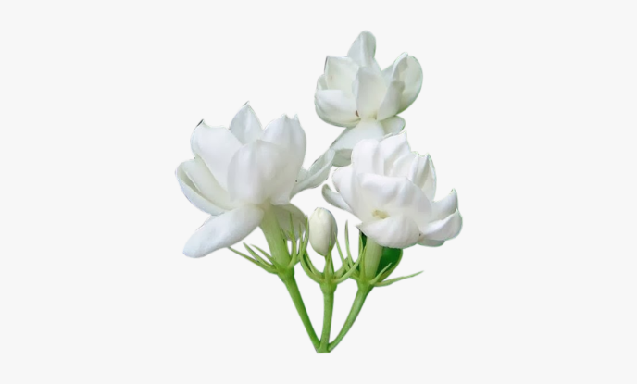 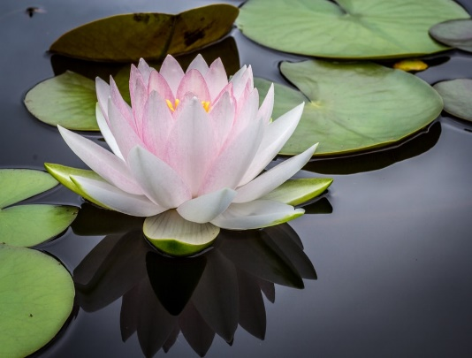

**Jasmine Lotus**

**Learn the names of common flowers and colour them:**

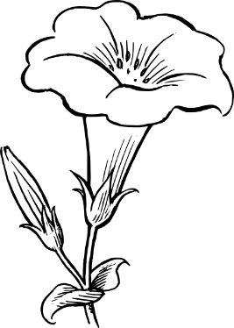



Rose Lily

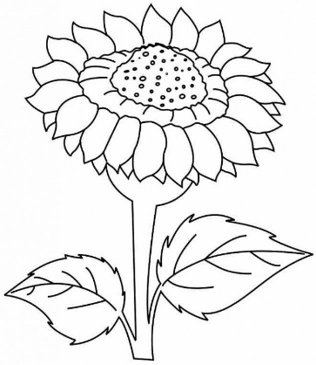

Sunflower

Sunflower

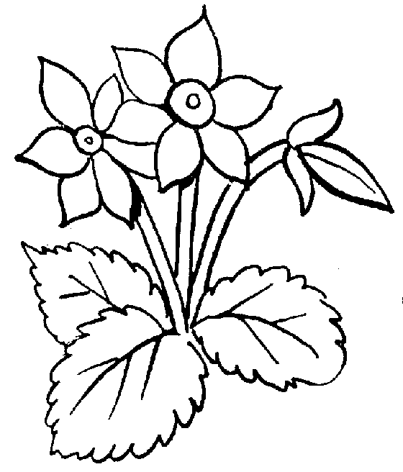

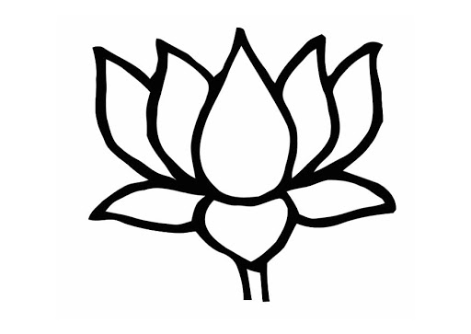

Lotus

Jasmine

**Complete these spellings of flowers:**





** R ____ s ____ L ___ l ___**

  **L ____ t ___ s**

**J ___ sm___ ne S ___ n flo____ er**