** Pakistan School, Kingdom of Bahrain**

**Subject: GK E- Support and Learning Material**

**Class : LKG( ) Name:___________________**

**Isa Town / Manama**

**Common Fruits. (Oral)**

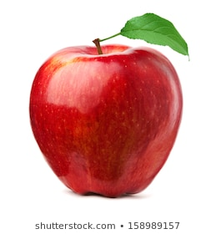**APPLE  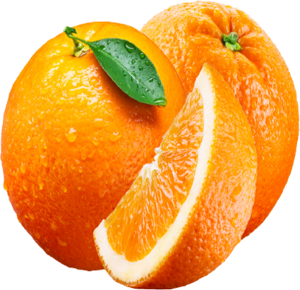ORANGE**

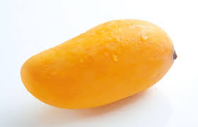**MANGO 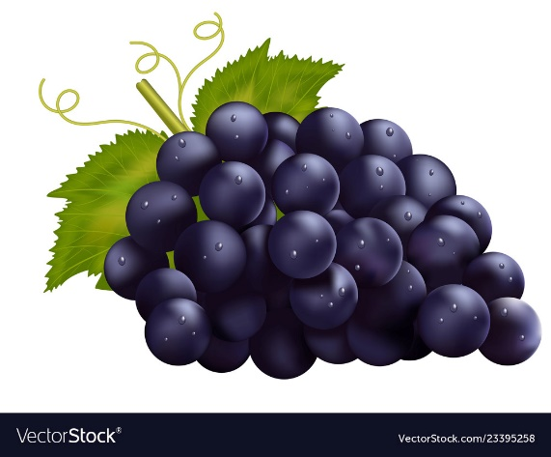GRAPES**

. 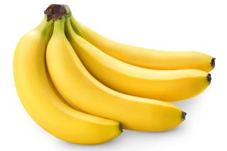**BANANA 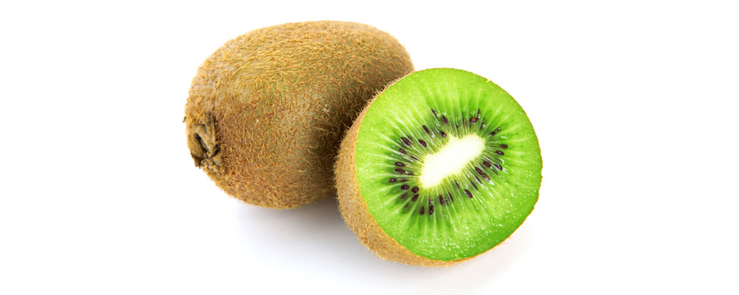KIWI**

**Q1. Match the same fruits.**

|  |  |
| --- | --- |
| Green Background Apple Images, Stock Photos & Vectors | Shutterstock | Kiwi fruit | Alimentarium |
| Realistic dark grapes Royalty Free Vector Image | Green Background Apple Images, Stock Photos & Vectors | Shutterstock |
| Bananas: Health Benefits, Risks & Nutrition Facts | Live Science | Esim - Lets make orange a orange! |
| Kiwi fruit | Alimentarium | Realistic dark grapes Royalty Free Vector Image |
| Esim - Lets make orange a orange! | Pakistani mango: The king of fruits | Arab News |
| Pakistani mango: The king of fruits | Arab News | Bananas: Health Benefits, Risks & Nutrition Facts | Live Science |

**Q2. Circle your favourite fruit:**

 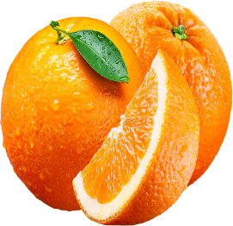 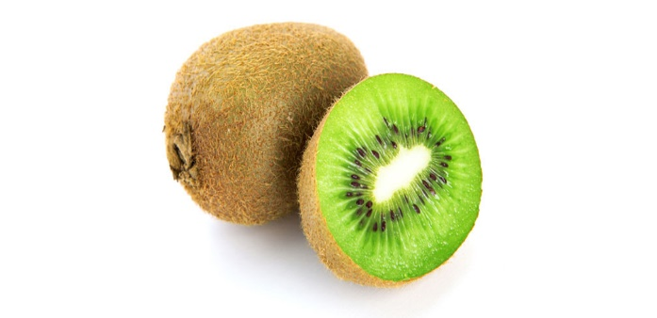

 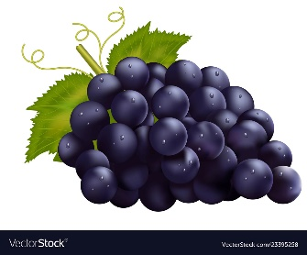 

**Q3. Draw and colour your favourite fruit:**

|  |
| --- |
|  |
|  |