 Pakistan School, Isa Town, Kingdom of Bahrain
E-Support and Learning Material / Session 2020-2021

Subject: Physics Grade: 12th
Book: Physics 12 KPKTB Peshawar First term

NOTE: FOR HSSC CLASSES PRESCRIBED TEXTBOOKS ARE THE MAIN SOURCE OF INFORMATION. FOLLOW THE TEXTBOOK ACCORDING TO ONLINE LECTURES. SAMPLE NOTES ARE PROVIDED FOR YOUR ASSISSTANCE.

Chapter: 11 Electrostatic
INTRODUCTION

Electrostatics: The branch of Physics which deals with the study of charges at rest under the action of electric force is called Electrostatics.

Electric charge:

An intrinsic property of fundamental particles which takes parts in conduction process is called electric charge. Either they repel or attract each other.

Kinds of charges

There are two types of charge, positive and negative, charge on proton is positive and charge on electron is negative. SI unit of charge: SI unit of charge is coulomb
How many electrons are in one Coulomb: 6.25*10¹⁸ electrons?

Electric force
The force which holds the positive and negative charges to make up atoms and molecules is called electric force.

Types of electric force
Repulsive force: The force b/w two same charges (The force b/w two electrons)

Attractive force: The force b/w two different charges (The force b/w electron and proton)

Basic law of electrostatics for knowing the nature of charge
“Like/same charges repel each other, while unlike/different charges attract each other”

Q.No.1: State and explain coulomb’s law and also give effect of medium on it.
In 1784, French military engineer Charles Coulomb deduced a law known as Coulomb’s law which measures the force b/w two charges.
Statement:-The force of attraction or repulsion b/w two charges is directly proportional to the product of the magnitude of charges and inversely proportional to the square of distance b/w them.
Where K is called Coulomb’s constant, whose value is 9*10⁹ Nm²C⁻²
Mathematically: F q₁q_{2 …………….1)}
And F α …………..2) on combining 1 & 2 we get
OR F= K

The value of K depends upon: - a) the system of units b) Nature of medium b/w charges If medium is free space then K = , ε_{o} is permittivity of free space its value in SI unit is 8.85 *10^{12}N^{1}m^{2}c²,so Coulomb’s law becomes F= K
This is mathematical form of Coulomb’s law.
Effect of medium on Coulomb’s force: Coulomb force is reduced when medium is placed b/w two charges.
The insulating medium placed b/w two charges is called dielectric like Teflon etc. so formula for Coulomb’s force becomes F= ,where ε_{r} is relative permittivity, its value is different for different dielectrics, and its value is greater than One other than vacuum. For air ε_{r}=1.0006, for vacuum ε_{r}=1.

Limitation of Coulomb’s law: Coulomb’s law is applied only on point charge

Q.No. 2: What is point charge, source charge and test charge?
Ans: The charges whose sizes are very small as compared to the distance between them are called point charges. The charge which produce field is called source and charge which detect the presence of field is called test charge.

Q.No. 3: What is Electric field and electric field intensity? Also derive its formula.
Ans: Electric field: Michael Faraday introduced the concept of electric field. “The space or region around a charge within which another charge experience a force is called electric field”.
Electric field intensity: The force experience by unit positive charge placed at a point in an electric field is called electric field strength or field intensity. Its unit is N/C. it is vector quantity and its direction is along the direction of force.
Electric field intensity due to a point charge q:
The force experienced by test charge q_{o} if placed in the field of charge q is calculated by coulomb’s law and electric field intensity is calculated by putting in the formula of field intensity.
E= ….................. (1)
F= rˆ……… (2) Put this value in equation (1) we get
E= = rˆ or E=K rˆ
Electric field intensity depends upon:
a) Magnitude of charge b) medium c) distance from charge

Q.No. 4: What are Electric field lines? Write down its properties.
Ans: Definition: “The direction of electric field intensity is represented by lines which are called electric field lines”.
- Michal Faraday introduced the concept of field lines.
- The field due to positive point charge is directed radially outward
- The field due to negative point charge is directed radially inward
- The middle region b/w two same charges has no field due to repulsion of like charges, is called zero field sport or neutral zone.

Properties:
- Electric field lines starts from positive charges and end on negative charges.
- The tangent to a field line at any point gives the direction of the electric field intensity at that point.
- The lines are closer where the field is strong; the lines are farther apart where the field is weak.
- No two lines cross each other because at a single point electric field has only one direction.
- No two lines cross each other because at a single point electric field has only one direction.

Applications of Electrostatics:

Q.No. 5: Write down the applications of electrostatics.
Ans: There are three applications of Electrostatics

a) Xerography (photocopier)
b) Laser Printer
c) Inkjet printers

- Xerography (Photo copier): It is Greek word, Xero mean dry, graphos mean writing, and Xerography mean dry writing. The copying process is called Xerography.

Photocopier works on the following principle:

“The lamp transfer image of page to the drum which leaves the static charge. The drum collects the toner dust and transfer it to the paper, the toner is melted on page”.
Main parts of photocopier: 1) Drum 2) toner 3) heated rollers

Drum is the heart of photocopier machine. Dum is an aluminum cylinder coated with layer of selenium.

Such materials which show conduction only when light falls on them, otherwise they are insulators in absence of light are called photoconductors like selenium.

Working:

If the drum is exposed to an image of document to be copied, the dark and light areas of document produce same dark and light areas on the drum.

The dark areas retain their positive charge but light areas becomes conducting, in this way a positive charge image of document remains on the selenium surface, then a special dry black powder called “Toner” is given a negative charge and spread over the drum, where it sticks to the positive charge areas, the toner from the drum is transferred on to a sheet of paper on which document is to be copied, heated pressure rollers then melt the toner into the paper to produce permanent image of document.

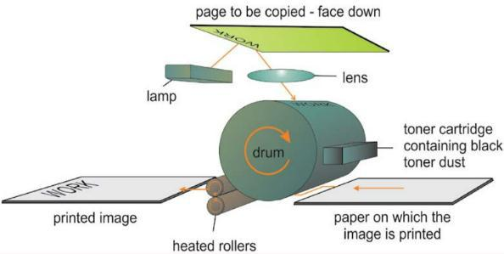

- Laser printer: laser printer is a type of printer which makes use of a laser beam to produce an image on the drum or you can say that it is a printer that makes use of a focused beam of light to transfer text and images onto paper. It was first developed by Gary Stark weather at Xerox PARC in 1971. A laser printer is a printer for computers.
It uses laser or LED-technology to get small particles of toner from a cartridge onto paper. Very often, this costs less to use than the ink of inkjet printers. Laser printers often print text more neatly than inkjet printers, but print photos less clearly. Printing on photo paper or coated paper designed for inkjet printers can damage the laser printer's drum and fuser unit.

Laser printing is a process which typically involves seven steps:
- Raster Image Processing:
- Charging
- Writing
- Developing:
- Transferring:
- Fusing:
- Cleaning:
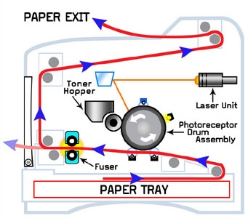

- Inkjet printer: Such a printer which uses electric charge in its working is called inkjet printer

Principle: “It ejects a thin stream of ink when shuttling back and forth across the paper and ink is ejected from small nozzle and break into small droplets”.

Working:

An inkjet print head eject a steady flow of ink droplets. The charging electrodes are used to charge the droplet that is not need on the paper charged droplets are deflected into a gutter by the deflection plates, while uncharged droplets fly straight on to the paper. Inkjet printer also produces colored images.
At the heart of an ink jet printer are a large number of high-precision microscopic nozzles which eject ink onto the paper. These nozzles are typically about 10 micrometers in diameter (roughly 1/10th of the diameter of a human hair). It is not unusual for a home ink jet printer to contain thousands of nozzles in all, several hundred for each color of ink. The diameter of each of these nozzles is fabricated with sub-micrometer accuracy to achieve consistent and uniform ink drop volume, which is essential for consistent and uniform color density on the page. Several different precision micro-fabrication techniques for ink jet nozzles are employed in commercial production, including electroforming, laser ablation, anisotropic etching, and photolithography.

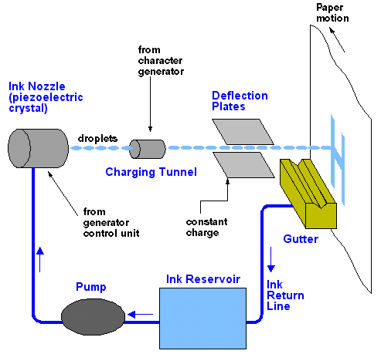

Q.No. 6: Define electric flux. Calculate the electric flux through a surface enclosing a charge.

Ans: Definition: Total number of electric field lines passing normally through a certain area is called electric flux.
OR: The scalar or dot product of electric field intensity and vector area is called electric flux.

Equation with unit: ,ɸ= E.A ,= EA cos ɵ its unit is Nm²C⁻¹, it is scalar quantity. ɸ is Greek letter.

Cases of electric flux: When angle b/w electric field and vector area ɵ=0° ɸ=EAcos0°= A= maximum electric flux.
When angle b/w electric field and vector area ɵ=90°,ɸ=EAcos90°=0= minimum electric flux

Vector area: An area whose magnitude is equal to surface area A of the element but its direction is normal to this area is called vector area

Q.No. 7: Derive a relation for electric flux through a surface enclosing a charge.

Consider a closed surface in the form of sphere of radius r having charge q. The surface is divided into n small patches of vector area are A1, ΔA2,ΔA3….. An so that each patch is a flat. Electric intensity for each patch are E1, E2, E3, En respectively.

 |  |  |  |  |  |  |  |  |  |  |  |  |  |  |  |  |  |  |  |  |  |  |  |  |  |  |  |  |  |  |  |  |  |  |  |  |  |  |  |  |  |  |  |  |  |  |  |  |  |  |  |  |  |  |  |  |  |  |  |  |  |  |  |  |  |  |  |  |  |  |  |  |  |  |  |  |  |  |  |  |  |  |  |  |  |  |  |  |  |  |  |  |  |  |  |  |  | 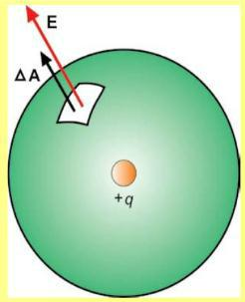
for first patch |  |  |  |  |  |  |  |  |  |  |  |  |  |  |  |  |  |  |  |  |  |  |  |  |  |  |  |  |  |  |  |  |  |  |  |  |  |  | ϕ_{e1} = E₁. |  |  |  |  |  |  |  |  |  |  |  |  |  |  |  |  |  |  |  |  |  |  | A₁,
for 2nd patch |  |  |  |  |  |  |  |  |  |  |  |  |  |  |  |  |  |  |  |  |  |  |  |  |  |  |  |  |  |  |  |  |  |  |  |  |  |  | ϕ_{e2} = E₂ . |  |  |  |  |  |  |  |  |  |  |  |  |  |  |  |  |  |  |  |  |  |  | ^{A}2
for 3rd patch |  |  |  |  |  |  |  |  |  |  |  |  |  |  |  |  |  |  |  |  |  |  |  |  |  |  |  |  |  |  |  |  |  |  |  |  |  |  | ^{ϕ}3 |  |  |  |  |  |  |  | = E₃. A₃
and so on...similarly
for nth patch |  |  |  |  |  |  |  |  |  |  |  |  |  |  |  |  |  |  |  |  |  |  |  |  |  |  |  |  |  |  |  |  |  |  |  |  |  |  | ^{ϕ}n |  |  |  |  |  |  |  | = E_{n} . A_{n}
Total electric flux through closed surface will be
^{ϕ}total |  |  |  |  |  |  | = ϕ₁ + ϕ₂ +ϕ₃ + ..................ϕ_{n} |  |  |  |  |  |  |  |  |  |  |  |  |  |  |  |  |  |  |  |  |  |  |  |  |  |  |  |  |  |  |  |  |  |  |  |  |  |  |  |  |  |  |  |  |  |  |  |  |  |  |  |  |  |  |  |  |  |  |  |  |  |  | putting values
^{ϕ}total |  |  |  |  |  |  | = E₁. |  |  |  |  |  |  |  |  |  |  |  |  |  |  | A₁ |  |  |  |  |  |  |  |  |  |  |  |  |  |  |  |  | + E₂. A₂ + E₃. |  |  |  |  |  |  |  |  |  |  |  |  |  |  |  |  |  |  |  |  |  |  |  |  |  |  |  |  |  |  | A₃ + ...........E_{n} . |  |  |  |  |  |  |  |  |  |  |  | A_{n}
^{ϕ}total |  |  |  |  |  |  | = E₁ΔA₁ cos θ + E₂ΔA₂ cos θ + E₃ΔA₃ cos θ + ...........E_{n}ΔA_{n} cos θ
As the direction of electric intensity and vector area is same at each patch so θ = 0º
ϕ |  | total |  |  |  |  | = E ΔA cos 0º + E |  |  |  |  |  |  |  |  |  |  |  |  |  |  |  |  |  |  |  |  |  |  |  |  |  |  |  |  |  |  |  |  |  |  |  |  |  |  |  |  |  |  |  |  | 2 |  |  |  |  |  | ΔA |  |  |  |  |  |  |  | 2 |  |  |  | cos 0º + E ΔA |  |  |  |  |  |  |  | cos 0º + ...........E |  |  |  |  |  |  |  | ΔA |  |  |  | n |  |  |  | cos 0º |  |  |  | cos0º |  |  |  | = 1
 |  |  |  |  |  |  |  |  |  |  |  |  | 1 |  |  |  |  |  |  |  |  |  |  |  |  |  |  |  |  |  |  | 1 |  |  |  |  |  |  |  |  |  |  |  |  |  |  |  |  |  |  |  |  |  |  |  |  |  |  |  |  |  |  |  |  |  |  |  |  |  |  | 3 |  |  |  | 3 |  |  |  |  |  |  |  | n
^{ϕ}total |  |  |  |  |  |  | = E₁ΔA₁ + E₂ΔA₂ + E₃ΔA₃ + ...........E_{n} ΔA_{n} |  |  |  |  |  |  |  |  |  |  |  |  |  |  |  |  |  |  |  |  |  |  |  |  |  |  |  |  |  |  |  |  |  |  |  |  |  |  |  |  |  |  |  |  |  |  |  |  |  |  |  |  |  |  |  |  |  |  |  |  |  |  | As we know that E₁ = E₂ = E₃... = E_{n} |  |  |  |  |  |  |  |  |  |  |  |  |  |  |  |  |  |  | = E for each patch
^{ϕ}total |  |  |  |  |  |  | = E |  |  |  |  |  |  |  |  |  |  |  |  |  |  | ₁ + E |  |  |  |  |  |  |  |  |  |  |  |  |  |  |  |  |  |  |  |  |  |  |  |  | ₂ + E |  |  |  |  |  |  |  |  |  |  |  |  |  |  |  |  |  |  | ₃ + ...........E |  |  |  |  |  |  |  | n
^{ϕ}total |  |  |  |  |  |  | = E(Δ( ₁ + ΔA₂ + ΔA₃ + ...........ΔA_{n} ) = E( Total Area of sphere)
As |  |  |  |  |  |  | E = |  |  |  |  |  |  |  |  |  |  |  |  |  | 1 |  |  |  |  |  |  |  |  |  |  |  |  |  |  |  |  |  | q |  |  |  |  |  |  |  |  |  |  |  |  |  |  |  |  |  |  |  |  |  |  |  |  |  |  | surface Area of sphere = 4π r²
 |  |  |  |  |  |  |  |  |  |  |  |  |  |  |  |  |  | 4πε |  |  |  |  |  |  |  |  | o |  |  |  |  |  |  |  |  |  |  |  | r ²
ϕ |  |  |  | = |  |  |  |  |  | 1 |  |  |  |  |  |  |  |  |  |  |  | q |  |  |  |  |  |  |  |  | (4π r² ) = |  |  |  |  |  |  |  |  |  |  |  |  |  |  |  |  |  |  |  | q
 |  | e
 |  |  |  |  |  |  |  |  |  |  | 4πε |  |  |  |  |  |  |  |  |  |  |  |  | r ² |  |  |  |  |  |  |  |  |  |  |  |  |  |  |  |  |  |  |  |  |  |  |  |  |  |  |  | ε
 |  |  |  |  |  |  |  |  |  |  |  |  |  |  |  |  |  |  | o |  |  |  |  |  |  |  |  |  |  |  |  |  |  |  |  |  |  |  |  |  |  |  |  |  |  |  |  |  |  |  |  |  |  |  |  |  |  |  | o
ϕ |  |  |  | = |  |  |  |  |  | q |  |  |  |  | ..........Req Result, shows that electric flux through closed surface depends upon medium and charge enclosed.
 |  | e
 |  |  |  |  |  |  |  |  |  |  | ε |  | o

Q.No. 8: State and Explain Gauss’s Law?

Ans: GAUSS’S LAW

Proof: consider a closed surface having n point charges q1,q2,…on, total electric flux is calculated as

Statement: | “Electric flux through any closed surface is equal to 1/εo | times the total charge enclosed in it”
flux due to first point charge q₁ = ϕ₁

flux due to2nd point charge q ₂ = ϕ₂

flux due to 3rd point charge q ₃ |  |  |  |  |  |  |  |  |  |  |  |  |  |  |  | = ϕ₃
flux due to nth point charge q _{n} |  |  |  |  |  |  |  |  |  |  |  |  |  |  |  | = ϕ_{n}
^{ϕ}total |  | = ϕ₁ |  |  | + ϕ₂ |  |  | + ϕ₃ |  |  |  | + ..................ϕ_{n}
ϕ |  | = | q₁ |  | + | q₂ |  |  | + | q₃ |  |  | + ....... | q_{n}
ϕ | total | = |  |  | + |  |  |  | + |  |  |  | + .......
 | total |  | ε | o |  | ε | o |  |  | ε | o |  |  | ε | o
    - ^{q}1 − − − − − (1)

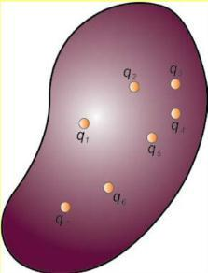
          - _{o}

  - ^{q}2 − − − − − (2)

        - _{o}

- ^{q}3 − − − − − (3)

      - _{o}

  - ^{q}n − − − − − (n)

        - _{o}

ϕ |  | = | 1 |  | * (q | + q |  | + q |  | + ..........q |  | )
ϕ |  | = | ε |  | * (q | + q |  | + q |  | + ..........q |  | )
 | total |  | ε | o | 1 |  | 2 |  | 3 |  | n
ϕ |  | = | 1 |  | * (Total charge enclosed surface) = |  |  |  |  |  |  |  | 1 |  | * Q = Req result
ϕ | total | = | ε | o |  |  |  |  |  |  |  |  | ε | o | * Q = Req result

Applications of Gauss law

Q.No. 9: Calculate the Intensity of field inside a hollow charged sphere?

Ans: To calculate the field intensity inside a charged sphere.
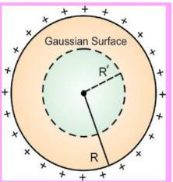
Step 01: Construct a Gaussian surface of R’ inside the sphere in which there is no charge q=0

Step 02: To calculate the flux use formula ϕ_{e} |  |  |  |  |  | = E.A ---------------- (1
Step 03: Using Gauss’s law ϕ |  | = | 1 |  | * q as there is no charge in surface so flux is zero then
Step 03: Using Gauss’s law ϕ | total | =
 | total |  | ε | o
 |  |  |  |  |  | ⃗
Equation 1) ϕ_{e} = E.A -=0 so this result into |  |  |  |  |  | ⃗
 |  |  |  |  |  | =0 inside the sphere.

Q.No. 10: calculate the electric field intensity due to an infinite sheet of charge?

Consider an infinite sheet on which positive charge is uniformly distributed.

To calculate the electric intensity at any point.

Step 01: consider a Gaussian surface in the form of cylinder passing through sheet having Area A and σ is uniform surface charge density, so the charge enclosed by it is q=σA
Step 02: For calculation of electric flux through each surface of Gaussian cylinder from figure below we have
=
As we know that, Flux through both ends will be: EA +EA i.e |  |  |  |  |  |  |  |  | as E and A are parallel so angle Ɵ=0°
 | ϕ |  |  | =2EA |  |  |  |  | ---------- (1

Step 03: According to Gauss’s law |  |  |  |  |  |  |  |  | ϕ |  | = | 1 |  |  | * q -------------(2
 |  |  |  |  |  |  |  |  | ϕ | total | =
 |  |  |  |  |  |  |  |  |  | total |  | ε | o
Comparing both eqs.
2EA = |  |  |  | 1 | * q by putting the value of q |  |  |  |  |  |  |  | so
 |  |  |  | ε _{o}
 | 1 |  |  |  |  |  | σ
2EA = |  |  | ( σA) |  |  | E = | σ | in vectorial form |  |  |  |  |  |  |  | E = | σ | rˆ
2EA = |  |  |  |  |  | E = | 2ε_{o} |  |  |  |  |  |  |  |  | E = |  | rˆ
 | ε _{o} |  |  |  |  |  | 2ε_{o} |  |  |  |  |  |  |  |  |  | 2ε_{o}

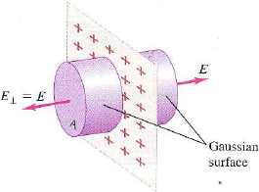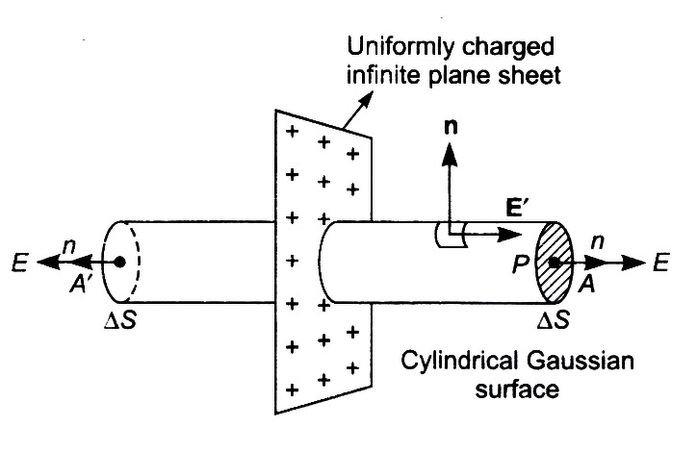

Q.No. 11: Calculate the electric intensity b/w two oppositely charged parallel plates?

Ans: Consider two parallel plate of closely spaced having opposite uniform distributed charge.. Electric field lines start from positive plate and end on negative plate

Step01: Consider a Gaussian surface in the form of hollow box having Area A and σ is uniform surface charge density, so the charge enclosed by it is q=σA

Step 02: For Calculating electric flux through each surface of hollow box we follow

Total electric flux= flux through upper surface of box+flux through lower surface of box+ flux through sides of box

As there is no field through upper end of box so flux through it will be zero Flux through lower surface =90°=EA

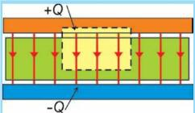
Flux through side of box is zero because they are parallel to field lines So total electric flux becomes= =0+EA+0=EA ------------ (1)

Step 03: According to Gauss’s law |  |  |  |  |  |  |  |  | ϕ |  | = | 1 |  |  | * q | ----(2)
 |  |  |  |  |  |  |  |  | ϕ | total | = |  | ε | o | * q
comparing both eqs to get the result
EA = | 1 |  | * q ⇒ EA = |  |  |  | 1 | * σA |  |  |  | ⇒ E = |  |  |  |  | σ
 | ε _{o} |  |  |  |  |  | ε _{o} |  |  |  |  |  |  |  |  |  | ε _{o}
in vector form |  |  |  | E = | σ | rˆ
 |  |  |  |  | ε _{o}

Q.No. 12: What is Electric potential and potential difference? Write SI unit with formula.

Ans: Electric potential: The electric potential energy per unit charge is called electric potential. Its unit is volt. Potential difference: The amount of work done in moving a charge from one point to other against electric field keeping the charge in equilibrium is called potential difference. OR The difference of potential energy per unit
Charge b/w two points is called potential difference and unit is volt.
Volt: SI unit of electric potential and potential difference

Definition: If one joule of work is done in carrying a unit positive charge of 1 coulomb from one point to other keeping the charge in rest position, then potential difference will be one volt. 1 joule/Coulomb=1 volt.
Potential Gradient. It is given as: Its unit is V/m.

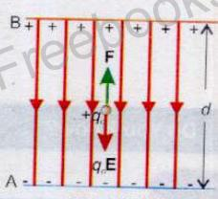
Relation: consider uniform Electric field E b/w two oppositely charged parallel plates and charge moves across the field.

The potential difference b/w two points
 |  | W |  |  |  |  |  | qoEd cosθ |  | qoEd cos180º
 |  |  |  | AB |  | F.d |  | qoEd cosθ
V | - V = |  |  | AB | = |  | = |  | = |  | = −Ed | cos180º = -1
B | A |  | q_{o} |  |  | q_{o} |  | q_{o} |  | q_{o}
as the distance b/w plates is small so d = Δr then above equation becomes V_{B} - V_{A} = ΔV = −E(Δr)

Q.No. 13: What is absolute potential? Calculate the Electric potential due to a point charge.

Ans: Defintion: The work done in bringing a unit positive charge from infinity to that point keeping electrostatic equilibrium is called absolute potential or electric potential at a point.

Calculation of potential: Consider a positive point charge q is moved from infinity to that point keeping it in equilibrium, since electric field intensity changes inversely to square of distance, so it does not remains same so taken two points A and B close to each other so that E remains same

The distance of point A from charge q = r_{A}

The distance of point B from charge q = r_{B}

Δr = r_{B} - r_{A} − − − − − − − − − − − − − − − (1)

The midpoint b/w A and B is given as r = ^{rA} ⁺ ^{rB} /2 , and the magnitude of field at this point is

E = | 1 |  |  |  |  | q |  | , |  |  |  |  |  |  |  |  | since the points are close to each other so we take approximations.
E = | 4πε _{o} |  |  |  | r ² |  |  | ,
r ≈ r = r |  |  |  |  |  |  |  |  |  | so we can say that r |  |  |  |  |  |  |  |  |  |  |  |  |  |  |  | ² = rxr = r r so the field becomes
A | B |  |  |  |  |  |  |  |  |  |  |  |  |  |  |  |  |  |  |  |  |  |  |  |  |  |  |  |  |  |  |  |  | A B
E = | 1 |  |  |  |  | q
E = | 4πε | o |  |  | r |  | r
 |  |  |  |  |  | A |  | B
now using the formula of potential gradient |  |  |  |  |  |  |  |  |  |  |  |  |  |  |  |  |  |  |  |  |  |  |  |  |  |  |  |  |  |  |  |  | ΔV = -EΔr
V_{B} - V_{A} = −E(r_{B} - r_{A} ) |  |  |  |  |  |  |  |  |  |  |  |  |  |  |  |  | it may also written as
V_{A} - V_{B} = −E(r_{A} - r_{B} ) , |  |  |  |  |  |  |  |  |  |  |  |  |  |  |  |  |  |  | applying minus inside the bracket
V_{A} - V_{B} = E(r_{B} - r_{A} ) |  |  |  |  |  |  |  |  |  |  |  |  |  |  |  |  |  |  | putting the value of field
V-V= |  |  |  |  |  | 1 |  |  |  |  |  |  |  |  | q | (r - r ) = |  |  |  |  |  |  |  |  | q |  | ( |  | r_{B} - r_{A} |  |  |  | )
A | B |  |  |  |  | 4πε _{o} r_{A} r_{B} |  |  |  |  |  |  |  |  |  |  | B |  | A |  |  |  | 4πε _{o} |  |  |  |  |  |  | r_{A} r_{B}
V-V= |  |  |  |  |  | q |  |  |  |  |  | ( |  |  | r_{B} |  | − |  | r_{A} | ) = |  |  |  |  | q |  |  | ( |  | 1 | − | 1 |  | )
A | B |  |  |  |  | 4πε _{o} r_{A} r_{B} |  |  |  |  |  |  |  |  |  |  |  | r_{A} r_{B} |  |  |  |  |  | 4πε _{o} r_{A} |  |  |  |  |  |  |  | r_{B}
As the point B is at infinity so r |  |  |  |  |  |  |  |  |  |  |  |  |  |  |  |  |  |  |  |  |  |  |  | = ∞ and V |  |  |  |  |  |  |  | = 0 and |  |  | 1 | = | 1 | = 0
 |  |  |  |  |  |  |  |  |  |  |  |  |  |  |  |  |  |  |  |  | B |  |  |  |  |  |  |  |  |  | B |  |  |  | r_{B} |  | ∞
V -0= |  |  | q |  |  |  |  |  | ( |  | 1 |  |  |  | −0) = |  |  |  | q |  |  | 1
A |  |  | 4πε _{o} |  |  |  |  |  |  |  | r_{A} |  |  |  |  |  |  |  | 4πε _{o} |  |  | r_{A}
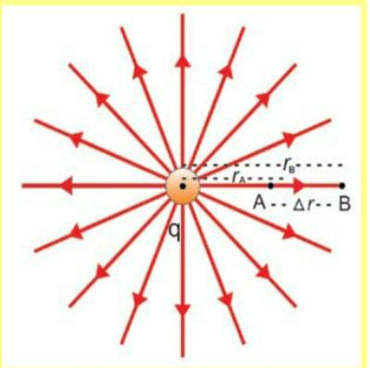

In general V= 1/4πε.q_{o}/_{r}²
Q.No. 14: What is eV? Prove that 1eV=1.6*10⁻¹⁹ J.
The amount of energy acquired or lost by an electron as it moves through a potential difference of one volt is called electron volt. This change in potential energy appears as kinetic energy q=e=1.6*10⁻¹⁹ C Δ(K.E)=qΔV=(1.6*10⁻¹⁹C)(1volt)
Δ(K.E)=1.6*10⁻¹⁹(CV) =1.6*10⁻¹⁹ J
1eV=1.6*10⁻¹⁹ J is required proof. | Where eV is the unit of energy

b) Write two similarities b/w electric force and gravitational force.
- Both forces are conservative

- Both obey inverse square law

c) Write four differences b/w electric and gravitational force.

Electric force |  |  | Gravitational force
Formula F = K | q₁q ₂ |  | Formula F = G | m₁m₂
Formula F = K | r ² |  | Formula F = G | r ²
It is explained by Coulomb law |  |  | It is explained by Gravitation law
It is stronger than gravitational force |  |  | It is weaker than electric force
It may be attractive or repulsive |  |  | It is attractive force only
It is medium dependent |  |  | It is medium independent
It is short range |  |  | It is long range

Q.No. 15: What is capacitor? Calculate the capacitance of parallel plate capacitor.
Definition: A Device which is used to store charge as well as electrical energy is called capacitor.

Construction: A capacitor consists of two parallel plates having opposite charge connected to potential difference V. let the Q charge on either of plate. So
Q α V , Q = CV, where C is constant of proportionality called capacitance of capacitance

Capacitance: The ability of capacitor to store charge is called capacitance. C=Q/V, its unit is farad.

Farad: If a charge of one coulomb given to plates of capacitor produces a potential difference of one volt b/w them then capacitance is 1 farad.1 Farad= 1C/1V.

Capacitance of parallel plate capacitor: Let us consider a parallel plate capacitor consisting of two metal plates each of area A separated by small distance d as shown in fig

Case A: When medium is air or vacuum b/w plates
If Q is the charge on the capacitor and V is the potential difference then C_{vac} = ^{Q /}_{V} - - (1) , the magnitude of electric intensity E is related with distance and potential

E = | V |  | , |  |  | V = Ed |  |  |  |  |  | also we know that Electric field intensity b/w two oppositely plates is E = ^{σ} |  |  |  |  |  | /ε _{o}
 | d |  |  |  |  |  |  |  |  |  |  |  |  |  |  |  |  | /ε _{o}
V = |  | σ |  |  |  | d |  |  |  |  |  | also we know σ = | Q |  |  | 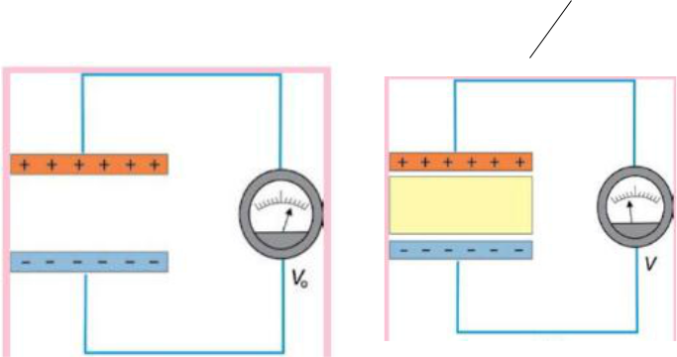
V = |  | ^{ε} o |  |  |  |  |  |  |  |  |  | also we know σ = | A
 | Q =σA |  |  |  |  |  |  |  |  |  |  | putting these values in eq (1)
C |  | = |  |  |  | σA |  |  |  | ,
vac |  |  |  |  |  |  | ^{σ} d
vac |  |  |  |  |  |  | σ | d
 |  |  |  |  | ^{ε} o
^{C} vac |  | = |  |  |  |  | Aε _{o} |  |  |  | this is the capacitance of parallel plate capacitor when air is placed b/w plates

Q.No. 16: What is electric polarization of dielectric and also define electric dipole?

Ans: Electric Dipole: Two equal and opposite charges placed at small distance d formed an electric dipole.
Polarization: A process in which the molecules of the dielectric under the action of external electric field become dipoles is called electric polarization and dielectric is called polarized.
OR The phenomenon in which negative and positive charges of atoms/molecules of dielectric are slightly displaced when a dielectric is placed in an electric field is called polarization.

Q.No. 17: What is the effect of polarization on capacitance of capacitor?

Ans: This decreases the effective electric field between the plates and will increase the capacitance of the parallel plate structure. The dielectric must be a good electric insulator so as to minimize any DC leakage current through a capacitor. The electric field between the plates of parallel plate capacitor is directly proportional to capacitance C of the capacitor. The strength of electric field is reduced due to presence of dielectric and if the total charge on the plates is kept constant then the potential difference is reduced across the capacitor plates.
When the dielectric is placed b/w plates then capacitance of capacitor is increased. Because dielectric material decreases surface charge density on plates which decreases the electric field intensity With this potential difference V is decreased V= Ed and capacitance is increased C= Q/V. In this way dielectric increases the capacitance of capacitor.
Q.No. 18: Calculate the energy stored in capacitor in terms of electric field.

Ans: Capacitor is device which is used for storing charge as well as electric energy.

When a capacitor is uncharged, the potential difference b/w plates is zero and finally it becomes V when charge q is deposited on each plate.
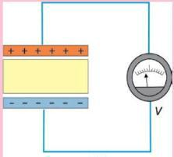
Average potential = |  |  |  |  | 0 + V |  |  | = |  | V
 |  |  |  |  | 2
 |  |  |  |  |  |  |  |  | 2
electric potential energy  Average potential x charge
P.E = | V | q |  |  |  |  | Also we know that q = CV
2
Energy = |  |  | V | (CV) = |  | 1 | CV ² |  | −−−−−−−−−−−−(1)
 |  |  |  | (CV) = | 2
2
Energy stored in an electric field
As we know that capacitance of capacitance C when medium is placed C = |  |  |  |  |  |  |  |  |  |  |  |  |  |  |  |  |  |  |  |  |  |  | Aε_{o} ε _{r} | , V = Ed
 |  |  |  |  |  |  |  |  |  |  |  |  |  |  |  |  |  |  |  |  |  |  | d
then Equation (1) becomes |  |  |  |  |  |  |  |  |  |  | Energy = | 1 |  | Aε_{o} ε _{r} | (Ed) ² | = | 1 | (E²ε |  | ε |  | )(Ad)
 |  |  |  |  |  |  |  |  |  |  | Energy = |  |  |  | (Ed) ² | = |  | (E²ε | o | ε | r
 |  |  |  |  |  |  |  |  |  |  |  | 2 d |  |  |  |  | 2 |  | o |  | r

Energy = ¹₂ (E ²ε_{o} ε _{r} )(volume)

Energy/Volume = Energy density = ¹₂ E ²ε _{o} ε _{r} , This is required result.
Q.No. 19: Discuss charging and discharging of capacitor.

Ans: RC circuit: The circuit consists of capacitor of capacitance C and resistor of resistance R is called RC circuit.
Charging of capacitor: When the switch S is set at terminal A connected to battery V which starts charging the capacitor through R. capacitor is not charged immediately and charges take some time to attain maximum value on capacitor qo=CVo

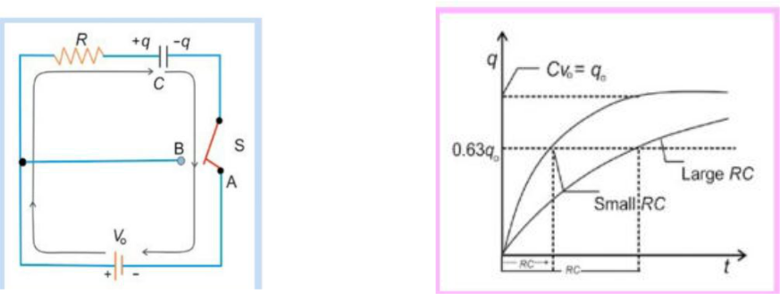

.

Time constant: The time required by capacitor to charge 63% of its maximum value is called time constant. OR the product of resistance and capacitance is called time constant t=RC. Its unit is second. For small value of time constant capacitor rapidly charges and discharges.

Discharging of capacitor: When switch is set at a point B, charge on positive plate start to discharge through R and neutralize the negative plate and graph of discharging is shown in fig below.

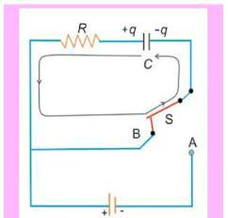
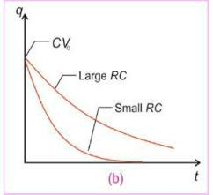

Graph of charging and discharging of capacitor is exponential.

  - Write the principle of working of windshield wipers of cars?
Charging and discharging of capacitor enable windshield wipers to be used. The time of the on-off cycle is found by the time constant of resistor capacitor combination.

  - Why electronic circuits such as T.V and computer are often enclosed within metal boxes?
To eliminate stray electric field interference circuits of such devices are enclosed within metal boxes.

  - What is ECG?

ECG stands for electro cardio gram. An ECG records the voltage b/w points on human skin generated by electrical process in the heart.
  - What is EEG?

EEG stands for electro encephala graph, in this potential difference created by the electrical activity of brain are used for diagnosing abnormal behavior.
  - What is ERG?

ERG stands for Electro retinography, in which electrical activity of the retina of eye generates the potential difference.
  - How shark and other sea creatures locate their prey very precisely?

Fish and other sea creatures produces electric field in variety of ways, sharks have special organ called ampullae of lorezini that are sensitive to field and can detect potential difference of nanovolt and can locate their prey very precisely

Choose the correct option. (Mcq’s)

 | Statements | A | B | C | D
1 | The number of electrons in one coulomb charge is equal to | 6.2x10¹⁸  electrons | Zero electrons | 1.6x10⁻²²  electrons | 6.2x10²¹  electrons
2 | The photo copying process is called | Xerography | Inkjet Printer | printing | photoediting
3 | Electric intensity due to an infinite sheet of charge is: | ∂/2ε∘ | ∂/rε∘ | ∂/r2ε∘ | none of these
4 | Electric flux is a: | Scalar quantity | Vector quantity | Variable quantity | All of these
5 | Electric potential at a distance ''r'' from ''q''  is: | V_{r} = 1/54πε∘q/r₂ | Vr=1/4πε∘2q/r | V_{r}=1/4πε∘2q/r | V_{r}=1/4πε∘q²/r
6 | The relative permitivity of air is | 79.5 | 1.006 | 1.06 | 1.0006
7 | The "toner" of photocopier is given: | Positive charge | Negative charge | Remains neutral | All of above
8 | The electric intensity at infinite distance from the point charge is | Infinite | Zero | Positive | Negative
9 | Who introduced the concept of electric field | Coulomb | Newton | Faraday | Millikan
10 | Net charge enclosed by Gaussian surface is: | zero | maximum | depend on intensity | Depend upon size of shape

