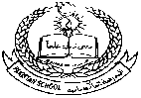**Pakistan School , Kingdom of Bahrain**

**E- Support and Learning Material**

**Subject: Math Name:________________________ Grade : 1 ( )**

* **Topic # 5. Basic Shapes & Patterns.**

**Q:1. Basic shapes and their names**

**Triangle**

**Rectangle**

**Square**

**Q: 2. Solve the following worksheets.**

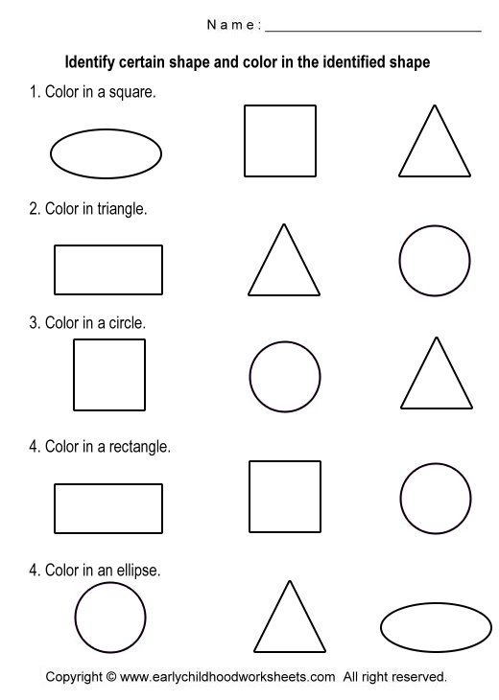 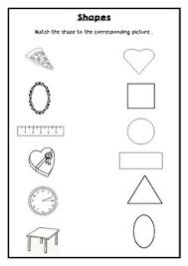

Color in oval

**Q: Can you complete these Patterns?**

**(Activity 1)**

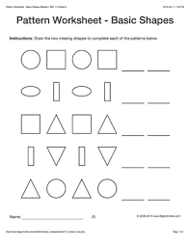

**(Activity 2)**

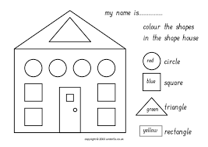

**(Activity-3) Draw the following shapes in notebook, circle, square, triangle, oval, rectangle**

**Assessment: Solve book page # 98 (on A4 size page)**

***\*Note: HW: Solve book pages 91,92,96,97, (on book)***