

**E-support and learning Materials /session 2020-2021**

**Subject: Computer Grade: 1**

**Unit 2**: Parts of a computer

**NOTES**

**PAKISTAN SCHOOL, M/O EDUCATION, KINGDOM OF BAHRAIN**

**FIRST TERM (Week 4)**

**Topic**: Monitor

**Objectives:**

* Identify a computer monitor
* Compare a monitor with a television

**Definition:** The computer monitor looks like a TV. It is used to see pictures and words on the monitor. We can watch movies, cartoons and play games on the monitor.

**Q1: Find the monitor in the pictures below and circle it:**

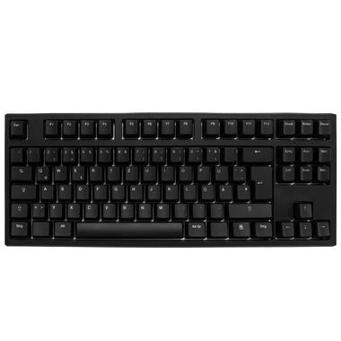 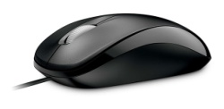 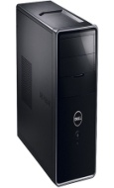

**Q2: Fill in the blanks** :

1. A computer monitor looks like a **TV.**
2. It is used to see **pictures** and word.

**Q3: Question and Answers**

Q: which part of the computer looks like a TV?

**Ans:** A monitor looks like a TV.