**Pakistan School , Kingdom of Bahrain**

**E- Support and Learning Material / Session 2020-2021**

**Subject: Chemistry Grade: 10th**

**Book: Text Book of Chemistry 10 FIRST TERM**

***NOTE: FOR SSC CLASSES PRESCRIBED TEXTBOOKS ARE THE MAIN SOURCE OF INFORMATION. FOLLOW THE TEXTBOOK ACCORDING TO ONLINE LECTURES. SAMPLE NOTES ARE PROVIDED FOR YOUR ASSISSTANCE.***

**Unit 10: Acids, Bases, and Salts**

**Q: Describe self –ionization of water:**

**Ans: Water molecules are highly polar. Occasionally, the collisions between water molecules are energetic enough to transfer a proton from one water molecule to another.**

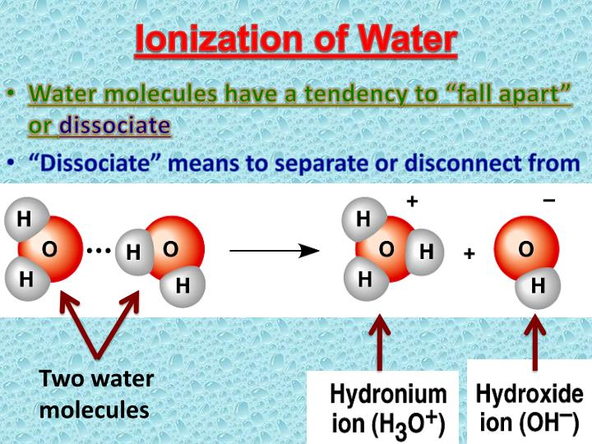

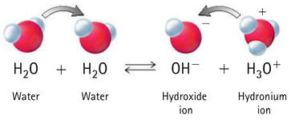

**A water molecule that donates or loses a proton becomes a negatively charged hydroxide ion OH- .The other water molecule which gains or accepts the proton becomes positively charged hydronium ion, H3O+**

**This reaction can be written as,**

**2H2O H3O+  + OH-**

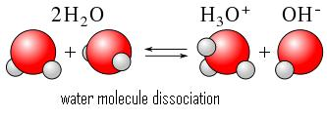

**The reaction in which two water molecules produce ions is called as the Self ionization or auto-ionization of water .This reaction can also be written as a simple ionization of water**

**H2O H+  + OH-**

**Water is a weak electrolyte. The self –ionization of water occurs to a very small extent. At 25 0C the experimentally determined concentrations of H+ ions and OH- ions are as follows.**

**[H+] = [OH-] =1x10-7 M**

**Equilibrium Constant**

**Kc =**

**Q: Derive the relation for ionization constant of water?**

**Ans: Ionization Constant for Water (Kw):**

**At 25 0C the experimentally determined concentrations of H+ ions and OH- ions are as follows:**

**[H+] = [OH-] =1x10-7 M**

**We can write equilibrium constant expression for the self-ionization of water as follows.**

**H2O H+ + OH-**

**Kc =**

**Since, H2O is a weak electrolyte, so the concentration of [H2O] will remain constant.**

**Kc [H2O] = [H+] [OH-]**

**Kw = [H+] [OH-]**

**Where Kw = Kc [H2O] is called Ionization Constant for water. It is also called the ion – product for water.**

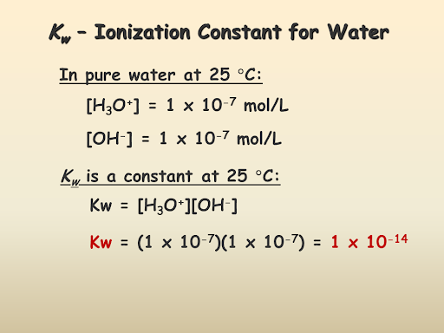

**Q: Write an Explanatory note on PH scale?**

**Ans:**

**Introduction:**

**In 1909, the Danish biochemist Soren Sorenson proposed a convenient method to express such small concentration of H+ ions and OH- ions by PH and POH**

**PH :**

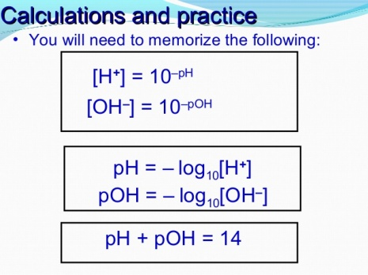**‘’ PH is defined as the negative logarithm of the molar concentration of H+ ions in aqueous solutions’’.**

**PH = -log [H+]**

**POH**

**‘’POH is defined as the negative logarithm of the molar**

**Concentration of OH- ions in aqueous solution’’**

**POH = -log [OH-]**

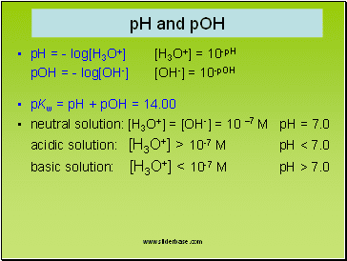

**Q: Prove that PH + POH = 14**



**2H2O H3O+  + OH-**

**Kc =**

**Since: Kw = Kc [H2O]**

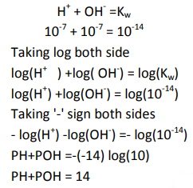**[H+] = [OH-] =1x10-7 M**

**Q: What is the importance of Kw?**

**Ans: Importance of Kw:**

**Kw is temperature dependent in any aqueous solution at 25 0C no matter what does it contain the product of H+ ion concentration and OH- ion concentration is always equal to 1.0x 10-14,This means that [H+] increases, the [OH-] must decreases so that the product of the two is still 1.0x10-14**

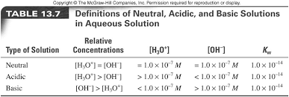

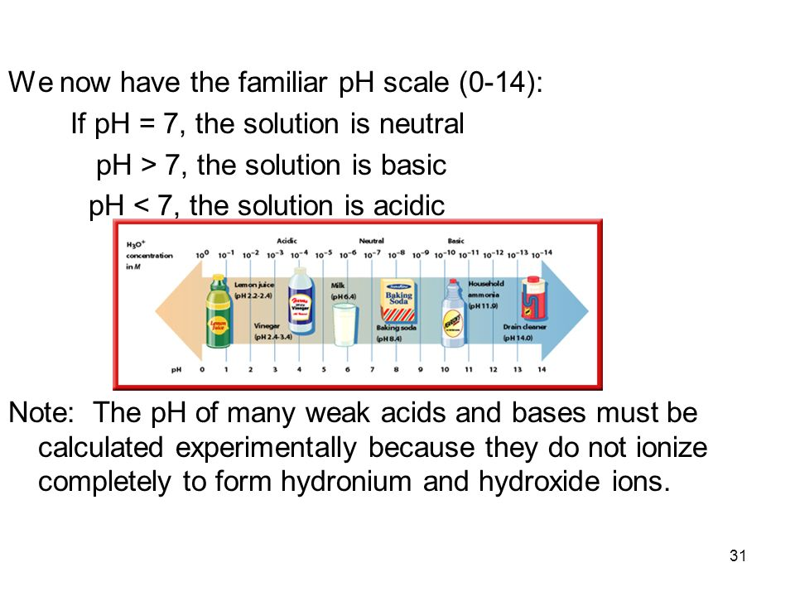

**Self Assessment Exercise 10.3: Classify a solution as neutral, acidic or basic.**

**1) A soft drink has [H+] = 3X10-3 M.Is drink acidic, neutral or basic?**

**Data:**

**Concentration of [H+] = 3X10-3**

**Remember that:**

**If [H+] =[OH-]=1X10-7 Solution is neutral**

**If [H+] > 1X10-7, Solution is acidic**

**If [H+] < 1X10-7 Solution is basic**

**Solution:**

**[H+] = 3X10-3 > 1X10-7 M, The solution is acidic**

**RESULT:**

**Because , 3X10-3  M > 1X10-7  M ,The solution is acidic**

**2) Ordinary vinegar is approximately 1M CH3COOH.Concentration of H+ in it is**

**4.2X10-3 M.Is vinegar acidic ,basic or neutral?**

**Data:**

**Concentration of [H+] =4.2X10-3 M.**

**Remember that:**

**If [H+] = [OH-] =1X10-7 Solution is neutral**

**If [H+] > 1X10-7, Solution is acidic**

**If [H+] < 1X10-7 Solution is basic**

**Solution:**

**[H+] = 4.2X10-3 > 1X10-7 M, The solution is acidic**

**RESULT:**

**Because , 4.2X10-3  M > 1X10-7  M ,The solution is acidic**

**THE PH SCALE**

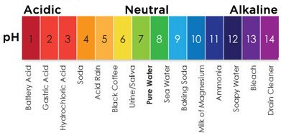

**Q: What do you mean by PH Scale?**

**Ans: Chemists use a number scale from 0 to 14 to describe the concentration of H+ ions in a solution is known as PH Scale.**

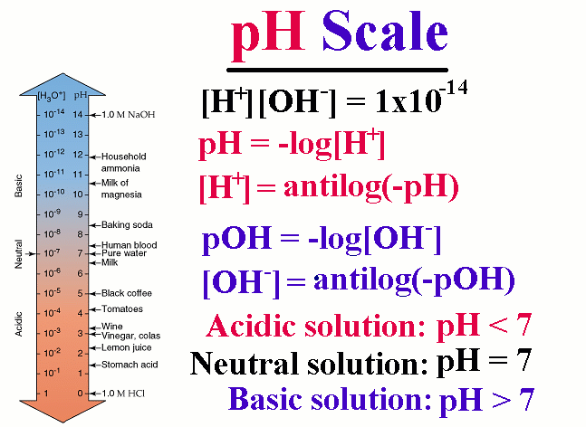

**Q: What is the PH range of Swimming pool?**

**Ans: The optimum PH range of a swimming pool is 7.2 to 7.6 because in human**

**Tears, when the PH is outside this range, eye irritation can occur.**

**Q: Describe Acidity of Stomach.**

**Ans: The main component of digestive or gastric juice in the stomach is hydrochloric acid. Almost two litre of it is secreted each day by gastric glands .However sometimes too much acid is secreted in the stomach which causes indigestion. This is called acidity of the stomach.**

**Q: Write down Application of PH Measurement?**

**Ans: Analytical chemist measures PH of solutions.PH measurement has valuable application. For instance, it helps analytical chemist to**

**(i) To create soil conditions ideal for plant growth**

**(ii) Medical diagnosis.**

**(iii) Maintaining the correct acid –base balance in swimming pools.**

**(iv) Electroplating.**

**(v) Manufacture of medicine etc.**

**(vi) Tap water and waste water.**

**ACID BASE INDICATOR**

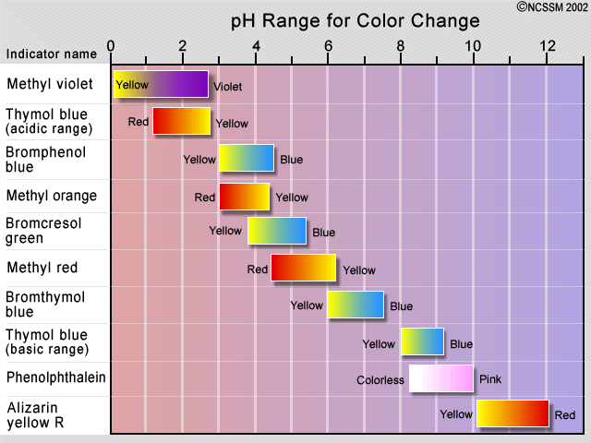

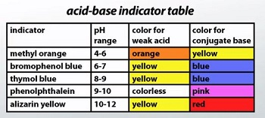

**Self Assessment Exercise: 10.4**

**Q: Write names of three acid base indicators.**

**Ans: Methyl orange, Bromophenol blue, Phenolphthalein,**

**Q: What is colour of methyl red in solution of (i) PH = 4 (ii) PH = 9**

**Ans: (i) Red (ii) Yellow**

**Q: Bromothymol blue added to a solution imparts blue color, what is the PH of this solution? PH= 9 or 5**

**Ans: PH= 9**

**Q: Etching is an art explain the method to crave the pattern into metal or glass.**

**Ans : Etching is an Art that uses acid to crave patterns into metal , glass and other materials. For this a piece of metal or glass is covered with wax, and then a design is etched on to the plate through the wax .The plate is then dipped into a tank of acid ,The acid eats away at the exposed portion ,Which leaves behind textured mark**

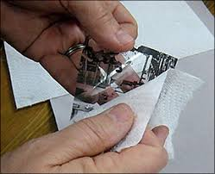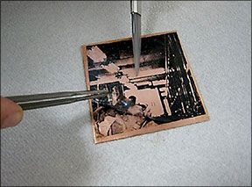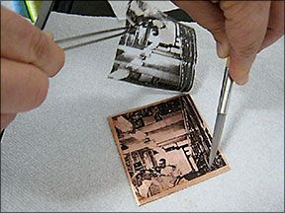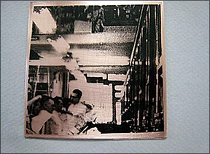

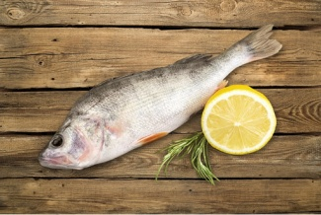**Q: Use of Lemon juice on fish**

**Ans: We make use of Chemistry when we put Lemon juice on fish .The unpleasant fishy odour is due to amines .The citric acid present in lemon juice convert amines into non volatile salts , thus reducing the odour.**