**Pakistan School , Kingdom of Bahrain**

**E- Support and Learning Material / Session 2020-2021**

**Subject: Chemistry Grade: 10th**

**Book: Text Book of Chemistry 10 (NBF) FIRST TERM**

***NOTE: FOR HSSC CLASSES PRESCRIBED TEXTBOOKS ARE THE MAIN SOURCE OF INFORMATION. FOLLOW THE TEXTBOOK ACCORDING TO ONLINE LECTURES. SAMPLE NOTES ARE PROVIDED FOR YOUR ASSISSTANCE.***

**Unit 10: Acids, Bases, and Salts**

**Q1: Write down some characteristic properties of acids and bases:**

|  |  |  |  |
| --- | --- | --- | --- |
| S.No. | Property | Acids | Base |
| 1 | **Tasty** | **Sour** | **Bitter** |
| 2 | **Effect on blue litmus** | **Turns red** | **No effect** |
| 3 | **Effect on red litmus** | **No effect** | **Turns blue** |
| 4 | **Effect of skin** | **Corrosive** | **Harm skin tissue** |
| 5 | **Electrical conductivity** | **Aqueous solutions conduct electricity** | **Aqueous solutions conduct electricity** |

**Q2: Give the Arrhenius concept of acids and bases. Also give the example:**

**Ans: Arrhenius Concept of Acids and Bases:**

**Introduction:**

**In 1887,a Swedish chemist Svante Arrhenius proposed the first successful theory of acids and bases .**

**Statement:**

**According to this theory,**

**ACID An acid is a substance that ionizes in water to produce H+ ions.**

**Example:**

**HCl $⇌$ H+ + Cl-**

**HNO3 H+ + NO3-1**

**BASE A base is a substance that ionizes in water to produce OH- ions.**

**Example:**

**NaOH Na+ + OH-1**

**KOH K+ + OH-1**

**Limitations:**

**Arrhenius theory has its limitations .It applies to aqueous solutions. It does not explain why compounds such as CO2 , SO2 etc. are acids .Why substance like NH3 are bases? There is no H in CO2 and OH in NH3**

**Dissatisfaction of Arrhenius theory(Defects):**

**i) There are certain substances which do not give H+  ions but still they are acidic in solution. e.g. AlCl3**

**ii) There are substances which do not give OH- ions in H2O but are basic in nature.**

**Q3: Give the Bronsted -Lowry concept of acid and basis also give examples.**

**Ans: Introduction:**

**In 1923 J.N Bronsted and T.M Lowry independently proposed another theory to overcome the shortcomings of Arrhenius theory this theory is known as Bronsted Lowry theory.**

**Statement:**

**According to this theory**

**ACID An acid it is a Proton Donor**

**BASE A base is a Proton acceptor**

**Example:**

** Consider the following example:**

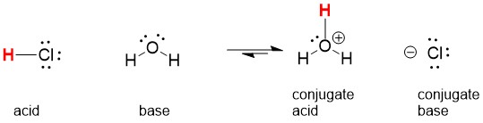

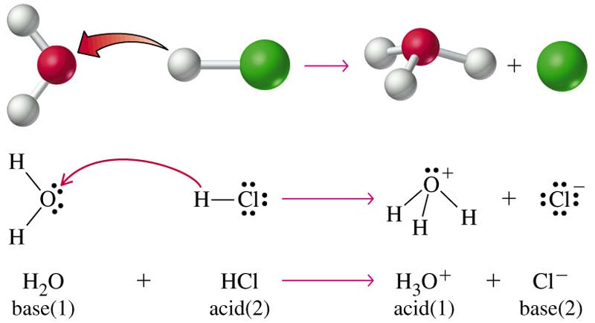

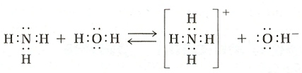

**MECHANISM**

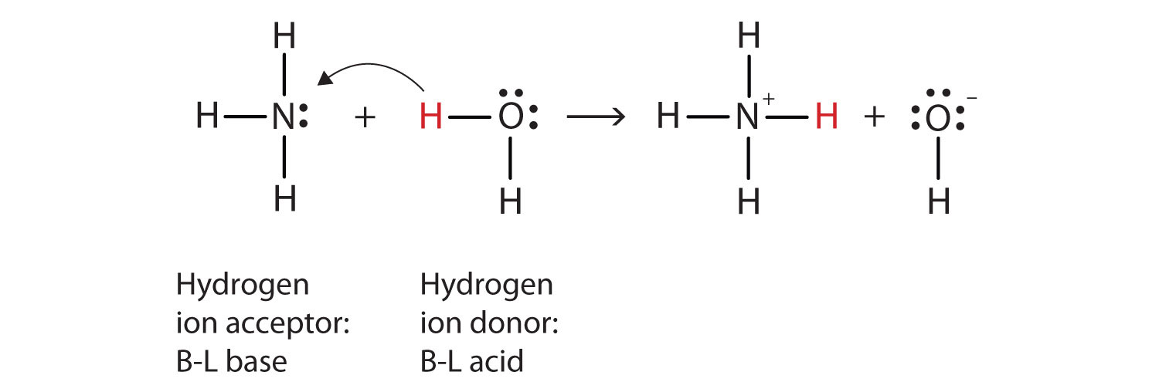

**Consider above two examples. In one example water molecule accept a Proton and in the other water donates a Proton. This means water behaves like an acid as well as a base. It is amphoteric in nature. Substances that react with both acids and bases are called amphoteric substances**.

**Q4:** **What are the limitations of Lowry Bronsted concept?**

**Ans: Dissatisfaction of Lowry Bronsted concept:**

**Bronsted-Lowry concept it is also not so comprehensive because following this concept certain compounds cannot be considered as acids or bases although they act as acids or bases for example sulphur trioxide(SO3) it is an acid but it cannot donate a Proton similarly calcium oxide(CaO) it is a base but it cannot accept a Proton**.

**Q5: Give the Lewis Concept of Acids and Bases.**

**Introduction:**

**In 1923 G.N Lewis proposed an acid-base theory that focuses on reaction .This concept is more general than either the Arrhenius theory or the Bronsted Lowry theory.**

**Statement**

**According to this theory:**

**ACID A Lewis acid is a substance that can accept a pair of electrons to form a**

**Coordinate Covalent bond.**

**BASE A Lewis base is a substance that can donate a pair of electrons to form a**

**Coordinate Covalent bond.**

**In Lewis acid base reaction a Coordinate Covalent bond is formed between the acid and the base.**

**Examples:**

**(1) Reaction between HCl and H2O**





**(2) Reaction between H2O and H2O**

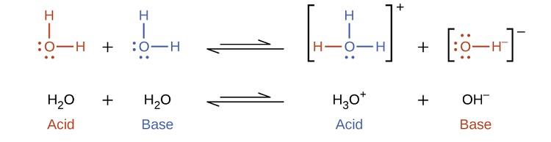

**(3) Reaction between HCl and NH3**

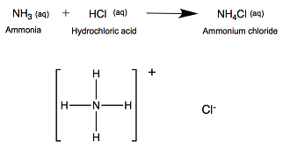

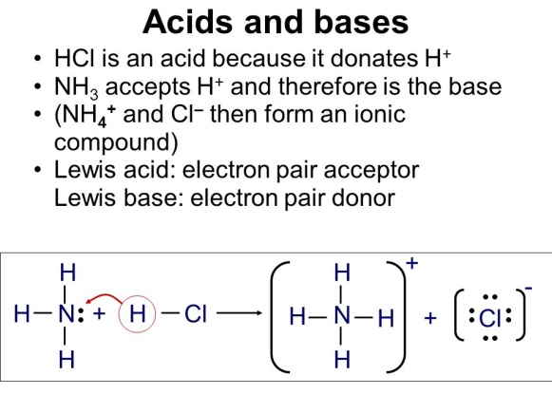

**(4) Reaction between BF3 and NH3**

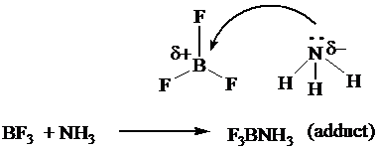**REACTION:**

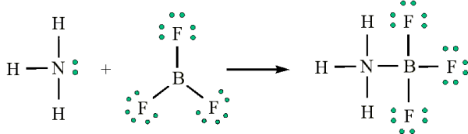**EXPLAINATION**

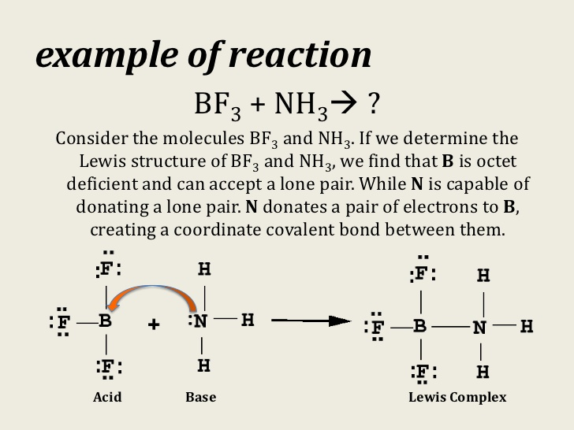

**Q: Acids Rain or acid snow:**

**Fossils fuels contain small amounts of sulphur and nitrogen , They produce sulphur dioxide and oxides of nitrogen when the fuel is burned large amounts of these oxides are released from coal-burning factories and power stations .They react chemically with the water vapours in clouds and oxygen in the air , forming acids**

**SO2 + ½ O2 + H2O H2SO4**

**4NO2 + O2 2H2O 4HNO3**

**The acid mix up with rain drops and falls as ACID RAIN or acid snow.**

**Q6: Write down used of some important Acids?**

**Uses of common Acids:**

|  |  |  |
| --- | --- | --- |
| Name | Formula | Common use |
| Hydrochloric acid | **HCl** | **Cleaning of metals, bricks, and removing scale from boilers** |
| Nitric acid | **HNO3** | **Manufacture of Fertilizers, explosives** |
| Sulphuric acid | **H2SO4** | **Manufacture of many chemicals, drugs, dyes, paints and explosives** |
| Phosphoric aciD | **H3PO4** | **Manufacture of fertilizers, acidulant for food** |

**Q7: Write down used of some important Bases?**

**Uses of common Bases:**

|  |  |  |
| --- | --- | --- |
| Name | Formula | Common use |
| Sodium hydroxide | **NaOH** | **Soap making, drain cleaners** |
| Potassium hydroxide | **KOH** | **Making liquid soap, shaving cream** |
| Calcium hydroxide | **Ca(OH)2** | **Making mortar, plasters, cement** |
| Magnesium hydroxide | **Mg(OH)2** | **Antacid , Laxative** |