**Pakistan School, Kingdom of Bahrain**

**E- Support and Learning Material / Session 2020-2021**

**Subject: Physics Grade: 10**

**Book: Physics 10 FBISE FIRST TERM**

***NOTE: FOR SSC CLASSES PRESCRIBED TEXTBOOKS ARE THE MAIN SOURCE OF INFORMATION. FOLLOW THE TEXTBOOK ACCORDING TO ONLINE LECTURES. SAMPLE NOTES ARE PROVIDED FOR YOUR ASSISSTANCE.***

**Ch. Simple Harmonic Motion and Waves**

* 1. **Q: Define the following terms which characterize simple harmonic motion?**

**Vibration, Time period, Frequency and Amplitude.**

**Characteristics of – SHM**

**Vibration: One complete round trip of vibrating body about its mean position is called one vibration.**

**Time Period (T): The time taken by a vibrating body to complete one vibration. Its Unit is (sec).**

**Amplitude (A) :The maximum displacement of a vibrating body on either side from its mean position.**

**Frequency: number of vibrations or cycles completed in one second. Its Unit is Hertz.**

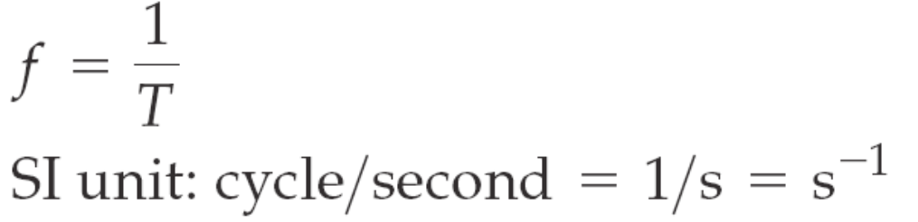

* 1. **Q: What are damped oscillations? How damping progressively reduces the amplitude of oscillation?**

**Answer:**

**Damped Oscillation.**

**The damping is a resistance offered to the oscillation. The oscillation that fades with time is called damped oscillation. Due to damping, the amplitude of oscillation reduces with time. Reduction in amplitude is a result of energy loss from the system in overcoming of external forces like friction or air resistance and other resistive forces. Thus, with the decrease in amplitude, the energy of the system also keeps decreasing as shown in figure below.**

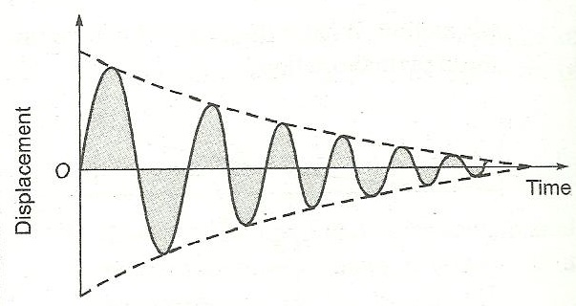

**Explanation:**

**Vibratory motion of ideal systems in the absence of any friction or resistance continues indefinitely under the action of a restoring force. Practically, in all systems the force of (fiction retards the motion, so the system do not oscillate indefinitely.**

**The friction reduces the mechanical energy of the system as time passes. And the motion is said to be damped. This damping progressively reduces the amplitude of the motion as shown in the figure above.**

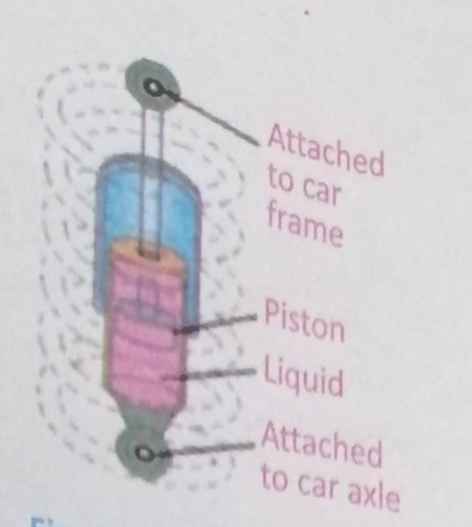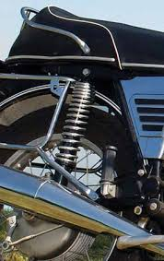

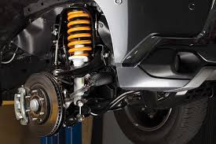

**Shock absorbers in automobiles are one practical application of damped motion. The shock absorber consists of a piston moving through a liquid such as oil. The upper part of the shock absorber is firmly attached to the body of the car. When the car travels over a hump on the road, the car may vibrate violently. The shock absorbers damp these vibrations and convert this energy into heat energy of the ‘oil.**

**Q. What is wave? Write its importance in our daily life.**

**Ans. “Wave is a mechanism in which energy is transferred from one place to another place due to disturbance in the medium”.**

**There are some waves, which we can see while there are some, which we cannot see, it can be detect with some sensitive instruments,**

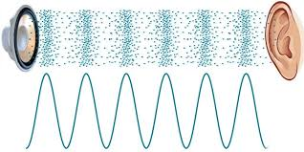**1 - Sound reaches in our ears in the form of waves**

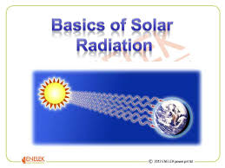

1. **The sunlight and heat reaches us in the form of waves.**
2. **The broad casting of radio and television is possible by waves.**
3. **The defects in human body i.e. broken bones, tumor s, bullets can also be detected by waves.**

**Q. What is wave motion? Explain.**

**Ans. “Wave motion in a medium is due to generated disturbance which causes the constituents of particles to repeat its to and fro motion about its mean position in equal intervals of time, and this disturbance is passed over from one end of the medium m to the other.”**

**Explanation:**

**Experiment-1:**

**Take a tub of water and dip one end of a pencil at the edge of a tub. Move the pencil rapidly up and down vertically. The ripples emerge outward on the surface of water. Place some pieces of paper or cork equally spaced in the direction of waves and observe the movement of paper, we will see that every piece of paper move up and down about its mean Position. They are not displaced in forward direction from their original position along with water waves. The pieces exhibit vibratory motion and have consecutive vertical vibratory motion. Hence this disturbance is transferred along with the waves and visible water waves are observed.**

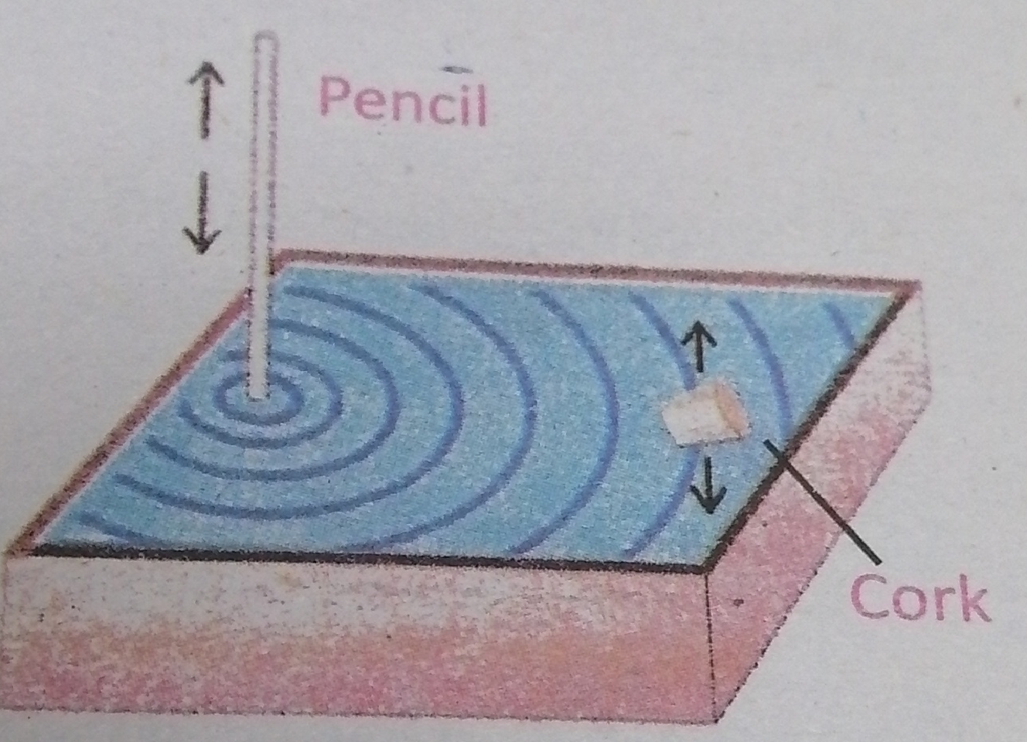

**Experiment-2:**

**Take a string and mark it with different colors at equal interval’s, Attach one end of string with a hook and keep the other end to oscillates. We will**

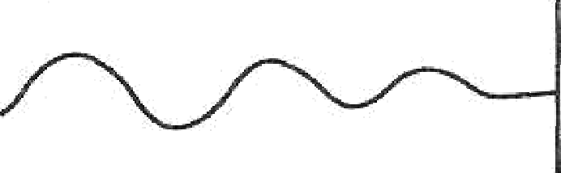

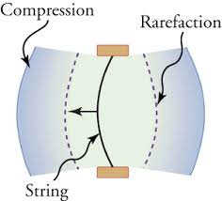**See that string will start oscillating vertically up and down briskly end wave will seen. When the color markings are observed the wave will travel down the string and they are vibrating about their mean position. At particular time it will observe that the markings are in different position along their vibratory path rather than vibrating together.**

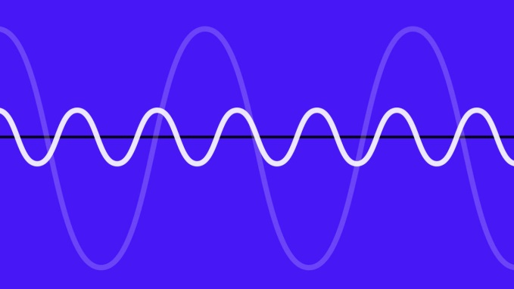

1. **CREST:**

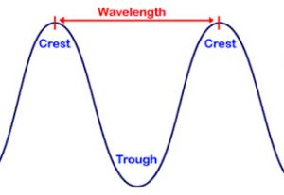**The part o1’ transverse waves where particles of medium are above the normal position are called crest.**

1. **TROUGH:**

**The parts of transverse waves where the particles of medium are below the normal position are called Trough.**

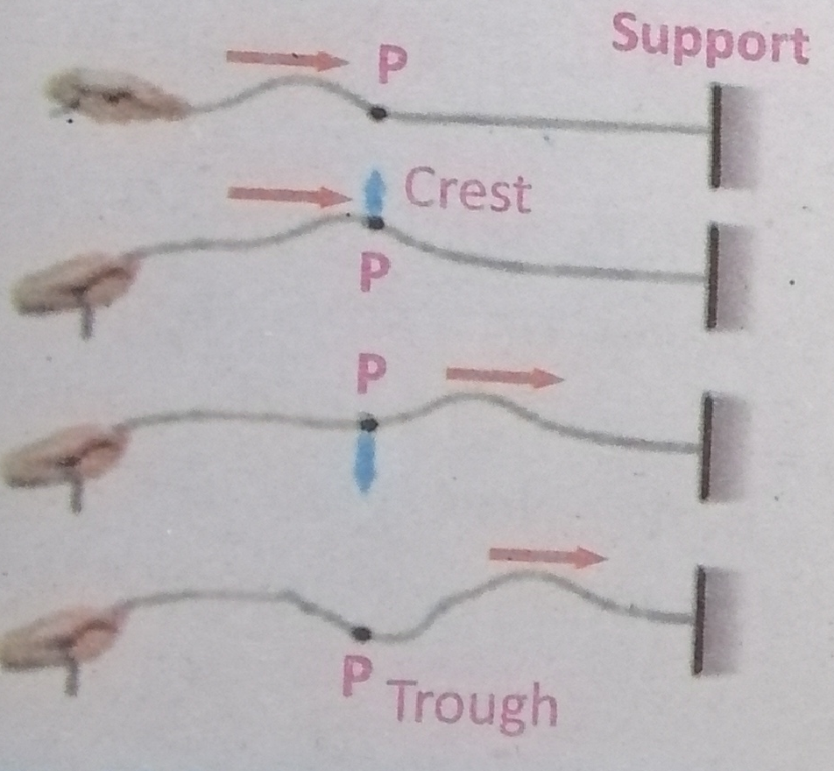

**Q: Describe the types of waves?**

**Answer: There are two categories of waves:**

1. **Mechanical waves**

**2. Electromagnetic waves**

**1) Mechanical waves:**

**Waves which require any medium for their propagation are called mechanical waves In such types of waves the particles of the medium vibrate about their respective mean position and propagate disturbance in the forward direction.**

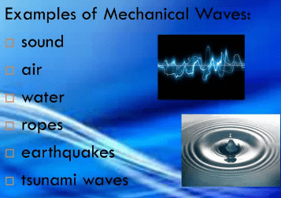**Examples of mechanical waves are water waves, sound waves and waves produced on the springs or strings.**

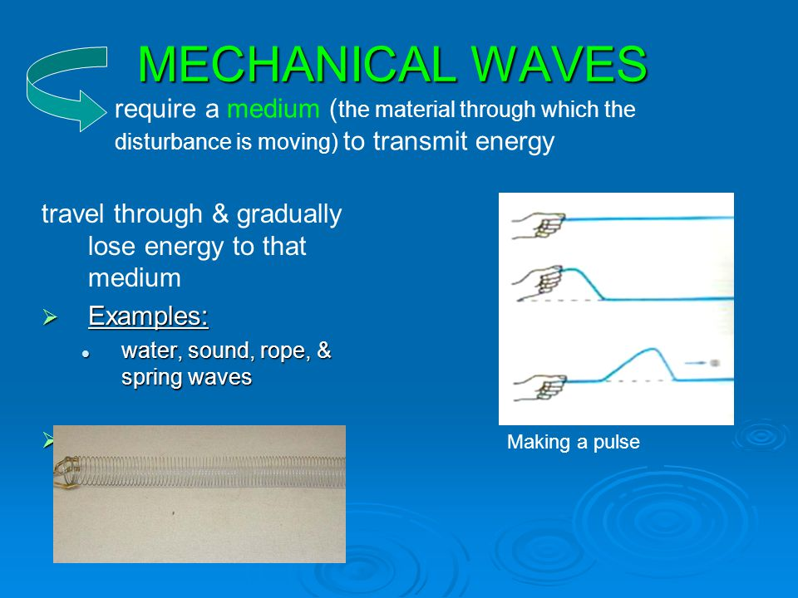

1. **Electromagnetic waves:**

**Waves which do not require any medium for their propagation are called electromagnetic waves.**

**Such waves are consisted of electric and magnetic fields.**

**Examples: Radio waves, television waves, x-rays, heat and light waves are some examples of**

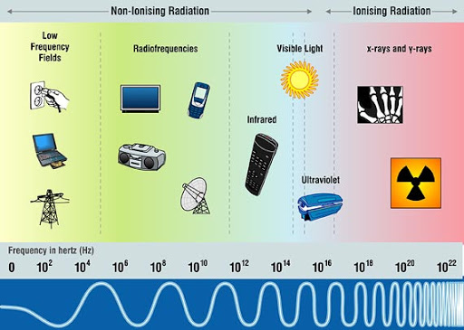**Electromagnetic waves.**

**Exercise:**

**Q: Choose the correct answer from the following choices:**

**1. Waves travels on water surface through**

**A. density of water B. mass of water**

**C. velocity D. disturbance**

**2. What can be transferred by the wave?**

**A. force B. acceleration**

**C. energy D. amplitude**

**3. Which of the following device is used to produce both transverse and longitudinal waves**

**A. A String B. A Ripple tank**

**C. A helical spring (slinky) d) A Tuning fork**

**4. Which of the following is method of energy transfer?**

**A. Conduction B. Wave motion**

**C. Radiation d) All of these**

**5. In vacuum all electromagnetic waves have same**

**A. Speed B. Wave length**

**C. Amplitude d) frequency**

**Q: Conceptual questions:**

**10.1 What type of waves does not require any material medium for their propagation?**

**Answer: Electromagnetic waves do not require any medium such as Radio waves, heat and light waves.**

**10.2 How many amplitudes are there in one oscillation?**

**Answer: There are four amplitudes in one oscillation.**

**Numerical Problems:**

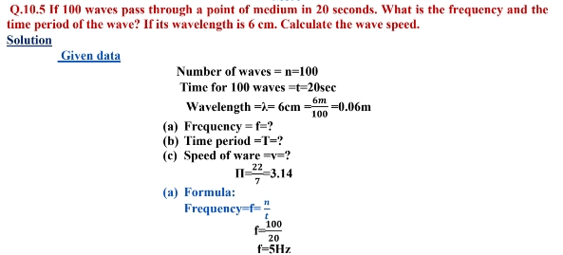

**(b)**

**(c)**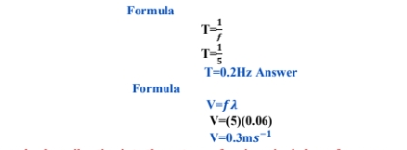

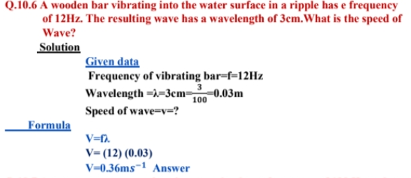

**ASSESSMENT:**

1. **Define the terms wave, crest and trough**
2. **Define damped oscillations and give one example.**
3. **Write down the characteristics of simple harmonic motion.**