**Pakistan School , Kingdom of Bahrain**

**E- Support and Learning Material / Session 2020-2021**

**Subject: Physics Grade : 10**

**Book: PHYSICS FIRST TERM**

**Unit 10: Simple harmonic motion and waves Pg. No: _2_+3____**

**QUESTIONS:**

Q. Define vibratory motion.

 Ans: A body moves back and forth or to and fro about a fixed point or equilibrium position then this motion is said to be vibratory motion.

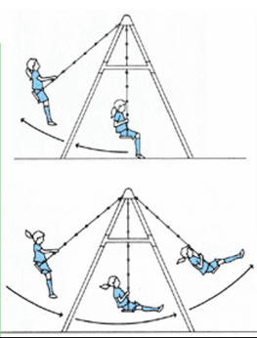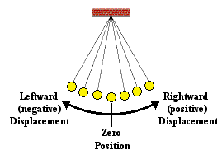 Examples:

1. The motion of a simple pendulum.
2. The motion of a swing.
3. The motion of   mass and spring system.

 Q. What is meant by simple harmonic motion?

Ans:

 Simple harmonic motion:

 The kind of vibratory motion in which acceleration of the body is directly proportional to the displacement from the mean position and is always directed towards the mean position is known as simple harmonic motion

Or

 Simple harmonic motion occurs when the net force is directly proportional to the displacement from the mean position and always directed towards the mean position.

Q. What are the necessary conditions for a body to execute simple harmonic motion?

Ans:

 Conditions for simple harmonic motion:

  A body executing simple harmonic motion must fulfill the following conditions.

i. Acceleration of a body must be directly proportional to the displacement from the mean position.

ii. Acceleration of a body should be directed towards its mean position.

iii. The system should be frictionless and body executing simple harmonic motion must have inertia and restoring force.

Q. Think of several examples in everyday life of motion that are simple harmonic.

Ans: Examples in everyday life of objects executing SHM.

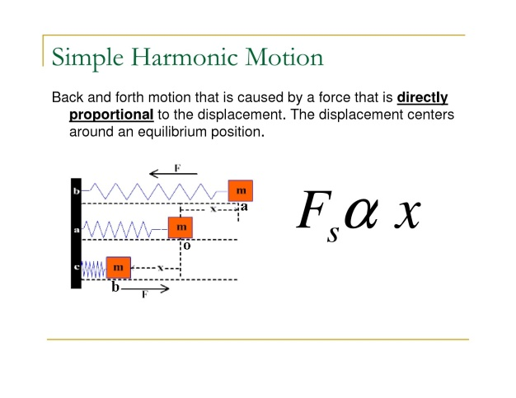

1. Oscillating pendulum.
2. Oscillating mass spring system.
3. Pendulum of wall clock.

Q. Prove that mass attached with a spring performs simple harmonic motion?

Ans:

Motion of mass attached with a spring:

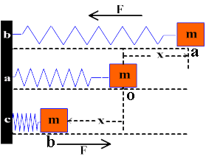 Consider a body of mass m is attached to a spring and is placed on a horizontal surface other end of the spring is attached with a firm support.  There is no extension in the spring in this state. This means that body is at equilibrium position.

Explanation:

Extreme Position:

 If an external force is applied on the mass m the length of the spring increases by an amount x and mass move from O to a new position A which is called extreme position.

 Hooke's law:

 According to Hooke's law:

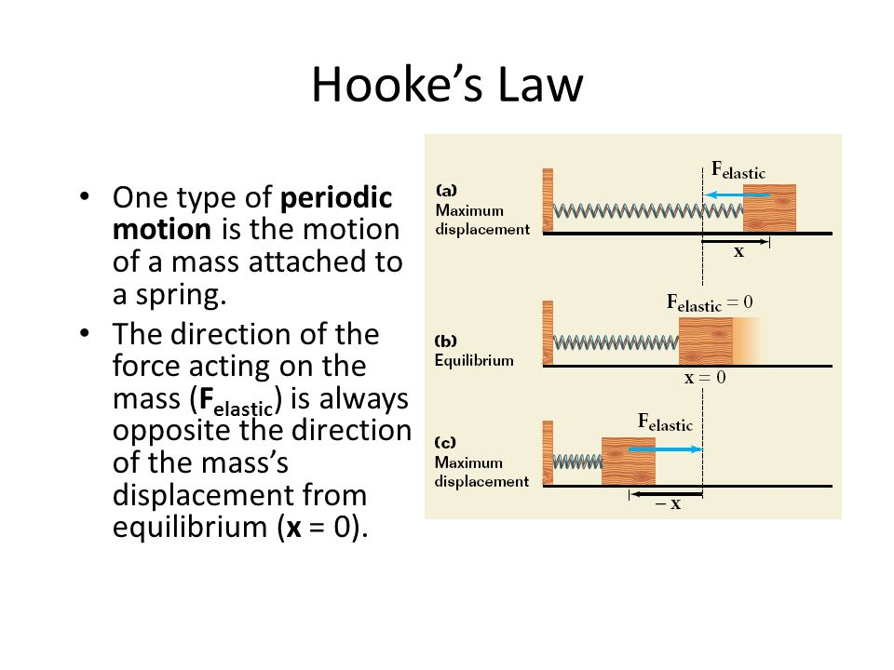 The external force applied on the spring is directly proportional to the increase in length.

  Mathematically:

Fext œ x

Fext =  k x

K = constant and is called spring constant.

Q. Define spring constant.

Ans:

Spring constant:

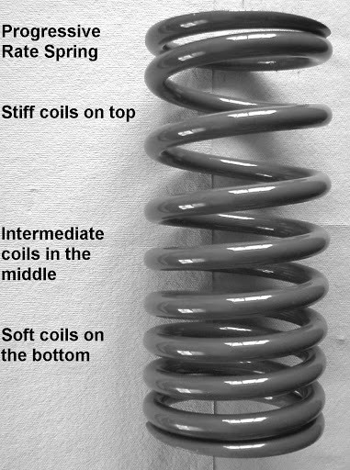 The ratio of external force acting on a   spring to the increase in length is called spring constant.

  Mathematically:

K = Fext  /x

Unit:

 Its unit is N/m.

 The value of k is a measure of the stiffness of the spring.   Stiff Springs have large value of k and soft spring have small value of k.

Q. What is meant by restoring force?

 Restoring force:  When an external force is applied on the spring, its length will increase. After releasing the force,   the spring will move towards mean position.  The motion of spring towards mean position is due to a force which is called restoring force.

Or

 Restoring force always pushes or pulls  the object performing oscillatory motion towards mean position.

 If displacement is x or mass m then restoring force is

F= - k x ……………… (a)

 Here negative sign indicates that restoring force of spring is opposite to the direction of motion or displacement of body from mean position.

When mass m is set free,  it starts moving towards O.

  According to second law of motion

F = ma ………………. (b)

 Comparing equation (a) and (b)

ma = - k x

a = - (k x)/m

a = - constant (x).

a œ -x

 This shows that acceleration is directly proportional to displacement from the mean position and negative sign shows that it is directed towards mean position.

 Forces acting on mass spring system:

 Vertical forces acting on the mass attached with a spring:

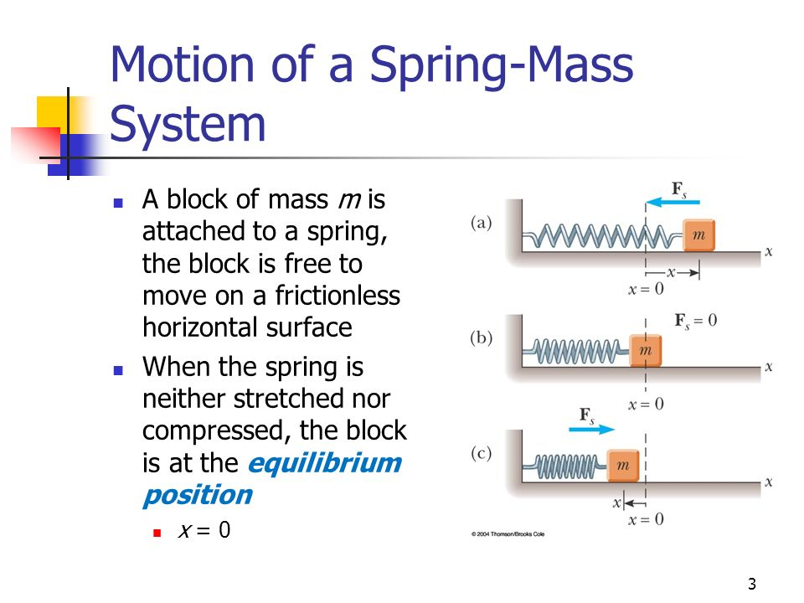 When the body is at mean position O the force acting on the mass is zero.  Because at this position two vertical forces i.e.  The weight of the body acting downward is equal to the upward normal reaction of the horizontal surface.  Hence, they cancel out effect of each other so there is no motion.

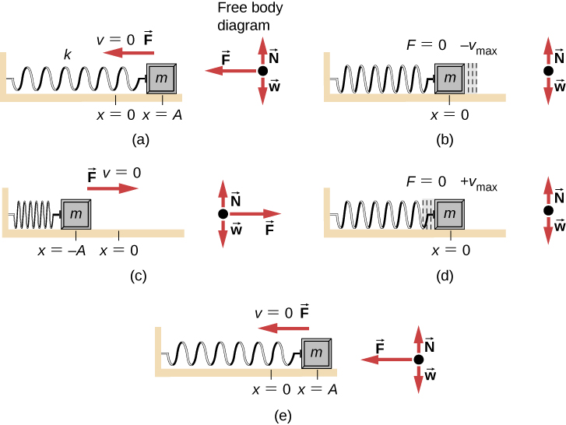

 Speed of mass attached with a spring between position A and B:

1. When the body is disturbed from O to A on ceasing the external force, body starts moving towards the mean position O  under the action of restoring force.
2. When the body is about to reach at O its velocity is maximum.
3. Due to inertia, body does not stop at point O but continues its motion towards point B, when it reaches at point B  its velocity reduces to zero.

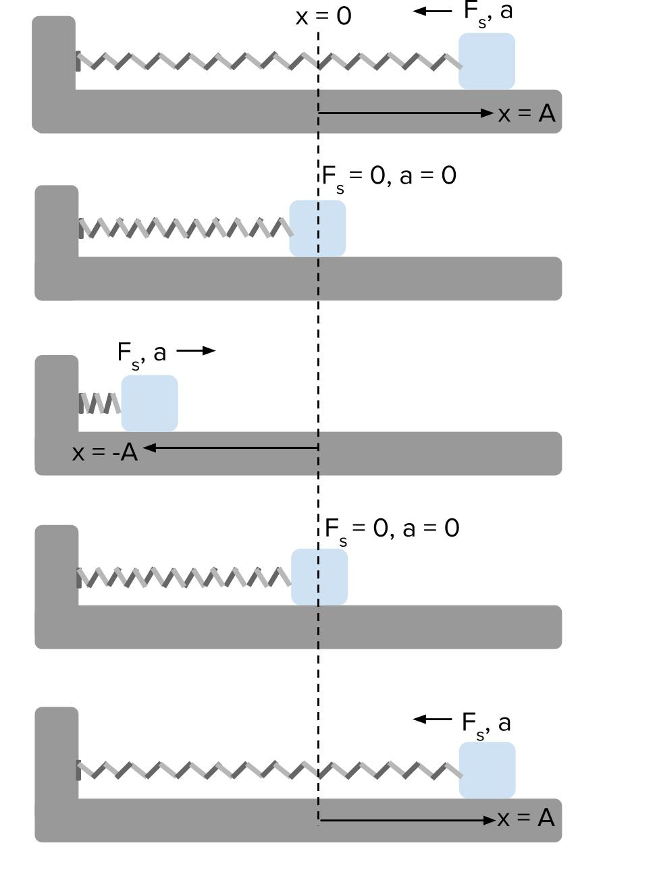 Acceleration of body between points A and B:

1. Acceleration of the body is directly proportional to its displacement x from the mean position O and is always directed towards the mean position x.
2. As the mass m moves towards the point O, Its displacement x it goes on decreasing and velocity goes on increasing. Resultantly the acceleration a of the body also decreases.
3. On reaching the point O, x becomes zero and so the acceleration a  of the mass  m also reduces to zero.
4. The acceleration of mass m remains towards mean position O when it moves from point O to B  . Because the velocity of the mass m starts decreasing as it passes the point O.
5. The body after coming to rest at point B again returns to the point O under the action of the restoring force.
6. This process continues and body keeps on vibrating between the points A and B.

 Conclusion:

 As the acceleration of the body is directly proportional to its displacement from the mean position and is always directed towards the mean position, therefore, we can say that the motion of a mass attached to a spring is simple harmonic motion.

#### Q: Explain the motion of ball in a bowl. Show that it is simple harmonic motion.

##### *Explain.*

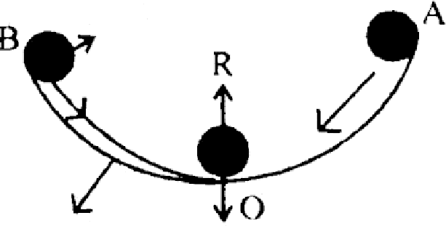

Ball

Answer:

The motion of a ball placed in a bowl is

An example of simple harmonic motion.

At Mean Position:

When the ball is at the mean position **‘O’**, that is, at the center of the bowl, net (force acting on the ball is zero. In this position weight of the ball acts downward and is equal to the upward normal force of the surface of the bowl.

At Position A

Hence there is no motion. Now if we bring the ball to position ‘A’ and then release it, the ball will start moving towards the mean position **‘O’** due to the restoring force caused by its weight. At position **‘O’** the ball gets maximum speed and momentum and moves towards extreme position **‘B’ due to inertia**.

At Position B

While going towards the posit ion “B” the speed of the ball decreases due restoring force which acts towards the mean position. At the position **“B”** the ball stops for a while and then again moves towards the position **“O”** because of restoring force and does not stop at O will go up to A, till all its energy lost due to friction. Thus to and fro motion of the ball about mean position placed in a bowl is an example of simple harmonic motion.

***Q. What is simple pendulum? Explain the motion of bob is simple harmonic motion.***

**Ans.**

**Simple Pendulum:**

**A simple pendulum consists of a single isolated bob suspended from friction less support by light inextensible .string. A small bob of mass “m’ is suspended by light inextensible string of length l**

***Velocity of Bob between ‘A’ and ‘B’:***

1. **- In equilibrium position, the pendulum is held stationary in a vertical position at point “O”.**
2. **When the bob is disturbed from ‘O’ to ‘A’ it starts moving towards the mean position under the action of gravitational force.**
3. **At ‘O’ the velocity of bob is maximum and due to inertia, the bob will not stop at ‘O’ and move to the other end ‘B’ and the velocity of the bob begin to decrease, anal becomes zero at ‘B’.**

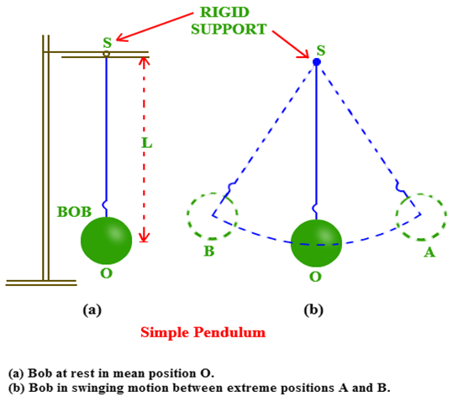

1. **The bob starts its motion from ‘B’ to ’O' and towards ’A’ the bob will continue its motion**

**Between 'A’ and ‘B’,**

**Acceleration of Bob Between A and B:**

1. **As speed of bob increases while moving from point ‘A’ to B’, the acceleration of the bob is**

**Towards ‘O’ the direction of acceleration remains same.**

1. **The direction of acceleration remain same towards ‘O’ during motion from point ‘O’ to ‘B’ because the speed of bob start decreasing.**

**This means that the direction of acceleration always towards mean position.**

**This show that acceleration is always directed towards the mean position and is directly proportional to the displacement So we can say that motion of simple pendulum is simple harmonic motion.**

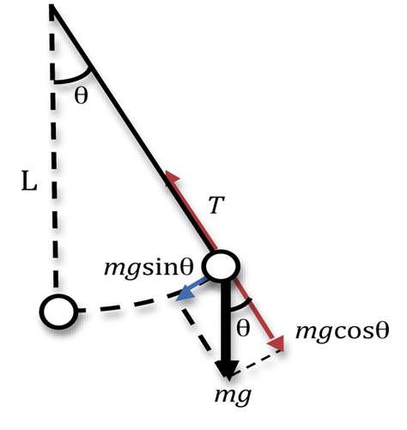

**Energy Changes Between A and B:**

1. **At point ‘O’ the bob is at lowest position so the potential energy of the bob is minimum.**
2. **At points 'A’ and B, at the highest level the potential energy is maximum and K.E 'of the bob is minimum i.e. zero.**
3. **In between extreme and mean position, the energy of the bob is partly potential and partly kinetic. But the total energy remains the same.**

**Note:**

**In simple harmonic motion, a body repeats it’s to and fro motion, in equal interval of time about its mean position.**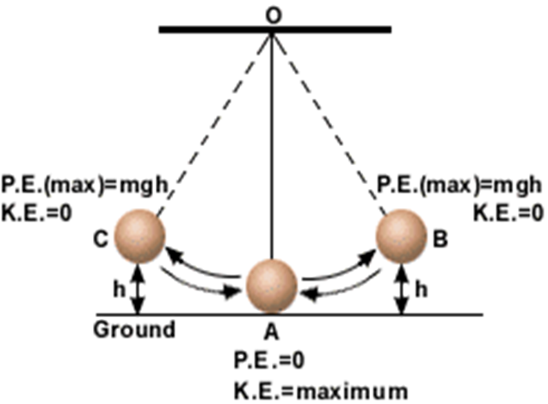

***TIME PERIOD:***

**The time period of simple harmonic motion of a mass attached to a spring can be found by the formula given below:**

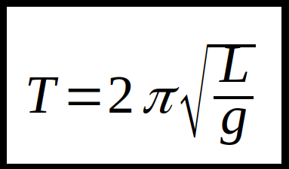

**Q. Describe some features of Simple Harmonic Motion.**

Important features of – SHM

1. **A body executing SHM always vibrates about a fixed position.**
2. **Its acceleration is always directed towards the mean position.**
3. **The magnitude of acceleration is always directly proportional to its displacement from mean position i.e. ( Acc = 0, at mean position and maximum at extreme position)**
4. **Its velocity will be maximum at mean position and zero at the extreme position.**
   1. **Q: Define the following terms which characterize simple harmonic motion?**

**Vibration, Time period, Frequency and Amplitude.**

Characteristics of – SHM

**Vibration: One complete round trip of vibrating body about its mean position is called one vibration.**

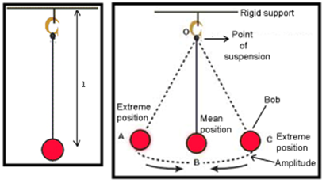

**Time Period (T): The time taken by a vibrating body to complete one vibration. Its Unit is (sec).**

**For mass spring system:**

**T = $2π\sqrt{(m}/k)$**

**For Simple Pendulum:**



**Amplitude (A) :The maximum displacement of a vibrating body on either side from its mean position.**

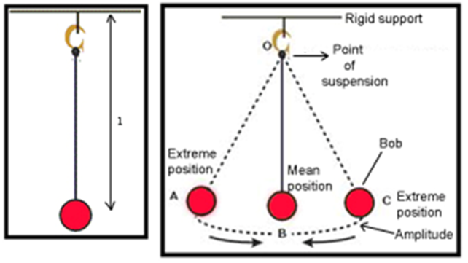

**Frequency: number of vibrations or cycles completed in one second. Its Unit is Hertz.**

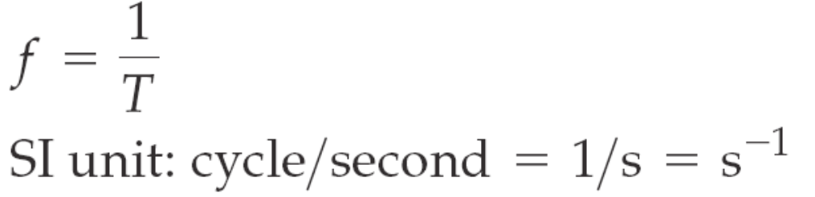

Assessment

Q: Choose the correct answer from the following choices:

**1. Which of the following is an example of simple harmonic motion?**

**A. motion of fan B. spinning of earth**

**C. motion of simple pendulum D. bouncing of ball**

**2. Simple harmonic motion is a type of?**

**A. Periodic motion B. Circular motion**

**C. Rotatory D. Random motion**

**3. If the mass of the bob of a pendulum is increased by a factor of 3, the period of the pendulum’s motion will:**

**A. Be increased by a factor of 2 B. Remain the same**

**C. be decreased by a factor of 2 d) be decreased by a factor of 4**

Conceptual questions:

**10.1 If the length of a simple pendulum is doubled what will be the change in its time period?**

**Answer: If the length of simple pendulum is doubled then it will be given as: As we know that**

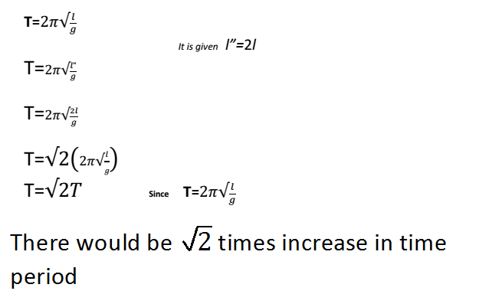

**10. 2 A ball is dropped from a certain height onto the floor and keeps bouncing. Is the motion of the ball simple harmonic? Explain.**

**Answer:**

**No, In case of a bouncing ball, when it hits the floor then there will be no restoring force or acceleration opposite to the downward displacement. So, it does not fulfill the Condition of simple harmonic motion. Secondly, in case of bouncing ball, the acceleration due to gravity remains the same, while for S.H.M the acceleration should vary at different points during the motion of the body.**

**10.3 A student performed two experiments with a simple pendulum. She/he used two bobs of different masses by keeping other parameters constant. To his/her astonishment the time period of the pendulum did not change! Why?**

**Answer: '**

**As we know that the time period of simple pendulum only depends upon the length of simple pendulum as given in its formula, i.e.**



**The value of ‘g’ will remain constant up to a certain height. So, by changing mass of**

**the bob or amplitude, there will be no effect on the time period, of simple pendulum.**

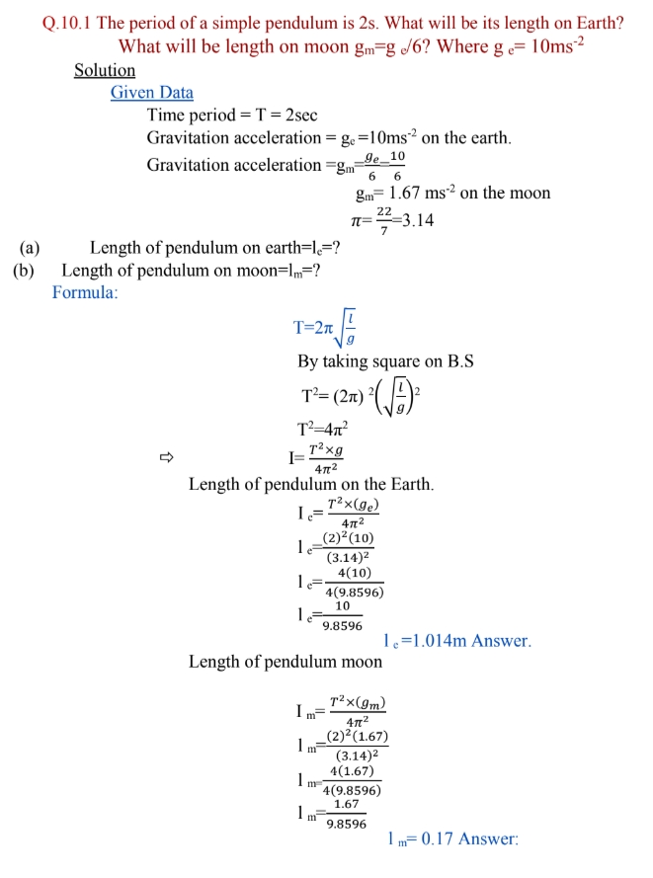





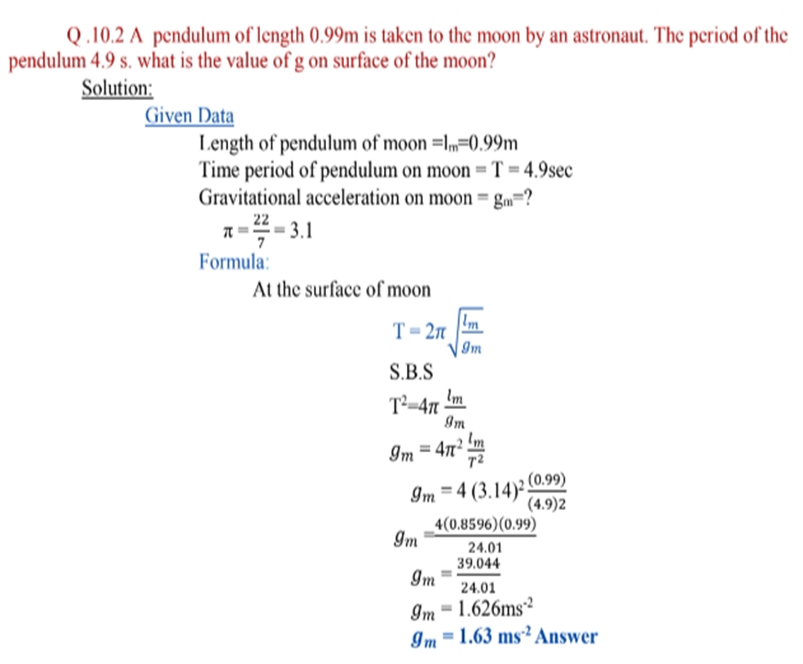

**Assessment:**

**Q.no. 10.3 Do yourself: It has two parts: part (a) can be done by using the same formula for time period.**

**For Part (b) use same above formula, just put the value of ‘gm’ for moon instead of on earth i.e. for earth ge=10ms-1 and for moon gm=ge/6= 1.67ms-2.**

**10.4 Self Try: Use same formula as used in Q.no (1) to find out length.**

**Q/A**

1. **Define Simple Harmonic Motion. Write its time period equation.**
2. **Define Hook’s Law.**
3. **Write down the important features of simple harmonic motion.**