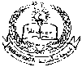 **E- Support and Learning Material / Session 2020-2021**

**PAKISTAN SCHOOL, M/O EDUCATION, KINGDOM OF BAHRAIN**

**Subject: Computer Grade: 2**

**Book: OXFORD KEYBOARD Book-2 (Third Edition)**

**FIRST TERM NOTES**

**Chapter 2:- Parts of a Computer (Week 4)**

**Chapter 2 (Topic: - Keyboard and Mouse)**

**OBJECTIVE**

The student should be able to:

* **Identify**  Keyboard and Mouse
* **Describe**  Keyboard (the use of a keyboard)

1. Mouse (the use of a mouse)

**Q1.Name the devices of a computer that you can see in the given picture:**-

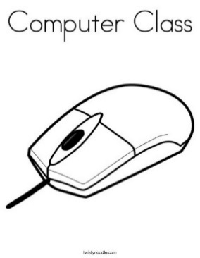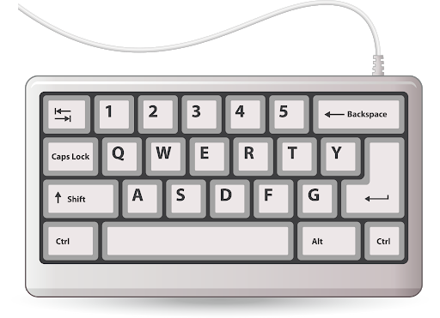

**Mouse Keyboard**

**Q2.Choose or underline the correct option:-**

1. Which one is an input device?
2. Printer
3. Speaker
4. **Keyboard**
5. Headphone
6. Which one is called a pointing device?
7. Keyboard
8. **Mouse**
9. Printer
10. Hard disk

**Q3.Answer the following:-**

1. **What is Mouse?**

Ans: Mouse is a Pointing device and it is used to move the things on the computer.

1. **List two uses of a mouse?**

Ans: A mouse is used to point at things on the computer. It is also used to click and drag things on the computer monitor.

1. **Why we use keyboard?**

Ans: Keyboard is used to enter data into a computer.