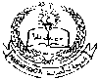 **E- Support and Learning Material / Session 2020-2021**

**PAKISTAN SCHOOL, M/O EDUCATION, KINGDOM OF BAHRAIN**

**Subject: Computer Grade: 2**

**Book: OXFORD KEYBOARD Book-2 (Third Edition)**

**FIRST TERM NOTES**

**Chapter 2:- Parts of a Computer (Week 5)**

**Chapter 2 (Topic: - Keyboard and Mouse)**

**OBJECTIVE**

The student should be able to:

* **Describe**  Keyboard (the use of a keyboard)

**Q2.Choose or underline the correct option:-**

1. A ________ has many small buttons called Keys.
2. Headphone
3. **Keyboard**
4. Speaker
5. By Pressing the Keys, we can type any letter or _________?
6. Mouse
7. Hard disk
8. **Numbers**
9. Keyboard looks like a __________
10. Television
11. **Type writer**
12. Mouse
13. Number keys are marked from ________ on computer keyboard.
14. 1 to 9
15. **0 to 9**
16. 0 to 10
17. Small button on the keyboard are called _________
18. **keys**
19. lock
20. Headphone

**Q2.Answer the following:-**

1. **What is Computer Keyboard?**

Ans: Keyboard is an Electric typewriter which is used to enter data.

1. **Write any two uses of a Keyboard?**

**Ans:** The uses of keyboard are:

1. Use it to type documents/messages.  
2. Usefull programs quickly with shortcut keys.

**Activity**

**Q1.Write the Missing letters of the following parts of Computer**?

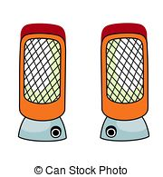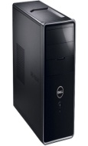

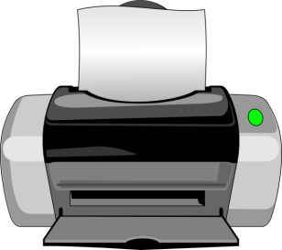

1. **C ----------- U** (b) **S _____ E A _____ E R** (c) **P R I _______ T E _____**

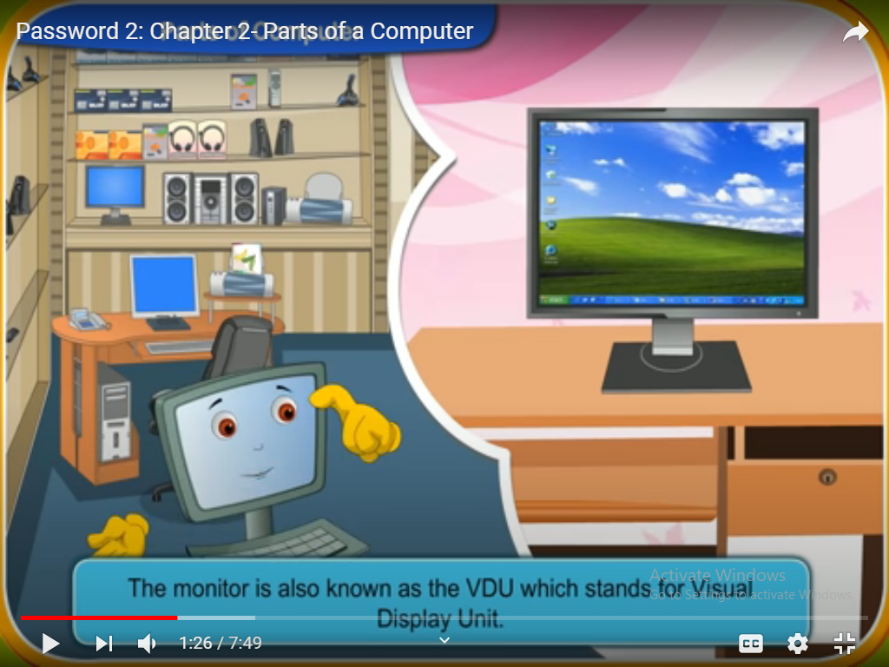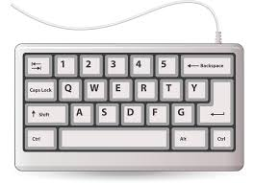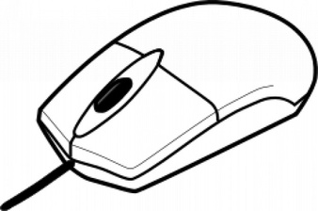

1. **M __ U S ___** (e) **K E __ B O A ___ D** (f) **M O ___ I T O ___**