****Pakistan School, Kingdom of Bahrain.

E-Support and learning Material

Subject: Math

Unit 1: Numbers to 1000

Activity: 8

Topic**: Even and Odd numbers** Grade: 2 ____

Name: _____________________________ Date: _________

**Note: Remember that even numbers always end with**

**( 0 , 2 , 4 , 6 , 8 ).**

Q1: Pick out the **even** numbers and write them in the given shapes.

519

624 611

386

450 722

818

Q2: Circle the **even** numbers.

1. 842 840 811 813
2. 215 216 219 218
3. 444 447 443 446

Q3: Write in the next missing **even** numbers:-

1. 610 __________ 614 __________ 618
2. 112 __________ 116 __________ 120
3. 746 __________ 750 __________ 754

****Pakistan School, Kingdom of Bahrain.

E-Support and learning Material

Subject: Math

Unit 1: Numbers to 1000

Activity: 9

Topic**: Even and Odd numbers** Grade: 2 ____

Name: _____________________________ Date: _________

**Note: Remember that odd numbers always ends with (1,3 ,5 ,7 ,9)**

Q1: Circle the **odd** numbers.

* 724 723 726
* 569 564 568
* 711 706 715

Q2: Fill in the missing **odd** numbers:

* 431 __________ 435 __________
* 865 __________869 __________
* __________ 233 __________ 237

Q3: Pick out the **odd** numbers and write them in the clouds.

463

247 644

671

256 545

819

 Pakistan School, Kingdom of Bahrain.

E-Support and learning Material

Subject: Math

Unit 1: Numbers to 1000

Activity: 10

Topic**: Even and Odd numbers** Grade: 2 ____

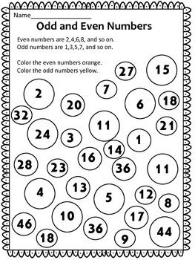Name: _____________________________ Date: _________

**Book Task**

Do the following pages in the book

**Page 21: Q4**

**Page 22: Q1**

**Unit 1 is done**

**Keep doing practice of the given work sheets and book pages**

**Thank you**