** Pakistan School, Kingdom of Bahrain**

**Subject: Maths E- Support and Learning Material**

**Class : 3( ) Name:___________________**

**Activity No :1 Date: / /**

**Topic: Addition**

**Q:Choose the correct answer by adding the ones and tens . First one is done for you.**

|  |  |
| --- | --- |
| **1** | 76  **56 + 20 = ( 76 , 85 )** |
| **2** | **54 + 12 = ( 66 , 74)** |
| **3** | **35 + 21 = ( 58 , 56)** |
| **4** | **70 +14** = **(84 , 82)** |

**Q: Add the 4 digit numbers together by adding ones , tens ,hundreds and**

**thousands.**

|  |  |  |  |
| --- | --- | --- | --- |
| **Th** | **H** | **T** | **O** |
| **4**  **+3** | **3**  **5** | **2**  **6** | **1**  **0** |
|  |  |  |  |

|  |  |  |  |
| --- | --- | --- | --- |
| **Th** | **H** | **T** | **O** |
| **4**  **+3** | **3**  **5** | **2**  **6** | **1**  **0** |
|  |  |  |  |

|  |  |  |  |
| --- | --- | --- | --- |
| **Th** | **H** | **T** | **O** |
| **4**  **+3** | **3**  **5** | **2**  **6** | **1**  **0** |
|  |  |  |  |

**Q: Solve the following sums.**

**1: 1 2 4 5 + 3 5 2 3 = _____________**

**2: 6 2 0 4 + 2 3 3 2 = _____________**

**3: 5 3 1 0 + 2 4 2 4 = _____________**

**Book pg: 23 Solve on Book.**

**Book pg: 24 , 25 ,26, 28 Solve on Book**

  **Pakistan School, Kingdom of Bahrain**

**Subject: Maths E- Support and Learning Material**

**Class : 3( ) Name:___________________**

**Topic: Adding mentally**

**Activity No : 2 Date: / /**

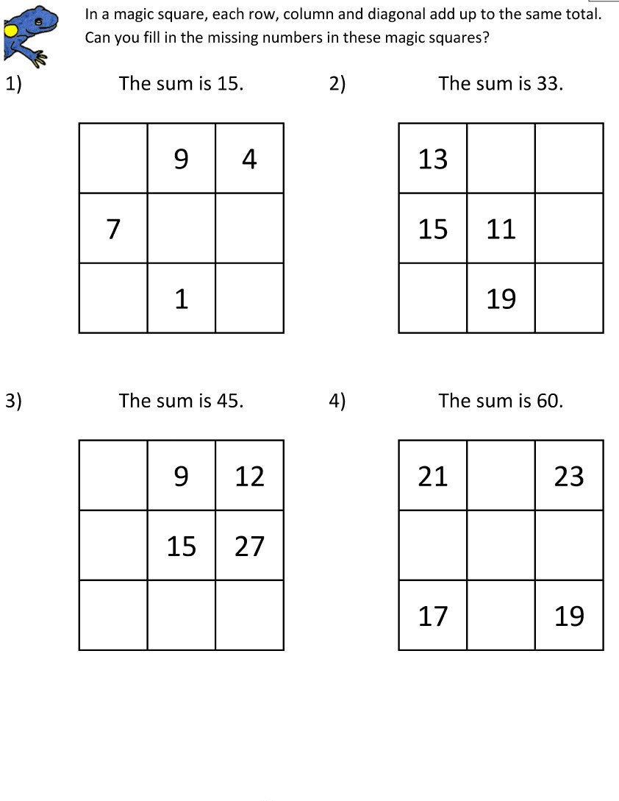

**Mental Math Addition book pg :30 ,31 Solve on book.**

**Do more practice of addition sums**

** Pakistan School, Kingdom of Bahrain**

**Subject: Maths E- Support and Learning Material**

**Class : 3( ) Name:___________________**

**Topic: Addition**

**Activity No :2 Date: / /**

**Q1: Add the following numbers without carrying .**

|  |
| --- |
| **2 4 6 2**    **+ 3 1 3 6** |

|  |
| --- |
| **1 3 4 5**    **+ 1 2 4 1** |

|  |
| --- |
| **5 1 1 2**    **+ 3 3 4 6** |

|  |
| --- |
| **4 5 6 7**    **+ 3 2 3 2** |

**Q2 : Fun with addition .**

**4 4 6 2**

**+ ________**

**6 5 9 3**

**6 4 2 6**

**+ ________**

**8 6 4 7**

**5 5 2 1**

**+ ________**

**9 7 5 2**

**5 4 1 0**

**+ ________**

**9 5 4 3**

**Q3: Solve the word problems.**

**( a): There are 1122 ducks in a farm . There are 235 fewer ducks than chickens .**

**How many chickens are there?**

**1122**

**Ducks**

**235**

**Chickens**

**= =**

**There are chickens.**

**( b): The baker made 1050 blueberry muffins and 920 chocolate muffins .**

**How many muffins did he make altogether?**

**[](https://www.bing.com/images/search?view=detailV2&ccid=GenP3ojq&id=5F3814DC8314D77A0A19B3EF4D6F6532AC12CA9D&thid=OIP.GenP3ojqNhYCdybaQ_q1CAHaIr&mediaurl=https://techcommgeekmom.files.wordpress.com/2014/09/double_chocolate_cupcakes.png&exph=2877&expw=2454&q=chocolate+muffin+wth+black+back+ground&simid=608045554827790635&selectedIndex=81)**

**No of blueberry muffins :**

**[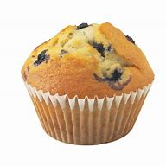](https://www.bing.com/images/search?view=detailV2&ccid=uqfmEsKm&id=1050C8DC6C1A91033D6E48FA12FF04545518AEA1&thid=OIP.uqfmEsKmj5z9cDQzYGWx2gHaHW&mediaurl=http://al-taiclub.com/images/blueberry-cupcakes-clipart-15.jpg&exph=1017&expw=1024&q=blueberry+muffin+wth+black+back+ground&simid=608006504952957733&selectedIndex=53) No of chocolate muffins :**

**=**

**The baker made muffins altogether.**

**Math Book pg: 46 , 50 , 51 Solve on Book**