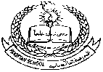**Pakistan School , Kingdom of Bahrain**

**E- Support and Learning Material / Session 2020-2021**

**Subject: Social-studies Grade : 4**

**Book: Social-studies for Pakistan 4 FIRST TERM**

**Unit #1 : Lesson # 3 Our country**

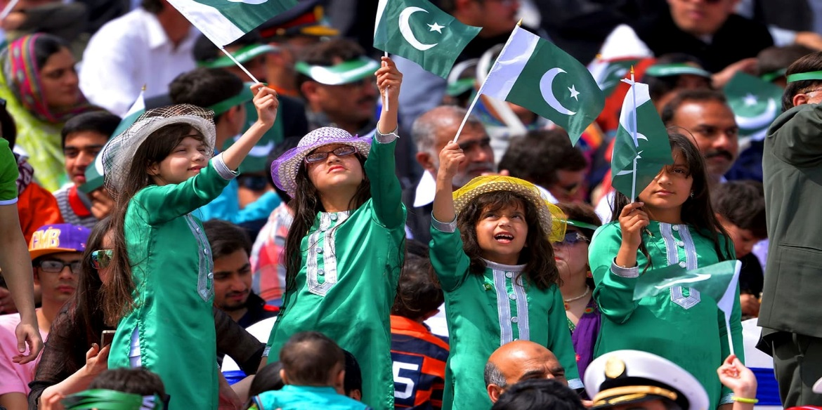

* **Oneline answers of the questions.**

**1.Which sea lies to the south of Pakistan?**

Ans: The Arabian Sea lies to the south of Pakistan.

**2.Where does the River Indus enter the sea?**

Ans: The River Indus enters the sea at South of Karachi.

**3. Which province is agricultural heartland of Pakistan?**

Ans: Punjab is called agricultural heartland of Pakistan.

* **Short answers of the questions.**

1. **Name the countries that share a border with Pakistan.**

Ans: Iran in the west, Afghanistan in the north-west, China in the north-east, and India to the east.

**2. Find out the names of the main deserts in Pakistan.**

Ans: Main deserts of Pakistan are : Cholistan Desert, Kharan Desert, Thal desert, Thar Desert.

**3. Where do the tributaries of the River Indus join it?**

Ans: River Indus, which starts in the Himalayas, is joined by the Jhelum, Chenab, Ravi and Sutlej rivers at Panjnad in southern Punjab.

**Worksheet 1**

**Q: 1 Write true or false.**

1. Pakistan is the Southern part of the continent of Asia. ( ……………….. )

2.The people of Pakistan speak many languages . ( ………………... )

3. Mostly people in Pakistan are Muslims. ( ………………… )

**Q:2 Match the Column A with Column B.**

|  |  |
| --- | --- |
| **Column A** | **Column B** |
| 1. Iran is in | the north- west of Pakistan.(………….) |
| 1. Afghanistan is in | the north-east of Pakistan.(…………) |
| 1. China is in | the west of Pakistan. (………..) |

**Q: 3 Describe the beauty of Pakistan in your own words?**

**Ans**:…………………………………………………………………………………………………………………………………………………………………………………………………………………………………………………………………………………………………………………………………………………………………………………………………………………………………………………………………………………………………………………………………………………………………………………………………..

**Worksheet 2**

**Q:1 Choose the correct answer.**

1. Coastal forests are called ……………………………. ( mangroves / vegetation)

2. Mangroves are rich in ……………………….life (desert / marine)

3. The Western Highlands and The Indus Plains are two separate …………… (regions / countries)

**Q:2 Match the column A with Column B.**

|  |  |
| --- | --- |
| **Column A** | **Column B** |
| 1. Pakistan is a | crowded and busy ( …………) |
| 2. Cities are | of Sindh (………….) |
| 3. Karachi is the province | beautiful country (……………..) |

**Q:3 Write five names of the countries larger than Pakistan.**

**Ans:…………………………………………………………………………………………………………………………………………………………………………………………………………………………………………………………………………………….**

**…………………………………………………………………………………………………………………………………………….**

**Home Work.**

**Please do the following exercises from text book in your note book.**

**Page # 16** ( Ex: A ) , ( Ex: B ) , ( Ex: C )

**Page # 17** ( Ex: D ) and ( Ex: E )