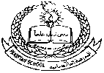**Pakistan School, Kingdom of Bahrain**

**E- Support and Learning Material / Session 2020-2021**

**Subject: SOCIAL STUDIES Grade 4:**

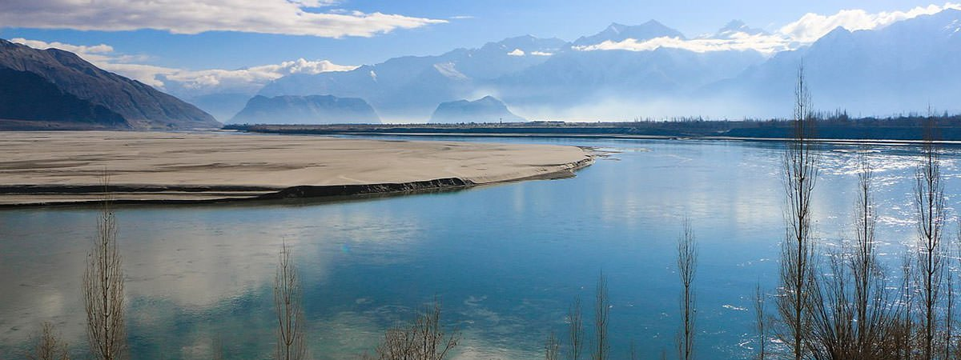**Unit 1: Lesson # 4 Landforms**

* **One line answers of the questions.**

**1. How are some areas of the country supplied with water?**

Ans: Canals carry the river water to many places.

**2. Where does the River Indus start?**

Ans: The River Indus starts high up in the Himalaya Mountains , from a lake called Mansorawar.

**3. How are valleys formed?**

Ans: Valleys are formed by fast flowing water or movement of glaciers.

**4. How long the River Indus is ?**

Ans: River Indus is about 2900 kilometres long.

**Short answers of the questions:**

**1: In which parts of Pakistan do you find deserts? Why?**

Ans: The deserts are on the Eastern and South-eastern border of Pakistan, where the plains are not drained by any water.

**2: Name the great Rivers of Punjab and at what point they join up?**

Ans: The great Rivers of Punjab are Jhelum, Chenab, Ravi and Sutlej. They join up at Punjnad , and flow together before joining the Indus.

**3. Which area is the most populated? Why?**

Ans: Most of our big cities and towns are in the Indus Plains. The Indus Plains provide Pakistan with its best agricultural land.

**4. Which is the highest peak in Pakistan? How high is it and where it is located?**

Ans: Mount Godwin Austen (K2) is the highest peak in Pakistan. Its height is 8611 metres. It is located in the north of Pakistan.

* **Detailed answer of the question:**

**Q:1 How does the River Indus change when it reaches the plains.**

Ans: By the time it reaches the plains, the river Indus spreads out into a much broader channel , about 16 kilometers wide. Its course become much straighter as it flows through the plains. About 650 kilometresbefore it reaches the Arabian Sea.

**Q: 2 Describe the course of the River Indus from its source as far as Kalabagh.**

Ans: It starts in the Himalaya Mountains. From here it flows west through a deep valley until it reaches Pakistan. It begins its long journey south through Pakistan and turn south at a point about 200 kilometres north of Islamabad. From here it continues into the Punjab plains.

**4. In which provinces will you find the western Highlands?**

Ans: The western Highlands are situated in the west and north of the country. They begin near the Makran Coast in the south, and cover most of Balochistan. They continue into Khyber Pakhtunekhwa and the northern part of Punjab.

**Q: Write True or False for each statement.**

1. Mansorawar lake is in Tibet. ( True)

2.The Indus turns south at a point about 200 kilometres north of Karachi.( False)

3.The winter snow and ice in the mountains melt in summer.( True)

4. Dams have to be built to save the water from being wasted. ( True)

5. The Indus Plains provide Pakistan with its poor agricultural land. ( False)

6. Large part of the population lives in the desert. ( False)

7. Most of our big cities and towns are in the Indus plains. ( True)

**Work to be done in the book**

**Reference:**

**Page # 33** ( Ex: A, B, C and D )