**Pakistan School, Kingdom of Bahrain**

**E- Support and Learning Material / Session 2020-2021**

**Subject: Computer Grade: 4**

**Book: Oxford Keyboard Book 4 (Third Edition) FIRST TERM**

**Unit 2: Input and Output Devices Week 4**

**Topic: Output Devices**

**Objectives:**

* Name various output devices.
* Identify the output devices available in computer lab.
* 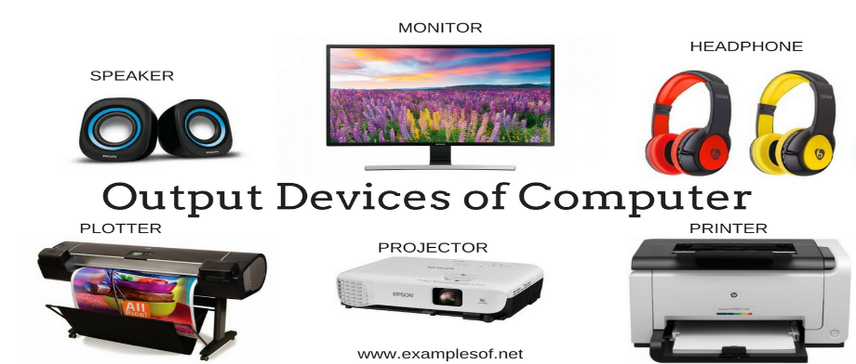Describe the uses of various output devices.

**Q1. Choose the correct option.**

1. The output on a monitor is called __________________________.

1. Soft copy 2.hard copy 3.printout 4.none of these

**b.** A device used to take the output on paper.

1. Printer 2.monitor 3.joystick 4.none of these

**c.** Which of these is an output device?

1. Mouse 2.keyboard 3.projector 4.scanner

**d.** A monitor is also called ______________.

1. VDU 2.DVD 3.CPU 4.none of these

**Q2.Write T for the true statement and F for the false one.**

1. Printer is a pointing device. (F)
2. A monitor is also called a VDU. (T)
3. Output on monitor is called hard copy. (F)
4. Output from printer is called soft copy. (F)
5. Speaker is an output device. (T)
6. A projector is used to give presentation. (T)

**Q3. Questions and Answers:-**

**1. What is an output device? Name any two output devices.**

Ans. The devices that we use to see the result from a computer are called output devices. Monitor and printer.

**2. What is the use of a monitor?**

Ans. The monitor is the most commonly used output device. It is also called a VDU. It is similar to a TV. It can display text and pictures.

**3. Which output device is used to give presentation?**

Ans. A projector is used to give presentation.

**4. Write the names of two devices that are used to give sound output?**

Ans. Speakers and Headphones are used to give sound output.

**Homework: Ref. Book Page # 12**

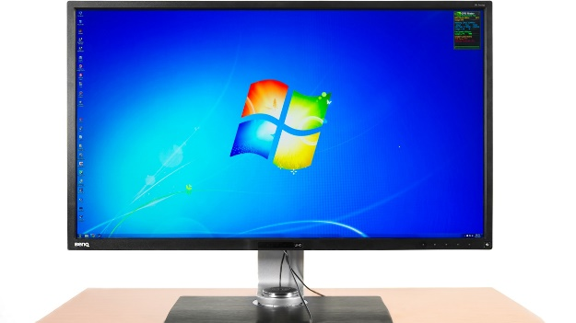Observe the following picture and answer the following questions.

1. Identify the device shown in the figure.
2. What is the other name of this device?
3. What is the use of this device?

**Exercises Ref. Book Page # 14, 15**