**Pakistan School , Kingdom of Bahrain**

**E- Support and Learning Material**

**Subject: Math Grade : 4**

**Unit 1: Numbers to 100 000**

**Topic 2: Factors**

**Definition**

To factor a number means to break it up into numbers that can be multiplied together to get original number.

**Q1: Find the missing factors.**

a. ____ x5=20

***Practice: Q1 (B. Pg# 23)***

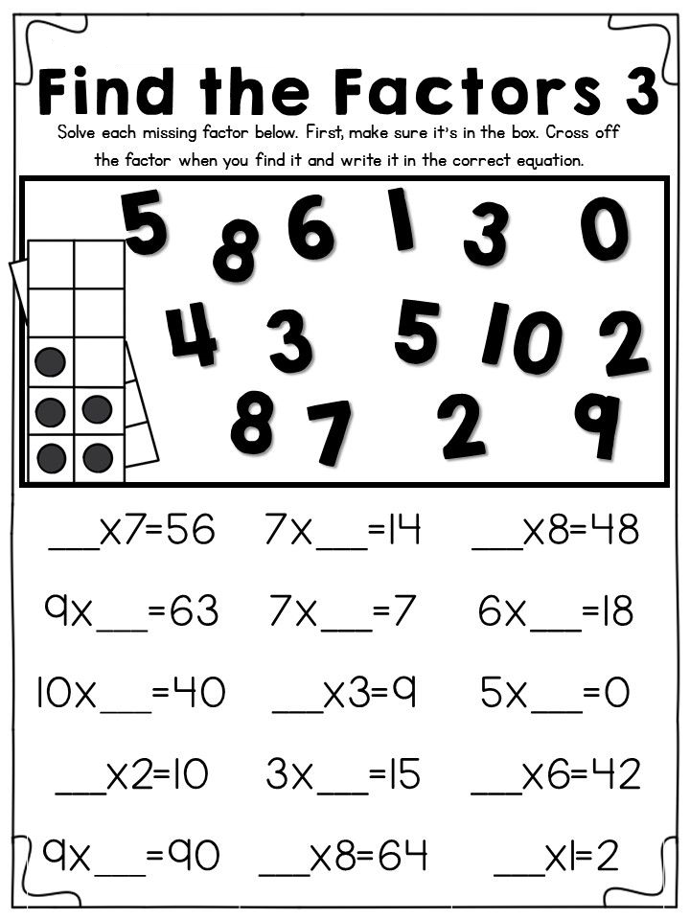

**`**

**Q. 2 Complete the table to find the factors of given numbers up to2o.**

|  |  |
| --- | --- |
| **Numbers** | **Factors** |
| **1** | **1** |
| **2** | **1,2** |
| **3** | **1,3** |
| **4** | **1,2,4** |
| **5** | **1,5** |
| **6** | **1,2,3,6** |
| **7** | **1,7** |
| **8** | **1,2.4,8** |
| **9** | **1,3,9** |
| **10** | **1,2,5.10** |
| **11** | **1,11** |
|  |  |

***Practice: Q2 (B. Pg# 23)***

**Q:3(a) Find the common factors of the given numbers.**

1. **20,28**

Factors of 20= 1 ,2 ,4 ,5 ,10 ,20.

Factors of 28=1, 2, 4, 7, 14, 28.

Common factors of 20,28 = 1 , 2 , 4 .Ans

**Q:3 (b) Find the highest common factors (HCF)of the given numbers.**

1. **10,18**

Factors of 10= 1 ,2 ,5 ,10 .

Factors of 18=1, 2, 3, 6, 9, 18.

Common factors of 10,18 = 1 , 2 .

H.C.F = 2 Ans

***Practice: Q3 (B. Pg# 23)***

**Topic 3: Multiples**

**Q:1 Write the next 10 multiples of each number.**

|  |  |
| --- | --- |
| Number | Multiples |
| 2 | 2, 4……….. |
| 6 | 6 , 12 ……… |
| 5 | 5 , 10……… |

***Practice: Q1(B. Pg# 27)***

**Q:2 Is 14 a multiple of 2? Why?**

7

2 14

-14

0  
14 is divisible by 2 so it is multiple of 2.

***Practice: Q 2 + Q 6(B. Pg# 27)***

**Q:3 Find the Least common multiple of the given numbers.**

1. 8 and 12

Multiples of 8 = 8, 16 , 24 ,32 ,40 ,48

Multiples of 12 =12, 24, 36

L. C. M= 24 Ans

***Practice: Q 3 + Q 4 +Q 5(B. Pg# 27)***

***Assessment activities***

Identifying Factors and Multiples

|  |  |  |
| --- | --- | --- |
| **Number** | **Ways of making the number** | **Factors the numbers** |
| 8 | 1 x 8 2 x 4 | 1 , 2 , 4 , 8 |
| 9 |  |  |
| 15 |  |  |
| 28 |  |  |
| 48 |  |  |

Shade multiples of followings numbers in different colours: 3 , 4 , 5 , 10

|  |  |  |  |  |  |  |  |  |  |
| --- | --- | --- | --- | --- | --- | --- | --- | --- | --- |
| 1 | 2 | 3 | 4 | 5 | 6 | 7 | 8 | 9 | 10 |
| 11 | 12 | 13 | 14 | 15 | 16 | 17 | 18 | 19 | 20 |
| 21 | 22 | 23 | 24 | 25 | 26 | 27 | 28 | 29 | 30 |
| 31 | 32 | 33 | 34 | 35 | 36 | 37 | 38 | 39 | 40 |
| 41 | 42 | 43 | 44 | 45 | 46 | 47 | 48 | 49 | 50 |
| 51 | 52 | 53 | 54 | 55 | 56 | 57 | 58 | 59 | 60 |
| 61 | 62 | 63 | 64 | 65 | 66 | 67 | 68 | 69 | 70 |
| 71 | 72 | 73 | 74 | 75 | 76 | 77 | 78 | 79 | 80 |
| 81 | 82 | 83 | 84 | 85 | 86 | 87 | 88 | 89 | 90 |
| 91 | 92 | 93 | 94 | 95 | 96 | 97 | 98 | 99 | 100 |

Multiples and factors code breaker-Answers

|  |  |  |  |  |  |  |  |  |  |  |  |  |
| --- | --- | --- | --- | --- | --- | --- | --- | --- | --- | --- | --- | --- |
| A | B | C | D | E | F | G | H | I | J | K | L | M |
| 12 | 16 | 6 | 24 | 27 | 1 | 64 | 4 | 525 | 80 | 70 | 29 | 28 |

|  |  |  |  |  |  |  |  |  |  |  |  |  |
| --- | --- | --- | --- | --- | --- | --- | --- | --- | --- | --- | --- | --- |
| N | O | P | Q | R | S | T | U | V | W | X | Y | Z |
| 56 | 423 | 20 | 5 | 26 | 233 | 15 | 8 | 21 | 25 | 46 | 192 | 30 |

Answers the questions below, link your answers to the table above to reveal what I called my unsuccessful, American.

Based big cat themed clothing company:

|  |  |  |  |
| --- | --- | --- | --- |
| What number is the 4th multiple of 5? | Which factor of 24 is missing from the list below  1,2,3,4,6,……..,12,24 | Which of the numbers listed below is a multiple of 7?  24,25,26,27,28,29 | Which of the numbers below is not a factor of 30?  15,12,6,5,30,1 |
|  |  |  |  |
| P | U | M | A |

|  |  |  |  |  |
| --- | --- | --- | --- | --- |
| Which of these below is factor of 60?  8,16,20,24,25 | Which factor of 36 is missing from the list below  1,2,3,4,6,9,……..,18,36 | What is the 7th multiple of 8? | Which factor of 30 is missing from the list below  1,30,10,3,5,2,6 | Which of the numbers listed below is not a multiple of 3?  233,192,423,525 |
|  |  |  |  |  |
| P | A | N | T | S |