**Pakistan School, Kingdom of Bahrain**

**E- Support and Learning Material / Session 2020-2021**

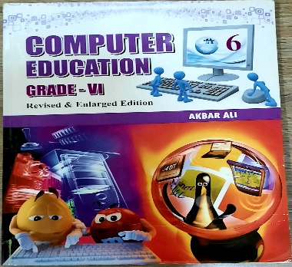 **Subject: Computer Grade: 6**

**Book: Computer Education FIRST TERM**

**Unit 2: Interacting with the computer Week 4**

**Topic: The Keyboard an Input Device**

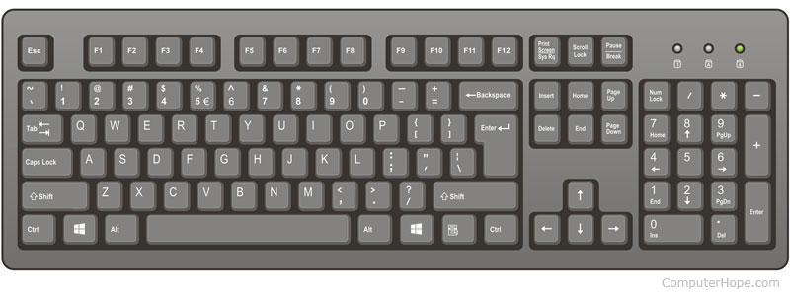**Objectives:**

The student should be able to:

* Identify the keyboard as an input device.
* Define the layout of a keyboard.
* Correct keyboarding techniques
* Ergonomic keyboard
* keystroking

**Q.1: Write a note on keyboard.**

**Ans.** The keyboard is the primary input device for entering text and numbers. It is a simple device, consisting of about 101 keys each of which sends a different character code to the CPU. It is the first peripherals to be used with PCs and still the most common one.

**Q.2: Explain the layout of a keyboard.**

**Ans.** There are several styles of keyboards, but the QWERTY is more popular. It pronounces KWER-tee; the name refers to the arrangement of keys on a Standard English computer keyboard. All keyboards, however, have the same basic parts.

**Q.3: Explain the following.**

1. **Alphanumeric keys:**

Alphanumeric keys are the parts of the keyboard that look like a typewriter.

1. **Modifier keys:**

These keys are used in conjunction with other keys. We press a letter or number while holding down one of the modifier keys.

* Ctrl for control
* Alt for alternate
* Shift

1. **Numeric keypad:**

Numeric keypad is usually located on the right side of the keyboard. It looks like a calculator.

1. **Function keys:**

These are located in a row at the top and are used to give commands.

1. **Cursor movement keys:**

These keys are used to control the movement of cursor on the screen.

**Q.4: Write a note on special purpose keys.**

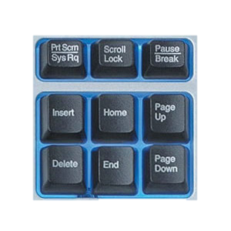**1. ESC:**

Esc short for escape, esc is a key located on the top-left of a computer keyboard that allows a user to cancel or abort operations.

**2. Print Screen:**

Pressing this key sends a copy of what appears on your screen directly to the printer. In Windows this key is also used to capture the screen.

**3. Scroll Lock:**

It was used to modify the behavior of the arrow keys.

**4. Pause/Break:**

In some programs, this key can be used to stop a command in progress.

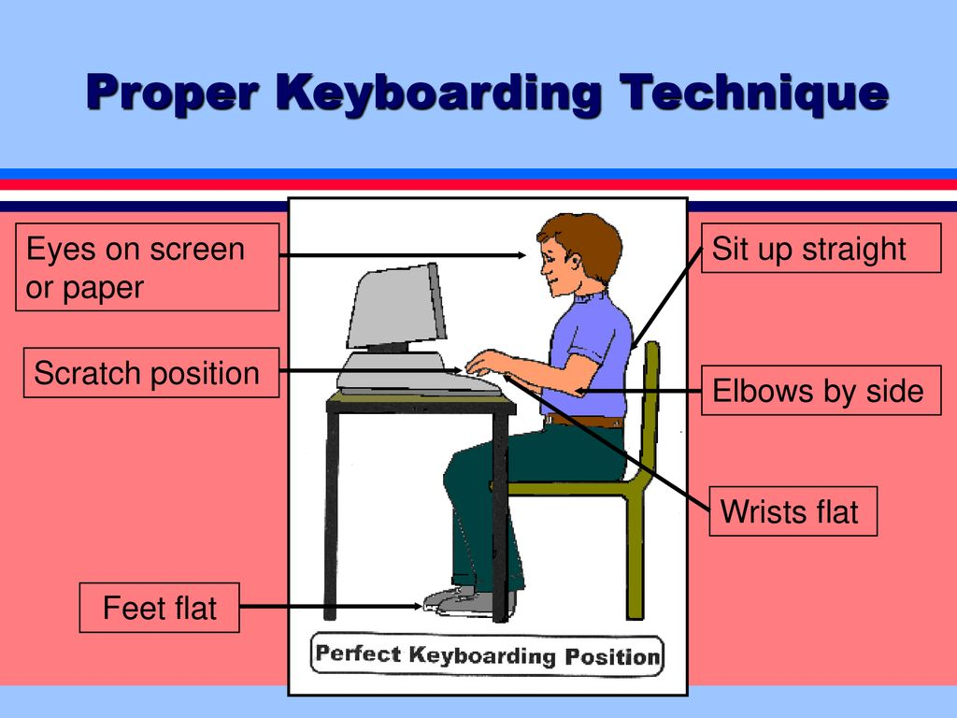**Q.5: Describe the correct keyboard techniques in few lines.**

**Ans.** There are many basic techniques that are required to learn how to touch keyboard effectively. These include using the correct posture, holding the hands and wrists properly, striking the keys correctly and using the home row keys properly. Sit up straight and your feet should be flat on the floor. Your eyes should be focused on the computer screen.

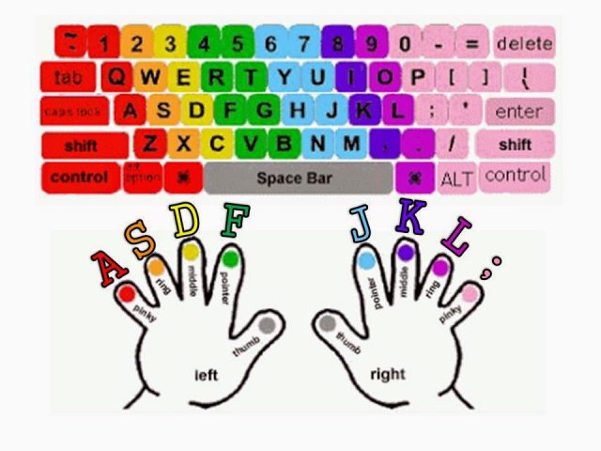**Q.6: What do you know about keystroking?**

**Ans.** Using the correct fingers to key, is very important. Your hands should be placed in a curved position over the home row. The home row keys include a, s, d, f, j, k, l and ;. These keys are called the home row keys because they are in the position from which all keystrokes are made. After the keystroke is made, the finger returns to the home row.

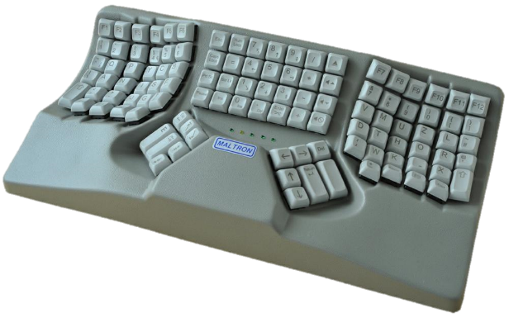**Q.7: What do you know about Ergonomic keyboard?**

**Ans.** Some keyboards are designed to relieve stress. Ergonomic keyboards are more comfortable, easier to use, result in less stress on the hands and wrists.

* **Fill in the blanks.**

1. Esc is a key located on the top-left of a computer keyboard.
2. Print screen key is used to capture the screen.
3. In keystroking your fingers should be placed over the home row.
4. Ergonomic keyboards are more comfortable to use.
5. The keyboard is the primary input device for entering text and numbers.
6. Modifier keys are used in conjunction with other keys.
7. Alphanumeric keys look like a typewriter.
8. Function keys are usually located in a row at the top of the keyboard.
9. The insertion point is sometimes referred to as the cursor.
10. Numeric keypad looks like a calculator.

* **Write T for the true statement and F for the false one.**

1. Numeric keypad is usually located on the right side of the keyboard. (T)
2. The keyboard is the primary output device. (F)
3. Modifier keys are used in conjunction with other keys. (T)
4. Using the correct fingers to the key is not very important for keystroking.(F)
5. Esc key is located on the top-right of a computer keyboard. (F)
6. Function keys are usually located in a row at the top of the keyboard. (T)
7. A keyboard consists of about 101 keys. (T)
8. Print Screen key is used to cancel operations. (F)
9. Ctrl for control is a modifier key. (T)
10. The keyboards are not available in many sizes and shapes. (F)

