**Pakistan School, Kingdom Of Bahrain**

**E-Support and Learning Material**

**NEW BOOK**

**Subject : Mathematics** **Grade: 6**

**Chapter: 3** **Fractions** Page No. 39 Lesson 2

**Topic**: Dividing a whole number by a fraction.

**Recap**: Solve Q# 1 and 2 page number 39 on the book.

**LET’S LEARN**

1. Divide 1 by $\frac{1}{2}$. (How many halves are there in 1 whole)

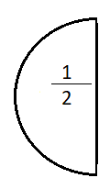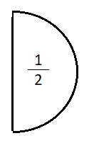

1 ÷ $\frac{1}{2}$ = 2 (where as 1 is a whole number and $\frac{1}{2}$ is a fraction)

1 x 2 = 2

1 ÷ $\frac{1}{2}$ is the same as 1 x 2

(2 is the reciprocal of $\frac{1}{2}$)

So, there are 2 halves in 1 whole.

1. Find the value of the following:

2 ÷ $\frac{1}{8}$

2 x 8 = 16 ( 8 is the reciprocal of $\frac{1}{8}$)

**Homework**

Solve Question numbers 2, 3, 4 and 5 (a, b, c, d, e, f) page# 42