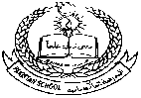

**Pakistan School , Kingdom of Bahrain**

**E- Support and Learning Material / Session 2020-2021**

**Subject: Social Studies Grade : 6**

**Social Studies 1 FIRST TERM**

**CHAPTER 3: WINDS AND CYCLONES**

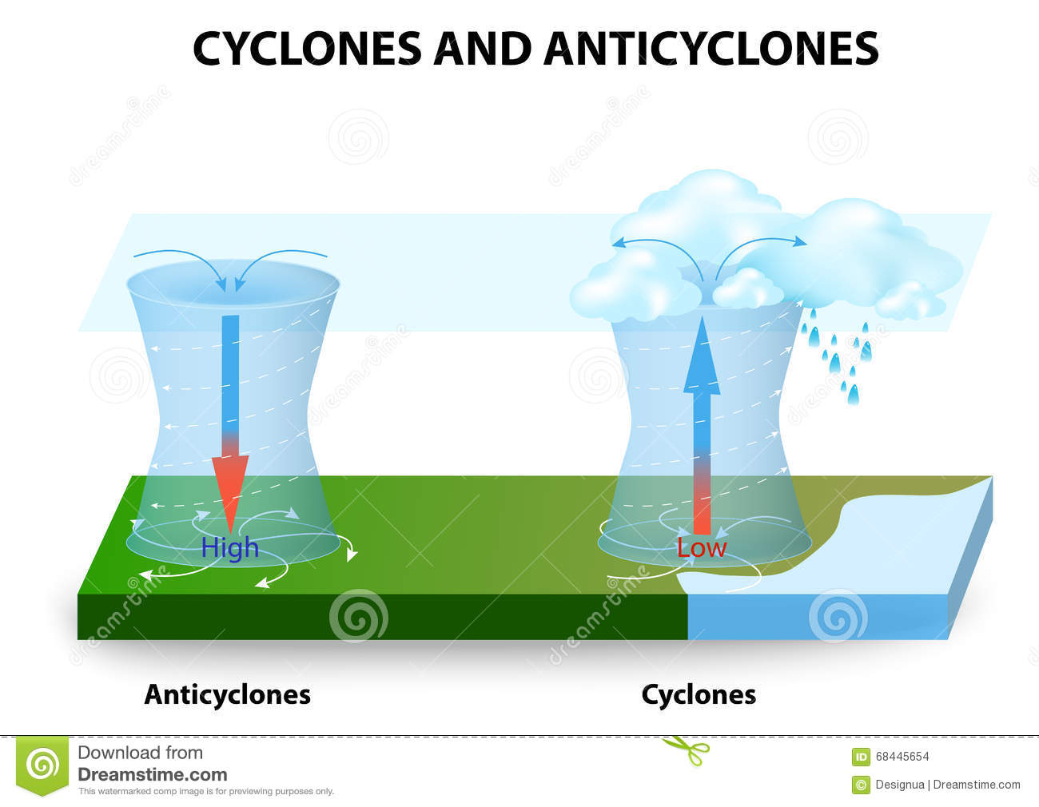

**Q#1.What is difference between cyclone and anticyclone?**

Ans**. Cyclone** :

1. Spins around anti clockwise in Northern hemisphere.
2. Clockwise in Southern hemisphere.
3. Air pressure on earth is low.
4. Covers a small area.
5. Bad weather with lot of rain.
6. A medium strength cyclone has power of 500,000 nuclear bombs.

**Anti- cyclone :**

1. Spins around clockwise in Northern hemisphere.
2. Anti clockwise in the Southern hemisphere.
3. Air pressure on earth is high.
4. Covers a big area.
5. Wind speed is fairly gentle.
6. Fine warm and dry weather.
7. Anticyclone winds are fairly gentle. The atmosphere is calm.

**Q#2.What is tornado?**

Ans. A much smaller but much more violent kind of cyclone is called a tornado or hurricane.

These form over the sea and can be only a few hundred meters across but wind speeds can be as much as 400-600 km/h. The tornado moves from sea to land where it can do great damage, destroying houses and lifting cars into air for distance of over a kilometre.

**Q# 3 Which part of south Asia is mostly affected by cyclones?**

Ans. The bay of Bengal and the coastal areas around it down to western coast of India and Bangaladesh are affected parts by cyclones which cause a lot of destruction.

**Q# 4 In which season do cyclones mostly occur?**

Ans. The cyclones mostly occur April to November.

**Q#5 How many cyclones have hit South Asia in last two years?**

Ans. 2 to 8 cyclones hit south Asia in last two years.

**Q#6 What is dust devil?**

Ans. In very dry place of Baluchistan the twisting column of air sucks up huge quantities of sand and is called a ‘dust devil’.

**Q.# 7 What is tsunami?**

Ans.Tsunami is the Japanese name for storm wave. It is a tidal wave that sweeps from the ocean like a huge tide. It has immense destructive power. It is caused by undersea earthquake or by hurricanes in the oceans.

**Worksheet and homework (chapter# 3)….Winds and Cyclones**

**WORKSHEET**

* Match each vocabulary word on the left, to its definition on the right

1. levee area where the ocean meets the shore
2. hurricane to be forced to leave a home
3. equator a wall that holds ocean water away from a city
4. tropical storm strong winds with speed of 400—600 kph
5. evacuate very intense low pressure winds on tropical oceans
6. coastline . an imaginary line around the center of the Earth

**HOMEWORK.**

Q...Imagine you were caught *in* cyclone or tornado. What happened to you and how did you escape to survive?