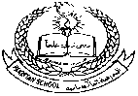**Pakistan School , Kingdom of Bahrain**

**E- Support and Learning Material / Session 2020-2021**

**Subject: SOCAIL STUDIES Grade : 6**

**Social studies Book 1 FIRST TERM**

**Unit 4: MEASURING THE WEATHER Pg. No: 15 and 16**

**Q#1.Why do you think the glass measuring cylinder of the rain gauge is inside 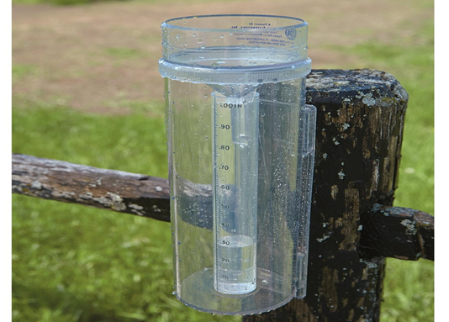an outer container?**

Ans. The measuring cylinder of the rain gauge is inside a container to prevent evaporation as far as possible, which would give an incorrect reading

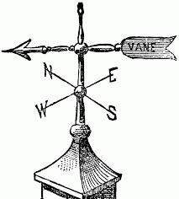

**Q#2.Why is it important to know which direction of the wind is blowing from.**

**Why does the vane have a tail?**

Ans.The wind direction is important because it is a powerful factor in predicting the weather.Northerly winds generally mean cold and dry weather, winds from southerly direction, generally bring precipitation. The tail on the weather vane is to keep the arrow pointing in the direction from which wind is blowing.

**Q.# 3**Which of these weather-measuring devices is also used in cooking or in

Candle-making:

a) rain gauge b)wind vane

c) thermometer d)barometer

Ans. The only instrument used in cooking and candle-making is the thermometer.

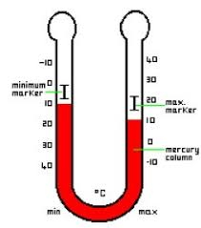**Q #4** .When was mercury barometer invented?

Ans. Mercury barometer was invented in 1643 by an Italian physicist

Evangelista Torricelli.

**Q# 5** What type of barometer is used in petrol stations?

Ans. Petrol stations use a type of aneroid barometer to measure the air pressure in a vehicle tyre.

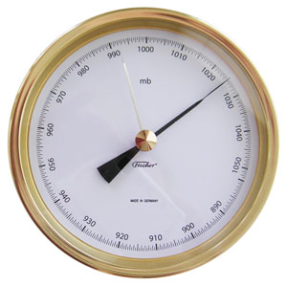**Q#6.Why do we need to measure weather and keep a record?**

Ans. Measuring weather and keeping records can help in many ways e.g Weather warning can help to protect life and property, day to day plans are amended in the light of forecast, farmers can also benefit from this and plant their crops accordingly.

**WORKSHEET**

**CHAPTER 4: MEASURING THE WEATHER**

**Q#1. Fill in the blanks**

1._________ measures the amount of rainfall.

2. The simplest measuring device is called_________.

3.__________ measures the temperature.

4. Weather thermometer is usually in ______ shaped.

5. Aneroid barometer looks like_________.

**Q#2. Give short answers to the following questions.**

1.What does metal arrow on tail of wind vane show?

Ans. ___________________________________________________________.

2. How many type of a barometer are there? Write their names.

Ans. __________________________________________________________.

3. How long is mercury barometer?

Ans.___________________________.

4. What do you think which device is used to check weight of air?

Ans.__________________________________________