**Assignment: 3**

**Activity: 1: Multiple choice questions.**

**1. The amount of oxygen in the air is kept roughly constant by the process called:**

(A) respiration (B) osmosis (C) photosynthesis (D) combustion

**2.carbon dioxide enters the leaves through:**

(A) Stomata (B) xylem (C) Phloem (D) Stem

**3. In number of natural and industrial processes the much required ingredient is:**

(A) Soil (B) Air (C) Coal (D) Water

**4. Which of the following word equation shows the process of rusting?**

(A) iron + oxygen 🡪 iron oxide

(B) carbon dioxide + water 🡪 glucose + oxygen

(C) glucose + oxygen 🡪 carbon dioxide + water + energy

(D) methane + oxygen 🡪 carbon dioxide and water

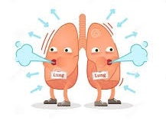

**Assignment: Activity: 2**

**1. List the gases and the percentage of them, present in air in an ascending order.**

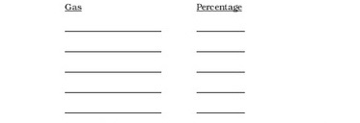

2. **What are the four important processes that use air, give an example about the processes using the equations.**

|  |  |  |  |
| --- | --- | --- | --- |
|  |  |  |  |
|  |  |  |  |

**3. Have you ever noticed, when a narrow beam of light passes across the darken room. What can you see? Is anything else also present in the air?**

**4. State whether True or False:**

**i. The atmosphere blanket makes the world Hot { }**

**ii. The thickness of the atmospheric layer decreases as it stretches upwards { }**

**iii. Water is required for the process of rusting { }**

**iv. Fish absorbs oxygen from water using its fins**



**Subject: General Science**

**Book: Oxford Secondary, Science 1**

**Unit 6: Air and the atmosphere**

**pg: 57-65**

**FIRST TERM**

**Assignment: 3 WEEK 3**

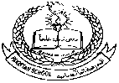**Pakistan School, Kingdom of Bahrain**

**E- Support and Learning Material / Session 2020-2021**

**Subject: General Science Grade: 6**

**Book: Oxford Secondary, Science 1 FIRST TERM**

**Unit 6: Air and the atmosphere pg: 57-65**

**Topic: The atmosphere (page: 57), The composition of Air and Air is soluble in water (page: 58)**

**Part 1: Short Question and Answers.**

**1. What is the role of atmosphere?**

**Answer:** Our planet Earth is surrounded by a thick layer of air called, the atmosphere that prevents the Earth from becoming too cold or too hot. It also supports life and causes changes in the weather.

**2. Why is air considered to be a mixture and not a compound?** 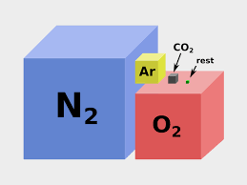

**Answer:** Air is considered to be a mixture and not a compound because its constituents vary from place to place and from time to time and they are not chemically combined.

**3. Some fish tanks have air pumps fitted to them. Why do you think this is so?**

**Answer:** Air pumps are fitted to many fish tanks to add oxygen to the water and also to keep the water circulating so that it does not become stagnant.

**Part 2: Detailed Question and Answers.**

**1. If you blow up a balloon, will the composition of the air inside the balloon be the same as the air outside it? Say why?**

**Answer:** If you blow up a balloon, the air inside the balloon is exhaled air and it will contain less oxygen and more carbon dioxide and water vapour than the outside air. It will also contain less dust and impurities because these will have been filtered out when the air was breathed in.

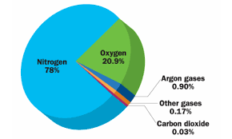

***Composition of air inhaled by a person***

**Part 3. Multiple choice questions.**

**1. The most common element in dry air is:**

(A) oxygen (B) nitrogen (C) water vapour (D) carbon dioxide

**2. Humidity is the term given to the amount of _______ present in air:**

(A) oxygen (B) carbon dioxide (C) nitrogen (D) water vapour

**Answers:**

**1.** (B) nitrogen

**2**. (D) water vapour

Don’t forget to learn these notes….



**Topic: Important processes that use air (page 58-60)**

**Part 1: Short question and answers.**

**Q1. What is meant by respiration process?**

**Answer**: Respiration is the term given to the process by which living things break down food and obtain the energy they need for living and growth. The process occurs all the time.

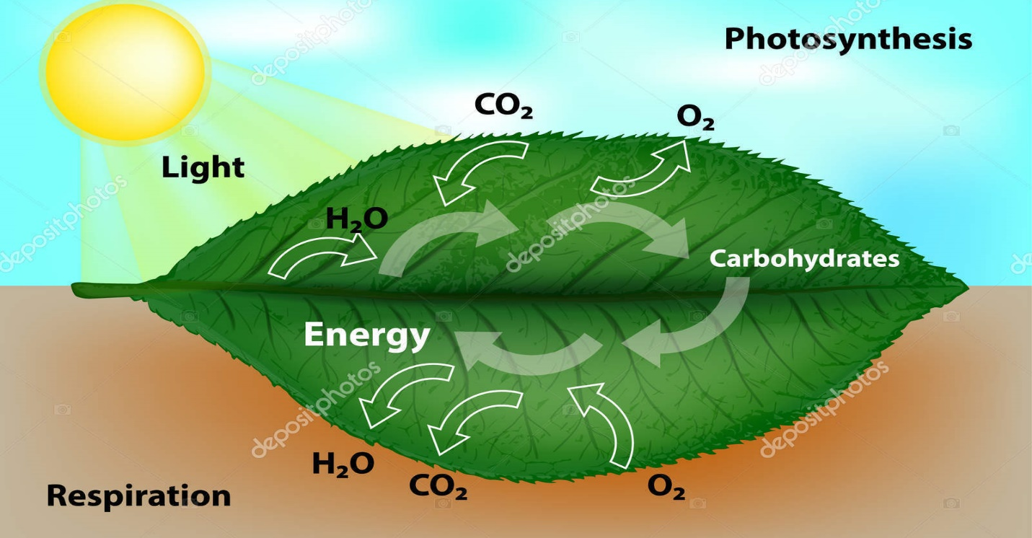

**Part 2. Multiple choice questions.**

**Which of the following is the correct word equation for respiration?**

(A) carbon dioxide + glucose🡪 oxygen + water + energy

(B) carbon dioxide + water🡪 glucose + oxygen + energy

(C) carbon dioxide + oxygen 🡪 glucose + water + energy

(D) glucose + oxygen🡪 carbon dioxide + water + energy

**Correct answer:**

(D) glucose + oxygen🡪 carbon dioxide + water + energy

**Topic: Important processes that use air (page 58-60) (continued…)**

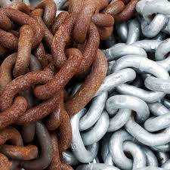**Part 1: Short question and answers.**

**Q1. What do you understand by the word rusting?**

Answer: It is the chemical reaction between oxygen in the air and iron. Rust is a form of iron oxide. This process also requires water.

**Q2. What products does methane give on burning?**

Answer: When methane burns, carbon dioxide and water are released.

Methane + oxygen 🡪 carbon dioxide and water

**Part 2: Detailed question and answers.**

**Q1. How can you define and explain the term Photosynthesis?**

**Answer:** It is the process used by plants to convert water and carbon dioxide into glucose, using energy and release oxygen into the air as waste product. Green pigment, Chlorophyll present in leaves of the green plant absorb energy from sunlight. Leaves absorb Carbon dioxide from air and water is absorbed by roots from soil.

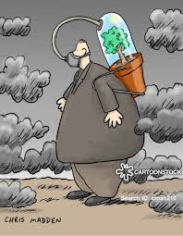**Q2. What is the meaning of the word combustion? Give examples.**

**Answer:** Combustion means “Burning”, the process was shown by a French chemist **Lavoisier.** He showed that burning requires oxygen from air, releasing energy, carbon dioxide, water and also gives out flames. Candles burning or burning piece of charcoal are an example of combustion.