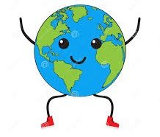

**Hello Champs!!**

**How have you all been??**

**Did you observe around you all the basics that we studied last time?**

**Hope you will enjoy today’s lesson as well…**

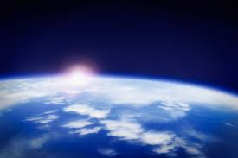

**Subject: General Science**

**Book: Oxford Secondary, Science 1**

**Unit 6: Air and the atmosphere**

**pg: 57-65**

**FIRST TERM**

**WEEK 4**

**Assignments 4**

**1. Give equations of the reactions that can take place in laboratory using carbon dioxide.**

**2. Complete the following table which lists the properties of some important gases in the air:**

|  |  |  |
| --- | --- | --- |
| **Important gases in the air** | **Nitrogen** | **Oxygen** |
| **Colour and odor** |  |  |
| **Density** |  |  |
| **Chemical reactivity** |  |  |
| **Supports combustion** |  |  |

**3. Match Column A with the appropriate answers in column B:**

|  |  |  |  |
| --- | --- | --- | --- |
| **No.** | **Column A** | **Column B** | **Ans** |
| **1** | **For large quantities of oxygen & nitrogen** | **Oxygen O2** |  |
| **2** | **Unreactive, no combustion, inert, colorless and odourless, support no life** | **Remove any dust particles that may be present** |  |
| **3** | **Colorless, odourless BUT support life** | **Nitrogen** |  |
| **4** | **Ammonia, Nitric acid are derivatives of** | **Air is converted into liquid** |  |
| **5** | **Filtration is done in order to** | **Oxygen O2** |  |
| **6** | **Present in sand, steel, Ozone O3, welding of metals** | **Nitrogen** |  |

**4. Let’s have some word search on “GLOBAL WARMING”.** 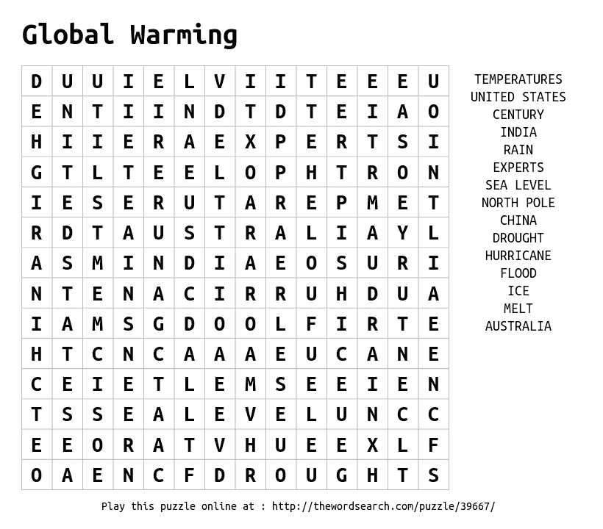

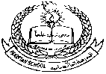**Pakistan School, Kingdom of Bahrain**

**E- Support and Learning Material / Session 2020-2021**

**Subject: General Science Grade: 6**

**Book: Oxford Secondary, Science 1 FIRST TERM**

**Unit 6: Air and the atmosphere pg: 57-65**

**Topic: The fractional distillation of air (page 60-61)**

**Topic: Properties of gases in the air (page 61-62)**

**Part 1: Short Question and Answers.**

**1. Nitrogen, an inactive gas, makes up about four-fifth of the air by volume. What would happen to something burning if there was no nitrogen in the air, only oxygen, and tiny amounts of carbon dioxide and the inert gases?**

**Ans:** Without nitrogen in the air, the percentage of oxygen would be much higher and materials would burn better and for longer in it.

**2. Why are the packets of peanuts, potato crisps and some other snack foods filled with nitrogen before they are sealed up?**

**Ans:** Because nitrogen is an inactive gas, it is sometimes used to replace the air in packets of snack foods to prevent them oxidising or decaying, which they would do in the presence of oxygen.

**Part 2: Multiple choice questions.**

**1. Oxygen and nitrogen are obtained in large quantities from air by a process called:**

(A) chromatography (B) fractional distillation (C) partial evaporation (D) filtration

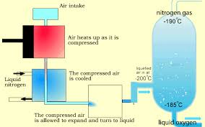

**2. To prepare large quantities of oxygen it is separated from nitrogen by a process which depends upon the fact that**

(A) oxygen is chemically more reactive than nitrogen.

(B) liquid nitrogen turns to a gas at a lower temperature than liquid oxygen.

(C) nitrogen is cooled more quickly than oxygen.

(D) liquid oxygen is denser (‘heavier’) than liquid nitrogen

**3. Which of the following is NOT a property of nitrogen?**

(A) It is very reactive. (B) It does not support combustion (burning).

(C) It is slightly less dense than air. (D) It is colourless and odourless.

**Answers:**

1. B. Fractional distillation

2. C. Liquid nitrogen turns to a gas at a lower temperature than liquid oxygen

3. A. It is very reactive

**Topic: Properties of gases in the air (page 61-62) (continued……)**

**Part 1: Short Question and Answers:**

**1. What are the important processes that involve oxygen?**

**Answer:** Rusting, Combustion, Photosynthesis, Respiration and oxides are the reactions that involve oxygen.

**Part 2: Multiple choice questions:**

**1. The test for oxygen is that it:**

(A) turns lime water milky. (B) relights a glowing splint.

(C) puts out a flame. (D) turns lime water green.

**2. Oxygen combines with most other elements to form:**

(A) oxides (B) carbonates (C) sulphates (D) sulphides

**3. A piece of wood is burnt in a jar of oxygen. There is some lime water at the bottom of the jar. After the wood has burnt for a while the jar is shaken and the lime water is seen to go cloudy or milky. This is because**

(A) the smoke, which consists of carbon particles, dissolves.

(B) carbon dioxide is produced when the wood burns.

(C) an acid is produced when some substances burn.

(D) wood contains carbon dioxide which is set free when the wood is heated.

Don’t forget to learn these notes….

**Answers:**

1. B. relights a glowing splint

2. A. Oxides

****3. B. Carbon dioxide is produced when the wood burns

**Topic: Carbon dioxide (page 62-63)**

**Part 1. Short Question and Answer.**

**1. What do you understand by the term ‘dry ice’ ?**

**Answer:** The white solid carbon dioxide used for cooling does not melt upon heating and directly forms the gas.

**Part 2: Detailed Question and Answers.**

**1. Why do you think a fire extinguisher which produces carbon dioxide is better for putting out oil and electrical fires than water?**

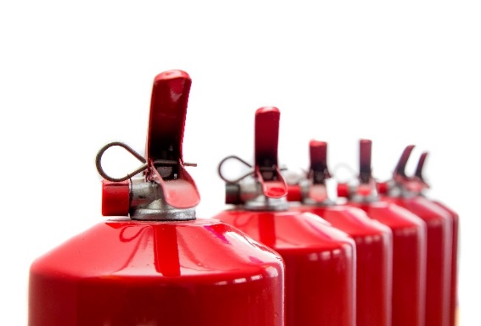**Answer:** A fire extinguisher containing carbon dioxide is better than water for putting out oil and electrical fires because oil floats on water and would continue burning, while water conducts electricity. Carbon dioxide, being ‘heavier’ (denser) than air would form a blanket over the fires, keeping oxygen out.

**2. Why is the proportion of water vapour in the air higher in places near the sea? Why is the proportion of carbon dioxide in the air higher in industrial areas than in residential areas?**

**Answer:** The proportion of water vapour in the air is higher in places near the sea, because water evaporates from the sea (and lakes, rivers, and other wet areas) as part of the water cycle. The proportion of carbon dioxide in the air is higher in industrial areas because all forms of combustion produce carbon dioxide.

**Part 2: Multiple choice questions.**

**1. Which of the following is NOT a property of carbon dioxide?**

(A) It is colourless and odourless. (B) It is produced during respiration and combustion.

(C) It has a lower density than air. (D) Plants use it to produce food during photosynthesis.

**Answer:** C. It has very low density than air

**Topic: Carbon dioxide and the greenhouse effect (page 63-64)**

**Part 1: Short question and answer.**

**1. What are fossil fuels?**

**Answer:** Coal, crude oil, and natural gas are all considered [fossil fuels](https://www.nrdc.org/issues/reduce-fossil-fuels) because they were formed from the fossilized, buried remains of plants and animals that lived millions of years ago. Because of their origins, fossil fuels have a high carbon content.

**Part 2: Detailed Question and Answers.**

**1. Name three different processes which result in more carbon dioxide going into the atmosphere.**

**Answer:** Three different processes which result in more carbon dioxide going into the atmosphere are respiration and any of the different forms of combustion or burning which take place in, for example, motor vehicles, power stations, incinerators, etc. The clearance of forests by fire for farmland, roads or industry also adds carbon dioxide to the air.

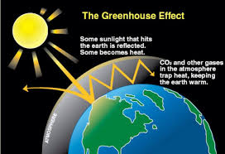

**2. Why Global warming is believed to be rising the temperature of the Earth. At the same time the polar icecaps and glaciers are beginning to melt. This together with the fact that water expands when it is warmed, could produce drastic increases in sea levels. What would be the result if the sea level surrounding Pakistan rises by, say, two metres?**

**Answer:** If the sea level surrounding Pakistan rose by two metres as a result of global warming, much coastal

land would be flooded and cities such as Karachi and Pasni would be inundated. The floodwaters would

also swamp much of the low-lying land and cities in the basin of the Indus River and its tributaries.

**Topic: The inert or noble gases (page 65)**

**Part 1: Short question and answer.**

**Q1. What are noble gases?**

Answer: Noble gases make 1% of the air, they do not react with most other elements but still have some uses. These gases glow to give different colours.

**Multiple choice questions.**

**1. Which of the following are ALL inert or noble gases?**

(A) oxygen, water vapour, neon, argon (B) carbon dioxide, oxygen, neon, argon

(C) neon, argon, xenon, water vapour (D) neon, argon, helium, krypton

**Answer:** D. Neon, argon, helium, Krypton

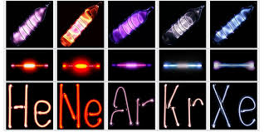

Don’t forget to learn these notes...