Welcome back Dear,

Hope you had a great time since we last met!

Did you learn all the questions we did?

And, what about the homework you were given?

Let’s get started again from where we have left……

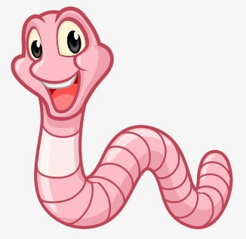

Do you know Mr. Crab will be joining us this week???

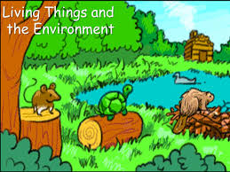

**Subject: General Science**

**Book: Oxford Secondary, Science 1**

**FIRST TERM**

**Unit 3: Living things and the environment**

Hello dear, I am Mr. Crab!!

**Pg: 30-39**

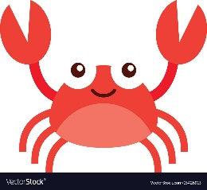

**WEEK 2. Day 01**

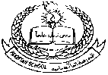**Pakistan School, Kingdom of Bahrain**

**E- Support and Learning Material / Session 2020-2021**

**Subject: General Science Grade: 6**

**Book: Oxford Secondary, Science 1 FIRST TERM**

**Unit 3: Living things and the environment Week 2. Day 01 pg: 30-39**

**Topic: Working together (pg: 36-37)**

**Part 1: Short Question and Answers.**

**1. What are Lichens?**

**Ans:** Lichens are plant- like organisms made up of threads of a fungus mixed together with cells of simple green plant, an alga. The alga benefits from the shelter provided by the fungus as protection from drying out.

**2. How does bacteria show mutualism with mammals?**

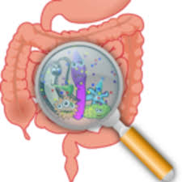**Ans:** The bacteria present in the stomach of the herbivorous mammals like cattle, deer, sheep, camels and antelopes help the mammals to digest the cellulose and other materials present in the grass and leaves they eat. In return, bacteria receive warmth, protection, shelter and food.

**3. When bees and other nectar-seeking insects visit flowers, how do the insects benefit? How do the flowers benefit?**

**Ans:** When bees and other nectar-seeking insects visit flowers, the insects benefit by finding a supply of food in the form or nectar and pollen. The flowers benefit by being cross-pollinated 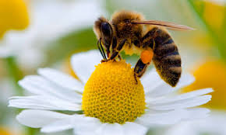with the pollen from another flower of the same species while, at the same time, having their pollen taken to another flower of the same kind.

**4. Explain the relationship between the Hermit crab, an empty shell of Whelks and sea anemone.**

**Ans:** Hermit crabs, take up home in an empty shell of whelks to protect them from accidental injury or attack. The crab benefits by being camouflaged and having its enemies frightened off by the anemone’s stinging tentacles. The anemone gains by feeding on the bits of the food the crab leaves.

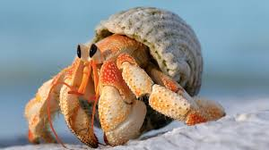

*Hermit Crab in Whelk shell*

Don’t forget to learn the notes….

**Pakistan School, Kingdom of Bahrain**

**E- Support and Learning Material / Session 2020-2021**

**Subject: General Science Grade: 6**

**Book: Oxford Secondary, Science 1 WORKSHEET 02 FIRST TERM**

**Unit 4: Living things and the environment WEEK 2. Day 1 pg 30-36**

**1. Select the correct answer:**

Pincers host Mutualism

Oxpeckers lichens herd

Parasitism

**1. Group of lions living together ___________**

**2. An animal or plant living at the expense of another living thing ____________**

**3. Alga and fungus benefit each other by living together ______________**

**4. Birds that cling onto the skin of large mammals and other invertebrates for ticks _____**

**5. The crab picks up a sea anemone using ____________**

**6. A parasite that gets its food from the living body of another organism __________**

**7. Two different type of organisms living together to benefit to each other without any harm ________**

