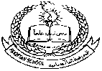**Pakistan School , Kingdom of Bahrain**

**E- Support and Learning Material / Session 2020-2021**

**Subject: Science Assignment:4 (activity 1) Grade : 7th**

**Book: Oxford Secondary Science Book 2 FIRST TERM**

**Chapter 7: Water, water everywhere Pg. No: 77**

**Topic2: Treatment of water**

**Write one word answer:**

Q.1 Chlorine is added to water to kill germs .What is the name of this step?

Ans. ____________________________.

Q.2 Small particles of dirt are removed from water when water passes through filter bed of sand and gravel .What is the name of this step?

Ans._______________________________

Q.3 In which step of water treatment suspended particles of clay stick together with alum and lime?

Ans. ___________________________.

Q,4 which removes large particles from water?

Ans.__________________________

Q.5 In which step the particles of clay sink to bottom of tank and remove from water?

Ans._____________________________.

**Pakistan School , Kingdom of Bahrain**

**E- Support and Learning Material / Session 2020-2021**

**Subject: Science Assignment:4 (activity 2) Grade : 7th**

**Book: Oxford Secondary Science Book 2 FIRST TERM**

**Chapter 7: Water, water everywhere Pg. No: 78**

**Topic3: Treatment of sewage water**

Label the following diagram:

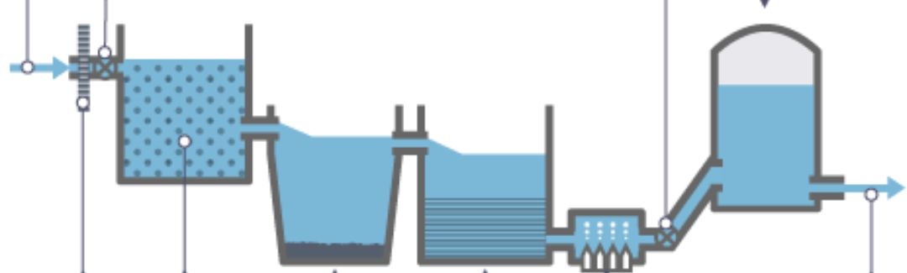

**Multiple Choice Questions:**

**Choose the correct answer:**

1. Sewage is a _____________waste which causes water and soil pollution
2. solid b. liquid c. gas d. all of these
3. Which microbe is used to decompose sludge into bio gas?
4. Virus algae c. bacteria d. fungi
5. Sludge is the _______________material formed during sewage treatment
6. Liquid b. gas c. solid
7. Bacteria convert unpleasant material in the sludge into ______ gas ,which is used as fuel.
8. Methane b. oxygen d. carbon dioxide
9. Large pieces such as cans, wood are removed from sewage by ____________
10. Girt tank b. filter bed c. metal screen

**Pakistan School , Kingdom of Bahrain**

**E- Support and Learning Material / Session 2020-2021**

**Subject: Science Assignment:4 (notes) Grade : 7th**

**Book: Oxford Secondary Science Book 2 FIRST TERM**

**Chapter 7: Water, water everywhere Pg. No: 77**

**Topic2: Treatment of water**

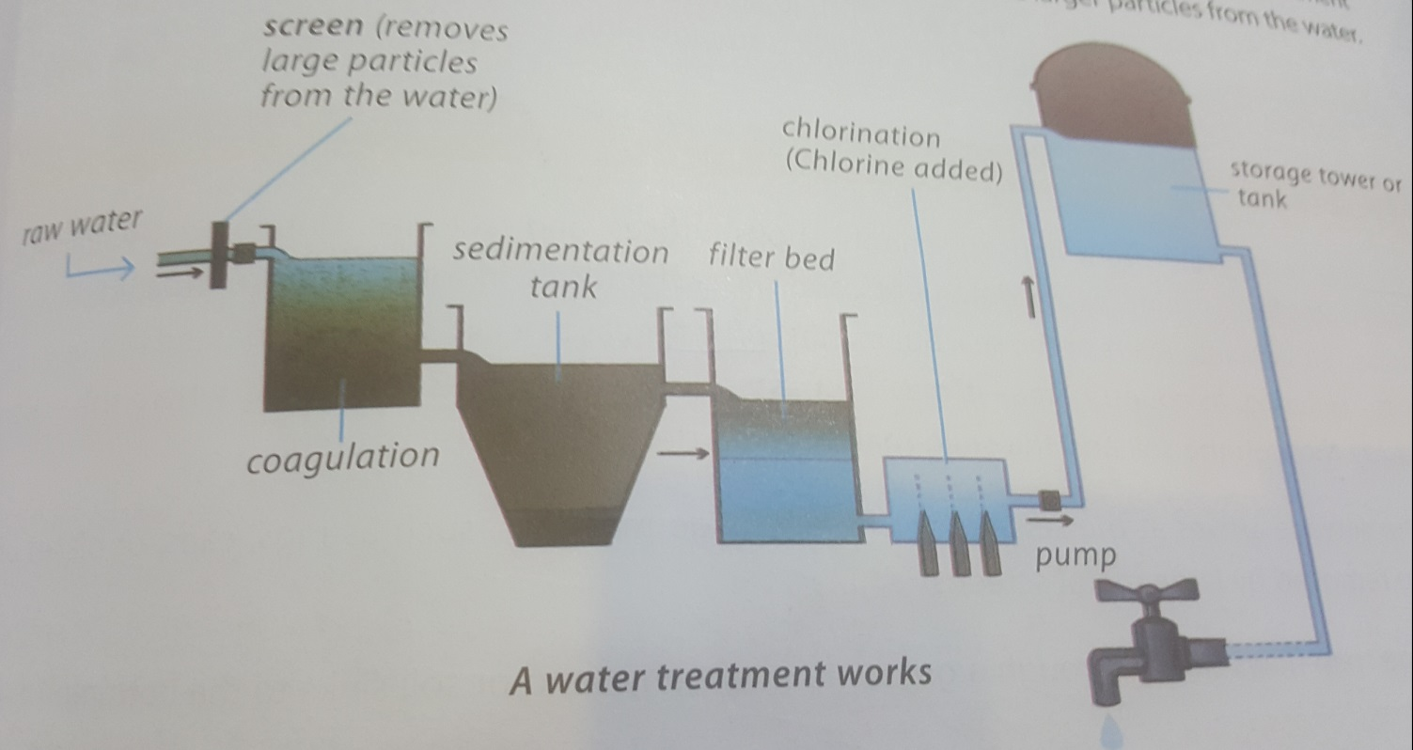

**Q.1 Explain the steps involved in water treatment.**

Ans. The various steps involved in water treatment are

1. Coagulation 2.Sedimentation 3.Filteration 4.Chlorination

First water is passed through screen it removes large particles from water.

**1.Coagulation:**

In this step raw water is mixed with alum( aluminium sulphate ) and lime.The alum and lime make the tiny suspended particles of clay stick together.

**3**.**Sedimentation:**

In this step particles of clay sink to the bottom of sedimentation tank

**4. Filtration:**

Next, the water is passed through filter bed of sand and gravel. Smaller particles of dirt is removed by filtration.

**5. Chlorination:**

In this step chlorine gas is added to water to kill germs

**6. Storage tank or tower:**

Now the clean and germ free water is pumped along large pipes to storage tank. From storage tank water is supplied to your homes.

**Topic 3 : Sewage Water treatment: page no (78,79)**

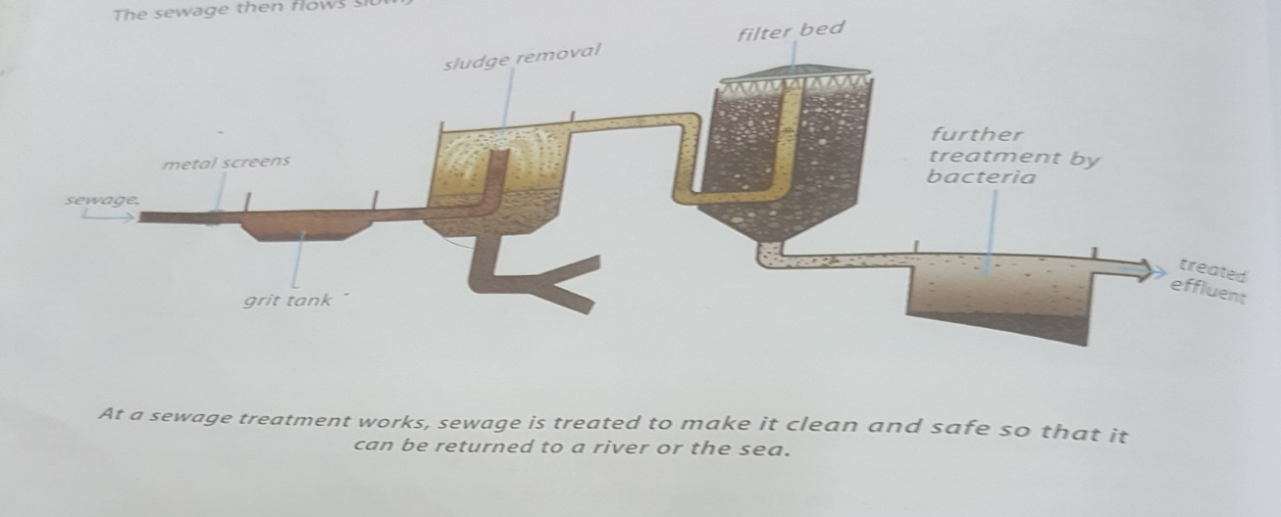

**Q.1 What is difference between sewage and a sewer?**

**Ans.**Sewage is waste water released by homes, industries, hospitals, offices and other places.

A sewer is a large pipe that carries sewage. Sewage contains impurities or pollutants.

**Q.2 What do you mean by waste water?**

**Ans.**The dirty water which contains various impurities like dust, polythene bags, kitchen waste oil, and water drained from sinks, showers, and toilets is waste water. Waste water cannot be used further.

**Q.3 What is sludge and how is it treated?**

Ans.The solid matter which is obtained after the sewage water treatment plant is known as sludge. The sludge is transferred to separate tank containing bacteria. These bacteria destroy the unpleasant materials in the sludge and change them into the methane gas, which can be used as fuel .The dried sludge is used as fertilizers for growth of plants

**Q.4 What are the various steps involved in sewage water treatment?**

**Ans.** 1.First cans, pieces of of wood and large materials are removed from the sewage by large metal screen.

**2.**The sewage then flows slowly through a grit tank where sand or soil sinks to the bottom

3. Next the sewage flows into large tanks where the sludge settles to the bottom.

4.The remaining liquid sewage is put into large tanks where bacteria feed on waste matter in water.

5.The water is then clean and returned to be river or pumped into sea.