**Pakistan School , Kingdom of Bahrain**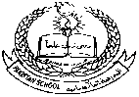

**E- Support and Learning Material / Session 2020-2021**

**Subject: General Science Grade : 8th**

**Book: Oxford Secondary Science 3 FIRST TERM**

**Unit 3: Pg. No: 78-83 WEEK 4**

**Pressure**

**Topics: Pressure and Force, Measuring Pressure, Changing Pressure, Liquid Pressure**

**ACTIVITY 1**

**Worksheet**

Fill in the blanks.

1. Snowshoes spread out the ________ ________ over deep snows.
2. Camel’s wide feet spread out its __________ so that it does not sink into the sand.
3. A sharp knife makes cutting easy as it applies force on a ________ ________ and produces high pressure.
4. The ________ heels will damage a wooden floor.
5. The pressure of a gas and liquid is ___________ to the walls of the container.

Mark True / False.

1. Pressure is not measured in newtons per square metres. _______
2. Unlike solids and liquids, gases can be compressed or squashed. _______
3. In a liquid or gas, the pressure increases with depth. _______
4. Liquids cannot be used to transmit forces because they cannot be compressed. ____
5. A large area causes a larger pressure than a small area. ______

Give reasons.

**Q2)** Why does a sharp knife cut better than a blunt knife?

**A:**

**ACTIVITY 2**

**MCQs**

1) Pressure depends on force and the

1. amount of force
2. area of contact of that force
3. direction of force
4. all of the above

2) A large force causes a larger pressure than

1. a large area
2. a small force
3. opposite direction of force
4. a small area

3) In solids, pressure acts only

1. in the direction of the force
2. in the opposite direction of the force
3. in both directions
4. all of the above

4) Liquids can be used to transmit forces because

1. they can be compressed
2. they flow easily
3. they cannot be compressed
4. all of the above

5) Hydraulic systems work by connecting cylinders of different diameters to a tube which

1. transfers the pressure between them
2. transfers force between them
3. do not transfer the pressure between them
4. all of the above

Give reasons.

**Q1)** How do hydraulic systems work by using liquids?

**A:**

**Questions & Answers**

**Q1)** Define pressure.

**A:** Pressure is the force acting on a unit area. It depends on a force and the area of contact of that force. A large force causes a larger pressure. A large area causes a smaller pressure. Pressure is equal to force divided by area.

**Q2)** How can we measure pressure?

**A:** Pressure is measured in newtons per square metre (N/m2). It is equal to force divided by area (Pressure = Force/Area).

**Q3)** What is the unit to measure pressure?

**A:** Pascal is the unit to measure pressure. Pressure is measured in newtons per square metres. 1 Pascal = Newton/square metres, or 1 Pa = N/m2.

**Q4)** Describe the pressure in the liquids.

**A:** 1)In liquids and gases, the pressure acts in all directions.

2) If a pressure is applied to a liquid or a gas, it is transmitted through the liquid or gas to the walls of the container.

3) Liquids can be used to transmit forces because liquids cannot be compressed.

4) Pressure at any depth in a liquid is the same.

5) Pressure increases with depth of liquid.

6) Upthrust is the upward push of water.

**Q5)** Why does a bulldozer have large caterpillar tracks?

**A:** Excavators and bulldozers have wide caterpillar tracks to move over soft ground. Wide caterpillar tracks exert small pressure because when a force is spread over a big area, then pressure is low.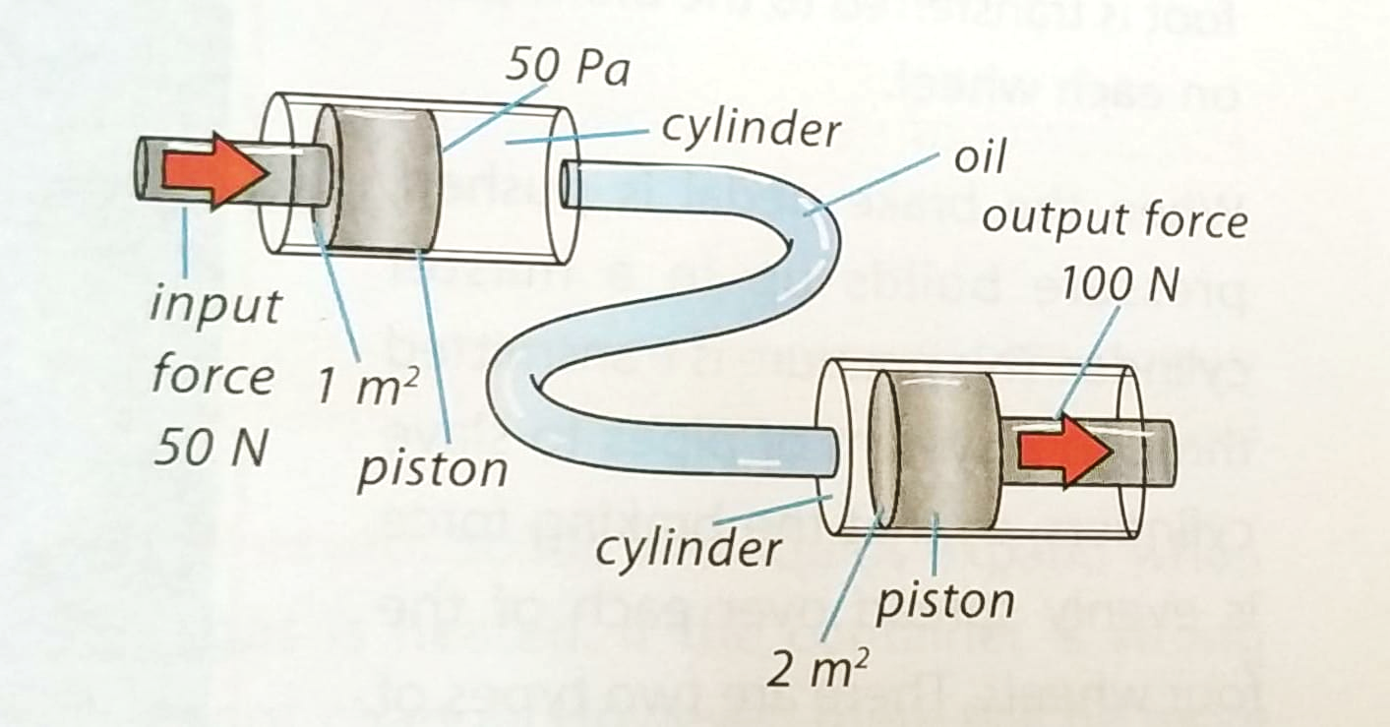

**Q6)** Describe the hydraulic system.

**A:** Hydraulic systems work by connecting cylinders of different diameters to a tube which transfers the pressure between them. Liquids flow continuously and are used to transmit forces because they cannot be compressed. Liquid in a hydraulic system is a special oil.

Use: Many machines are operated by hydraulic pressure. The braking system in a modern car is hydraulic. Force from the driver’s foot is evenly spread over each of the four wheels. The small force in the left-hand piston exactly balances the large force in the right-hand piston of the hydraulic system.