

**Pakistan School , Kingdom of Bahrain**

**E- Support and Learning Material / Session 2020-2021**

**Subject: Physics Grade : 9**

**Book: Physics 9 PTB FIRST TERM**

**Unit 3: Physical Quantities and measurement Pg. No: 20+21**

**Questions:**

**Q. Explain the construction and working of mass measuring instruments?**

**Ans: MASS MEASURING INSTRUMENTS:**

**Pots were used to measure grain in various part of the world in the ancient times. However, balances were also in use by Greeks and Romans. Today people use many types of mechanical and electronic balances. You might have seen electronic balances in sweet and grocery shops. These are more precise than beam balances and are easy to handle.**

### Beam Balance:

**Beam balances are still in use at many places. In a beam balance, the unknown mass is placed in one pan. It is balanced by putting known masses in the other pan.**

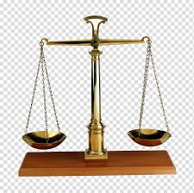

### Q. What is physical balance? Write its construction and working.

### Physical Balance:

**A physical balance is used in the laboratory to measure the mass of various objects by comparison.**

**Construction: It consists of a beam resting at the center on a fulcrum. The beam carries scale pans over the hooks on either side.**

**Working: Unknown mass is placed on the left pan. Some suitable standard masses are placed in right pan that cause the pointer to remain at zero on raising the beam.**

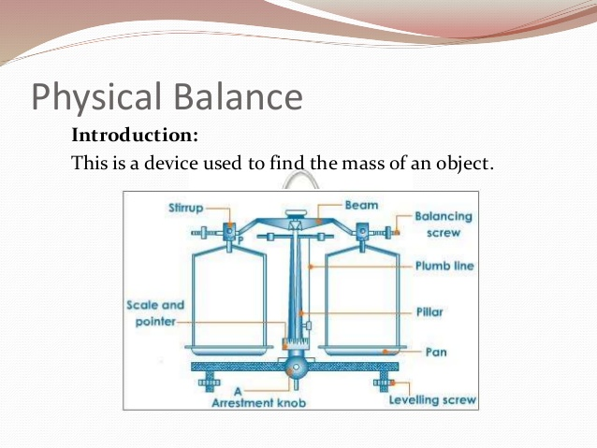

**Working:**

**Method to Find Mass with Physical Balance:**

**Follow the steps to measure the mass of a given object.**

1. **Adjusting the leveling screws with the help of plumb line to level the platform of physical balance.**
2. **Raise the beam gently by turning the arresting knob clockwise. Using balancing screws at the ends of its beam bring the pointer at zero position.**
3. **Turn the arresting knob to bring the beam back on its supports. Place the given object (stone) on its left pan.**
4. **Place suitable standard masses from the weight box on the right pan. Raise the beam. Lower the beam if its pointer is not at zero.**
5. **Repeat adding or removing suitable standard masses in the right pan till the pointer rests at zero on raising the beam.**
6. **Note the standard masses on the right pan. Their sum is the mass of the object on the left pan.**

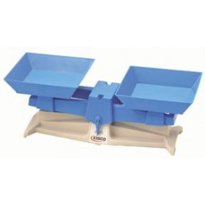

**Q. What is a lever balance?**

**Ans: A lever balance consists of a system of levers. When lever is lifted placing the object in one pan and standard masses on the other pan, the pointer of the lever system moves. The pointer is brought to zero by varying standard masses.**

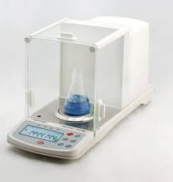

**Q. What do know about electronic balance?**

**Electronic balances come in various ranges, milligram ranges, gram ranges and kilogram ranges.**

**Working: Before measuring the mass of a body, it is switched on and its reading is set to zero. Next place the object to be weighed. The reading on the balance gives you the mass of the body placed over it.**

**Q. Show by the help of an example which one is the most accurate balance?**

### The Most Accurate Balance:

**Let the mass of one rupee coin is done using different balances as given below:**

### Beam Balance:

**Let the balance measures coin's mass = 3.2 g**

**A sensitive beam balance may be able to detect a change as small as of 0.1 g Or 100 mg.**

### Physical Balance:

**Let the balance measures coin's mass = 3.24 g**

**Least count of the physical balance may be as small as 0.01 g or 10 mg. Therefore, its measurement would be more precise than a sensitive beam balance.**

### Electronic Balance:

**Let the balance measures coin's mass = 3.247 g**

**Least count of an electronic balance is 0.001 g or 1 mg. Therefore, its measurement would be more precise than a sensitive physical balance.**

### Conclusion:

**Thus electronic balance is the most sensitive and precise balance in the above balances.**

### Example 1.3: Find the mass of a small stone by using a physical balance.

**Follow the steps to measure the mass of a given object.**

1. **Adjusting the leveling screws with the help of plumb line to level the platform of physical balance.**
2. **Raise the beam gently by turning the arresting knob clockwise. Using balancing screws at the ends of its beam bring the pointer at zero position.**
3. **Turn the arresting knob to bring the beam back on its supports. Place the given object (stone) on its left pan.**
4. **Place suitable standard masses from the weight box on the right pan. Raise the beam. Lower the beam if its pointer is not at zero.**
5. **Repeat adding or removing suitable standard masses in the right pan till the pointer rests at zero on raising the beam.**
6. **Note the standard masses on the right pan. Their sum is the mass of the object on the left pan.**

**Q. What is stopwatch? Explain the construction, types and working of stopwatch?**

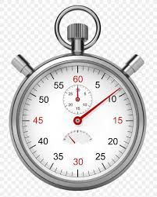 **Ans: STOPWATCH: A stop watch is a device used to measure the time interval of an event**

**Types of Stop Watch:**

**There are two types of stopwatches:**

1. **Mechanical stopwatch**
2. **Digital stopwatch**

### Mechanical Stopwatch:

**A mechanical stopwatch can measure a time interval up to a minimum 0.1 second.**

**Construction: A mechanical stopwatch has a knob that is used to wind the spring that powers the watch. It can also be used as a start-stop and reset button**

**Working: The watch starts when the knob is pressed once. When pressed second time, it stops the watch while the third press brings the needle back to zero position.**

**Q. What is the least count of mechanical stop watch you have used in the laboratories?**

**Ans: The mechanical stopwatch has least count of 0.1 second.**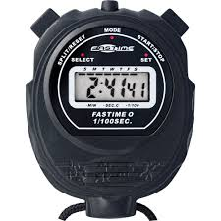

**Q. Describe digital stopwatch.**

### Digital Stopwatch:

**Digital stopwatches commonly used in laboratories can measure a time interval as small as 1/100 second or 0.01 second.**

**How to Use a Digital Stopwatch:**

**The digital stopwatch starts to indicate the time lapsed as the start/stop button is pressed. As soon as start/stop button is pressed again, it stops and indicates the time interval recorded by it between start and stop of an event. A reset button restores its initial zero setting.**

**Q. Why do we need to measure extremely small interval of time?**

**Ans: In most of experiments and in scientific calculations, time is recorded for very short intervals. So we need to measure small interval of time.**

### Q. What is measuring cylinder? Explain the construction and working of measuring cylinder?

**MEASURING CYLINDER:**

**“Measuring cylinder is used to measure the volume of a liquid or powdered substance. It is also used to find the volume of an irregular shaped solid insoluble in a liquid by displacement method”.**

**Construction:**

**A measuring cylinder is a glass or transparent plastic cylinder. It has a scale along its length that indicates the volume in milliliter (mL). Measuring cylinders have different capacities from 100 mL to 2500 mL.**

### Working:

**Take a measuring cylinder. Place it vertically on the table. Pour some water into it. Note that the surface of water is curved. The meniscus of the most liquids curve downwards while the meniscus of mercury curves upwards.**

### Precautions While Using Measuring Cylinder:

1. **While using a measuring cylinder, it must be kept vertical on a plane surface.**
2. **The correct method to note the level of a liquid in the cylinder is to keep the eye at the same level as the meniscus of the liquid figure (b).**
3. **It is incorrect to note the liquid level keeping the eye above the level of liquid figure (a).**
4. **When the eye is above the liquid level, the meniscus appears higher on the scale.**
5. **Similarly when the eye is below the liquid level, the meniscus appears lower than actual height of the liquid.**

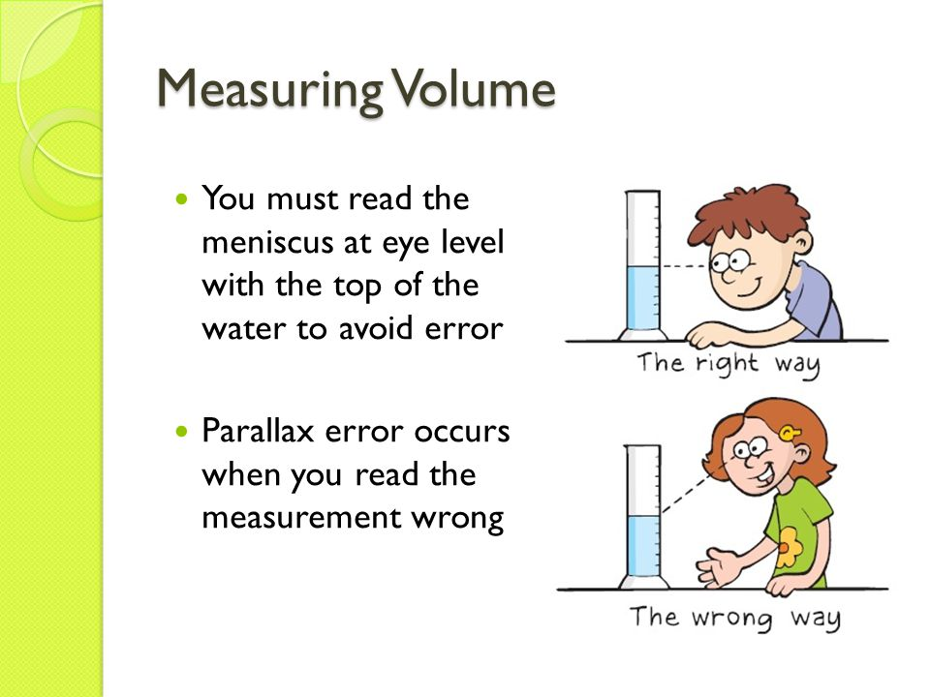

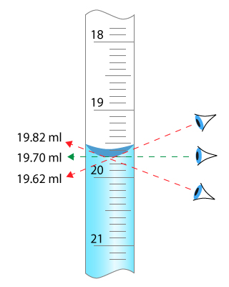

**Q. How can we measure the volume of an irregular shaped solid by using measuring cylinder?**

### Ans: Measuring Volume of an Irregular Shaped Solid:

**Measuring cylinder can be used to find the volume of a small irregular shaped solid that sinks in water. Let us find the volume of a small stone.**

1. **Take some water in a graduated measuring cylinder.**
2. **Note the volume Vi of water in the cylinder.**
3. **Tie the solid with a thread.**
4. **Lower the solid into the cylinder till it is fully immersed in water. Note the volume Vf of water and the solid.**
5. **Volume of the solid will be Vf – Vi.**

Q**. What is meant by significant figure of a measurement? What are the main points to be kept in mind while determining the significant figures of a measurement? Also explain the rules of rounding the number?**

**Ans: SIGNIFICANT FIGURES:**

**“All the accurately known digits and the first doubtful digit in an expression are called significant figures”.**

**Explanation:**

**The value of a physical quantity is expressed by a number followed by some suitable unit. Every measurement of a quantity is an attempt to find its true value.**

**Factors: The accuracy in measuring a physical quantity depends upon various factors:**

1. **the quality of the measuring instrument**
2. **the skill of the observer**
3. **the number of observations made**

### For Example:

1. **A student measures the length of a book as 18 cm using a measuring tape. The numbers 'of significant figures in his/her measured value are two. The left digit 1 is the accurately known digit. While the digit 8 is the doubtful digit for which the student may not be sure.**
2. **Another student measures the same book using a ruler and claims its length to be 18.4 cm. In this case all the three figures are significant. The two left digits 1 and 8 are accurately known digits. Next digit 4 is the doubtful digit for which the student may not be sure.**
3. **A third student records the length of the book as 18.425 cm. interestingly; the measurement is made using the same ruler. The numbers of significant figures is again three, consisting of two accurately known digits 1, 8 and the first doubtful digit 4. The digits 2 and 5 are not significant.**

**It is because the reading of these last digits cannot be justified using a ruler. Measurement up to third or even second decimal place is beyond the limit of the measuring instrument.**

**Conclusion: An improvement in the quality of measurement by using better instrument increases the significant figures in the measured result. The significant figures are all the digits that are known accurately and the one estimated digit. More significant figure means greater precision.**

### Rules to Find the Significant Digits in a Measurement:

### Capturesdfgsr.JPG

**The following rules are helpful in identifying significant figure**

1. **Non-zero digits are always significant.**

**For Example 27 has 2 significant digits and 275 has 3 significant digits.**

1. **Zeros between two significant figures are also significant.**

**For Example 2705 has 4 significant digits.**

1. **Final or ending zeros on the right in decimal fraction are significant**

**For Example 275.00 has 5 significant digits.**

1. **Zeros written on the left side of the decimal point for the purpose of spacing the decimal point are not significant**

**For Example 0.03 has 1 significant digit and 0.027 has 2 significant digits.**

1. **In whole numbers that end in one or more zeros without a decimal point. These zeros may or may not be significant. In such cases, it is not clear which zeros serve to locate the position value and which are actually parts of the measurement. In such case, express the quantity using scientific notation to find the significant zero.**

**For Example 123000 in scientific notation it can be written as 1.23 x 10 has 3 significant digits.**

### Q. How is precision related to the significant figure in a measured quantity?

**Ans: In any measurement more significant means more precision. Thus a measured quantity having more significant figures will be more precise or accurate means an improvement in the quality of measurement by using better instrument increases the significant figure in the measured result.**

### For Example:

**If length of rod is measured using ruler and it is 5 cm. When the same length is measured by using vernier callipers it becomes 5.02 cm. In first case significant figure is 1 while in the second can**

**it becomes 3. Since second measurement is more precise because the number of significant figures are increased. Hence greater number of significant figures means greater precision.**

### Q. Find the number of significant figures in each of the following values. Also express them in scientific notations.

**a) 100.8s b) 0.00580 km c) 210.0 g**

**Sol: a) All the four digits are significant. The zeros between the two significant figures 1**

**and 8 are significant.**

**To write the quantity in scientific notation, we move the decimal point two places to the left,**

**2**

**thus 100.8s = 1.008 x10 s**

1. **The first two zeros are not significant. They are used to space the decimal point. The digit 5, 8 and the final zero are significant. Thus there are three significant figures.**

**In scientific notation, it can be written as 5.80x10–3 km.**

1. **The final zero is significant since it comes after the decimal point. The zero between last zero and 1 is also significant because it comes between the significant figures. Thus the number of significant figures in this case is four.**

**In scientific notation, it can be written as 210.0 g = 2.100 x 102 g.**

### Q. What are laboratory safety rules?

### Ans: LABORATORY SAFETY RULES:

**The students should know what to do in case of an accident. The charts or posters are to be displayed in the laboratory to handle situations arising from any mishap or accident. For your own safety and for the safety of others in the laboratory, follow safety rules given below:**

1. **Do not carry out any experiment without the permission of your teacher.**
2. **Do not eat, drink, play or run in the laboratory.**
3. **Read the instructions carefully to familiarize yourself with the possible hazards before handling equipments and materials.**
4. **Handle equipments and materials with care.**
5. **Do not hesitate to consult your teacher in case of any doubt.**
6. **Do not temper with the electrical appliances and other fittings in the laboratory.**
7. **Report any accident or injuries immediately to your teacher.**

### Q. Enlist some laboratory safety equipments.

### Ans: LABORATORY SAFETY EQUIPMENTS:

**A school laboratory must have safety equipments such as:**

1. **Waste-disposal basket**
2. **Fire extinguisher**
3. **Fire alarm**
4. **First Aid Box**
5. **Sand and water buckets**
6. **Fire blanket to put off fire**
7. **Substances and equipments that need extra care must bear proper warning signs such as given in figure.**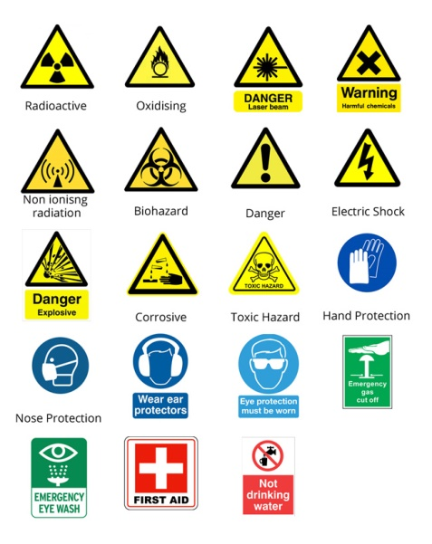

**Multiple Choice Questions:**

**1. The number of base units in SI are ……………………..**

**a) 3 b) 6**

**c) 7 d) 9**

**2. Which one of the following unit is not a derived unit?**

**a) Pascal b) kilogram**

**c) Newton d) watt**

**3. Amount of substance in terms of numbers is measured in ………………………**

**a) Gram b) kilogram**

**c) Newton d) mole**

**4. An interval of 200 s is equivalent to ………………….**

**a) 0.2 s b) 0.02 s**

**c) 2 x 10–4 s d) 2 x 10–6 s**

**5. Which one of the following is the smallest quantity?**

**a) 0.01 g b) 2 mg**

### c) 100 μ g d) 5000 n g

1. **Which instrument is most suitable to measure the internal diameter of a test tube?**

**a) Metre rule b) vernier callipers**

**c) Measuring tape d) screw gauge**

### A student claims the diameter of a wire as 1.032 cm using vernier callipers. Up to what extent do you agree with it?

**a) 1 cm b) 1.0 cm**

**c) 1.03 cm d) 1.032 cm**

1. **A chocolate wrapper is 6.7 cm long and 5.4 cm wide. Calculate its area up to reasonable number of significant figures.**

|  |  |  |
| --- | --- | --- |
| **Sol:** | **Length Width**  **Area** | **= 6.7 cm**  **= 5.4 cm**  **= ?** |
| **Now** |  |  |
|  | **Area** | **= Length x Width**  **= 6.7 x 5.4**  **= 36.18 cm2**  **= 36 cm2** |

### 8. A measuring cylinder is used to measure ………………..

**a) Mass b) area**

**c) Volume d) level of a liquid**

### A student noted the thickness of a glass sheet using a screw gauge. On the main scale,it reads 3 divisions while 8 division on the circular scale coincides with index line.

**Its thickness is ……………………**

**a) 3.8 cm b) 3.08 mm**

**c) 3.8 m d) 3.08 m**

**10. Significant figures in an expression are …………………**

1. all the digits
2. all the accurately known digits
3. all the accurately known digits and the first doubtful digit
4. all the accurately known digits and all the doubtful digits

|  |  |  |  |  |  |  |  |  |  |
| --- | --- | --- | --- | --- | --- | --- | --- | --- | --- |
| **CHAPTER-1** | | | **9thPHYSICS MCQS ANSWERS** | | | | | | |
| **1** | **2** | **3** | **4** | **5** | **6** | **7** | **8** | **9** | **10** |
| C | B | D | c | d | b | c | c | b | c |