**Pakistan School , Kingdom of Bahrain**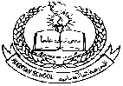

**E- Support and Learning Material / Session 2020-2021**

**Subject: Physics Grade : 9**

**Book: Physics 9 PTB FIRST TERM**

***NOTE: FOR SSC CLASSES PRESCRIBED TEXTBOOKS ARE THE MAIN SOURCE OF INFORMATION. FOLLOW THE TEXTBOOK ACCORDING TO ONLINE LECTURES. SAMPLE NOTES ARE PROVIDED FOR YOUR ASSISSTANCE.***

**Unit 9: Transfer of heat**

**Q-1: What is meant by transfer of heat? What are the ways of transfer of heat?**

**TRANSFER OF HEAT:**

**“When two bodies at different temperature are in thermal contact with each other,**

**Thermal energy from a hot body flows to a cold body in the form of heat. This is called as ‘Transfer of heat”.**

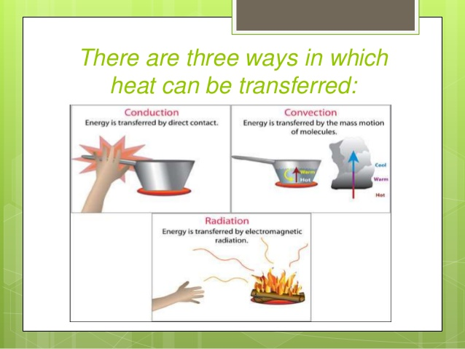

**Explanation:**

**Transfer of heat is a natural process. It continues all the time as long as the bodies in thermal contact are at different temperature.**

**Q. 2 How many ways are there for transfer of heat?**

**Ans:**

**Ways of Transfer of Heat:**

**There are three ways by which transfer of heat takes place.**

**These are:**

**i. Conduction**

**ii. Convection**

**iii. Radiation**

**Q-3: What is the process of conduction? Explain it briefly. Also explain that why metals are good conductors than non-metals?**

**CONDUCTION:**

**“The mode of transfer of heat by vibrating atoms and free electrons in solids from hot to cold parts of a body are called conduction of heat”.**

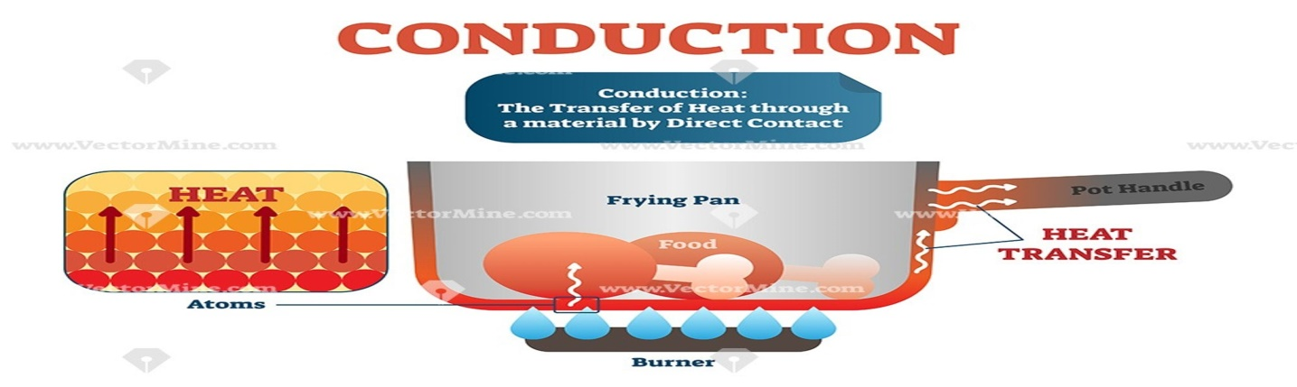

**Explanation:**

**In solids, atoms and molecules are packed close together. They**

**Continue to vibrate about their mean position. When one of its ends is**

**heated, the atoms or molecules present at that end begin to vibrate more**

**rapidly. They also collide with their neighboring atoms or molecules. In**

**doing so, they pass some of their energy to neighboring atoms or**

**molecules during collisions with them with the increase in their**

**vibrations. These atoms or molecules in turn pass on a part of the**

**energy to their neighboring particles. In this way some heat reaches the**

**other parts of the solids. This is a slow process and very small transfer of**

**heat takes place from hot to cold parts in solids.**

**Q. 4 Define conductors and insulators.**

**Conductors:**

**“The substances through which heat conducts easily are called conductors”.**

**For Example:**

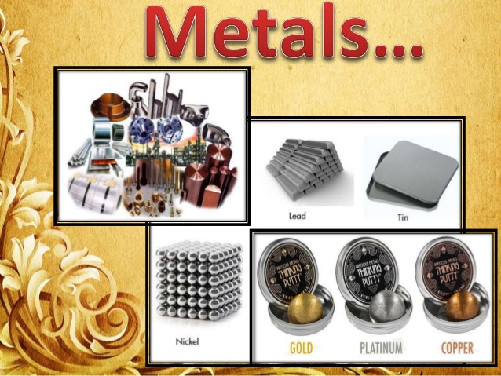

**All metals (aluminum, iron, copper etc.) are good conductors of heat.**

**Insulators:**

**“The substances through which heat does not conduct easily are called bad conductors or insulators”.**

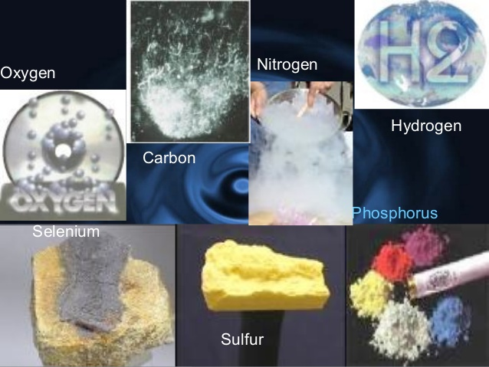

**For Example: Wood, cork, cotton, wool, glass, rubber, etc. are bad conductors or insulators.**

**Q. 5 Why metals are good conductors than non-metals?**

**Ans:**

**Metals are Good Conductor than Non-Metals:**

**The handle of metal spoon held in hot water soon gets warm.**

**But in case of a wooden spoon, the handle does not get warm. Both**

**the materials behave differently regarding the transfer of heat. Both**

**metals and non-metals conduct heat. Metal are generally better**

**conductors than non-metals.**

**Reasons:**

**Heat flow from hot to cold parts in metals so rapidly than non-**

**metals, because metals have free electrons. These free electrons**

**move with very high velocities within the metal objects. They carry**

**energy at a very fast rate from hot to cold parts of the object as they**

**move. Thus, heat reaches the cold parts of the metal objects from**

**its hot part much more quickly than non-metals.**

**Q-6: What is thermal conductivity and rate of flow of heat? On what factors rate of flow of heat depends. Derive its formula.**

**Ans:**

**THERMAL CONDUCTIVITY:**

**Thermal conductivity of a substance can be defined as:**

**“The rate of flow of heat across the opposite faces of a meter cube of a substance maintained at a temperature difference of one Kelvin is called the thermal conductivity of that substance”**

**Rate of Flow of Heat:**

**“The amount of heat that flows in unit time is called the rate of flow of heat”.**

**Explanation:**

**Conduction of heat occurs at different rates in different materials. In metals, heat flows rapidly as compared to insulators such as wood or rubber.**

**Consider a solid block. One of its two opposite faces each of cross-sectional area A is heated to a temperature T1 Heat Q flows along its length L to opposite face at temperature T2 in t seconds.**

**Thus**

**Rate of flow of heat = Q/t ..................... (1)**

**Factors on which Rate of Flow of Heat Depends:**

**It is observed that the rate at which heat flows through a solid object depends upon various factors.**

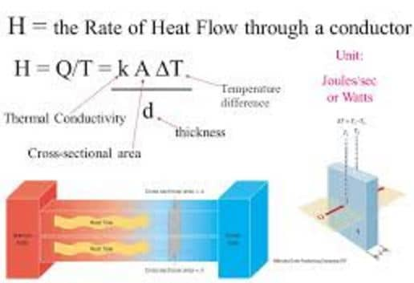

**i. Cross-Sectional Area of the Solid:**

**Larger cross-sectional area A of a solid contains larger number of molecules and free**

**electrons on each layer parallel to its cross-sectional area and hence greater will be the rate of flow of**

**heat through the solid. Thus**

**Q/t ∝ A**

**ii. Length of the Solid:**

**Larger is the length between the hot and cold ends of the solid, more time it will take to conduct heat to the colder end and smaller will be the rate of flow of heat. Thus**

**Q /t ∝ 1/L**

**iii. Temperature Difference between Ends:**

**Greater is the temperature difference T1– T2 between hot and cold faces of the solid, greater will be the rate of flow of heat. Thus**

**Q/t ∝ T1–T2**

**Combining the above factors, we get**

**Q/t ∝ A (T1-T2)/ L**

**Q/t= kA(T1-T2)/L ..................... (2)**

**Here k is the proportionality constant called thermal conductivity of the solid. Its value depends on the nature of the substance and is different for different materials. From equation (2)we can find k as:**

**k =Q x L/ A(T1-T2)**

**..................... (3)**

**Unit of k: In SI the unit of k is Wm–1K–1**