**PAKISTAN SCHOOL, KINGDOM OF BAHRAIN**

**E-Support and Learning Material**

**Subjects: MATHS Class LKG ( )**

**TOPIC: NUMBER 11**

**Student Name: _________________________________________________**

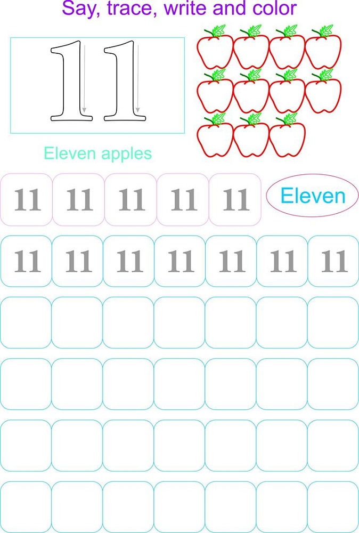

**PAKISTAN SCHOOL, KINGDOM OF BAHRAIN**

**E-Support and Learning Material**

**Subjects: MATHS Class LKG ( )**

**TOPIC: NUMBER 12**

**Student Name: _________________________________________________**

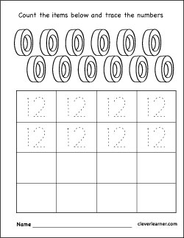Count the items below trace then write the number 12

Circle the number 12

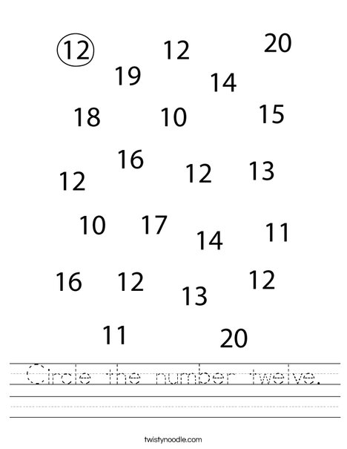

**PAKISTAN SCHOOL, KINGDOM OF BAHRAIN**

**E-Support and Learning Material**

**Subjects: MATHS Class LKG ( )**

**TOPIC: NUMBER 13**

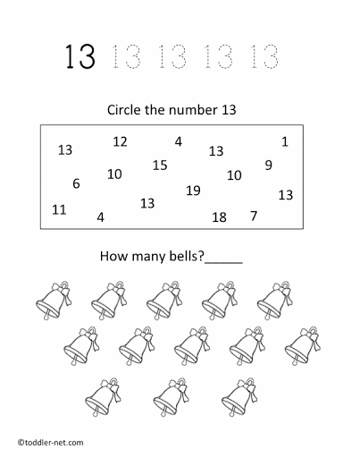**Student Name: _________________________________________________**

Trace the number 13

**PAKISTAN SCHOOL, KINGDOM OF BAHRAIN**

**E-Support and Learning Material**

**Subjects: MATHS Class LKG ( )**

**TOPIC: NUMBER 14**

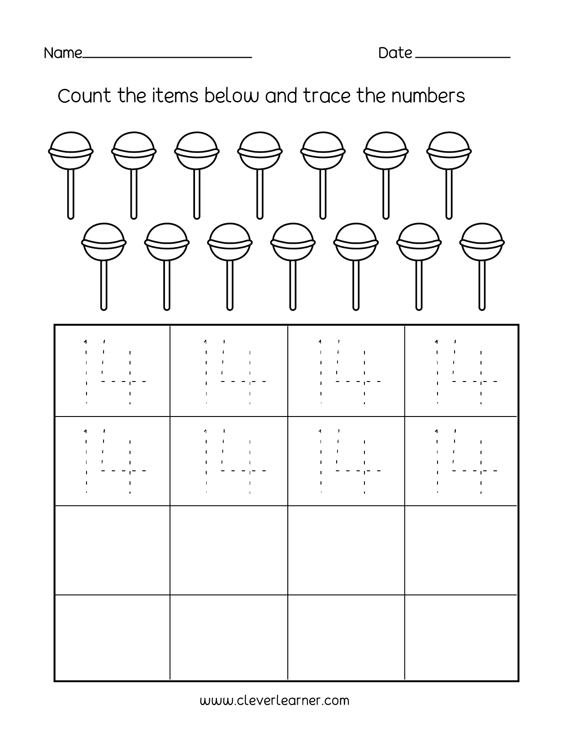**Student Name: _________________________________________________**