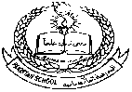 **Pakistan School, Kingdom of Bahrain**

**E- Support and Learning Material / Session 2020-2021**

**Subject: Islamiyat Grade: 1**

**Book: Islamiyat for primary classes- 1 FIRST TERM**

**Unit2:Allah is one . Allah the creator Pg.NO:9-11**

[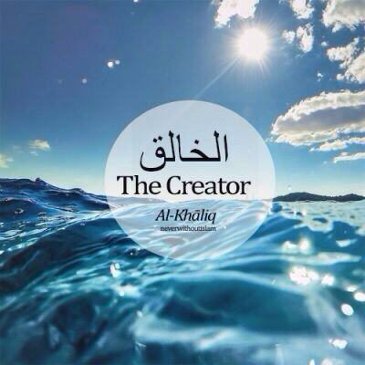](https://www.google.com.bh/url?sa=i&url=https://www.pinterest.com/pin/409827634817694207/&psig=AOvVaw11PnLlBBDiu_u_MSXK1vrd&ust=1584943690776000&source=images&cd=vfe&ved=0CAIQjRxqFwoTCJjo88S1regCFQAAAAAdAAAAABAD)

**Difficult words:**

* Sun.
* Flowers.
* Except.
* Colors.
* Declare.
* Trees.
* Mountains.
* Children.

**Write answers of the given questions:**

**Q1: Who is one and only?**

Ans: Allah is one and only.

**Q2: Does Allah have a family?**

Ans: No , Allah does not have a family.

**Q3: Who made the sun and moon?**

Ans: Allah made the Sun and Moon.

**Q4: Can Allah see us?**

Ans: Yes ,Allah can see us.

**Q5: Is there any other God except Allah?**

Ans: No, there is no God except Allah.

**Q6: Why Allah made the air?**

Ans: Allah made the air so we can breathe.

**Q7: Why Allah made the fruit?**

Ans: Allah made the fruit for us to eat.

**Q: 2 Complete the sentences by using these words:**

**god, worship, air, parents, one**

1. Allah is one.
2. Allah has no parents.
3. There is no god but Allah.
4. Allah made the air we breathe.
5. We all worship Allah alone.

**WORKSHEET**

**Subject: Islamiyat Grade: 1**

**Unit:2 Allah is one, Allah the creator Pg.NO:9-11**

**Draw , label and colour the things that Allah made for us:**

|  |  |  |  |
| --- | --- | --- | --- |
|  |  |  |  |
|  |  |  |  |

|  |  |  |  |  |
| --- | --- | --- | --- | --- |
| **Rubric:** | **Ex.** | **Go.** | **Sat.** | **NI** |
| **Content Accuracy** | **1** | **2** | **3** | **4** |
| **Creativity** | **1** | **2** | **3** | **4** |
| **Completeness** | **1** | **2** | **3** | **4** |
| **Neatness** | **1** | **2** | **3** | **4** |
| **1-Excellent 2- Good 3- Satisfactory**  **4- Needs improvement** | | | | |