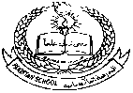**Pakistan School , Kingdom of Bahrain**

**E- Support and Learning Material / Session 2020-2021**

**Subject: Islamiat Grade : 3**

**Book: Islamiat for Primary Classes (FIRST TERM)**

**Pg. No: 15** Unit 3: -

*The Holy*

*The Holy Quran*

Answer these questions

**1- Why did Allah send the Quran?**

Ans- Allah sent the Quran to guide us.

**2- Who brought the message of the Quran to our dear Prophet Muhammad (S.A.W)?**

Ans- Angel Jibraeel (A.S) brought the message of the Quran to our dear Prophet Muhammad (S.A.W).

**3- What does the Quran teach us?**

Ans- The Quran teaches us to lead a good life.

**4- What is the recitation of Holy Quran is called?**

Ans- The recitation of Holy Quran is called Qirat.

**5- Who is Qari?**

Ans- The person who recites the Holy Quran is called Qari.

**6- Which is the shortest surah of the Holy Quran?**

Ans- Surah Al- Kausar the shortest surah of the Holy Quran.

**7- Which is the longest surah of the Holy Quran?**

Ans- Surah Al- Baqarah is the longest surah of the Holy Quran.

**8- How many Surahs are there in the Holy Quran?**

Ans- There are 114 Surahs in the Holy Quran.

Write T for true and F for false statements

1- Proper recitation of Holy Quran is called Qirat. **True**

2- The Quran is the first book of Allah. **False**

3- We must try to do what Allah tells us in the Quran. **True**

**Exercise**

Use these words to fill in the blanks.

Quran, Isa, languages, calligraphy, times, final.

**Book pg-18**

a- The Quran is the **final** book of Allah.

b-There are **four** famous books that Allah has sent.

c- Injeel was given to **Hazrat Isa (A.S).**

d- The **Quran** was given to our dear Prophet (S.A.W) for the guidance of the people.

e- The Quran is for all the people of the world for all **times**.

f- The Quran has been translated into many **languages**.

g- The Arabic writing is of the Quran is called **calligraphy**.

**WORKSHEET**

**Subject: Islamiat The Holy Quran Grade 3**

**Draw or stick the Quran and write 3 lines about the Quran.**

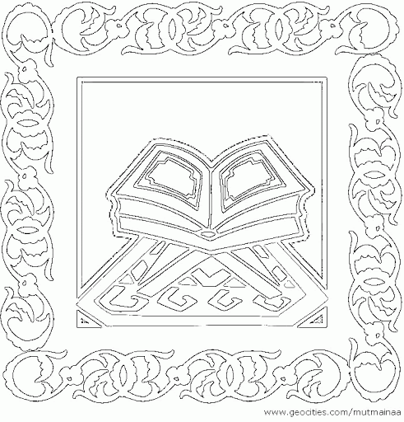

1-­­­­­­­­­­­­­­____________________________________________

2-____________________________________________

3-____________________________________________

**Allah has sent four Holy books mention the name of books: Page: 15**

___________ is given to Hazrat Moosa(A.S)

___________ is given to Hazrat Daud (A.S)

___________ is given to Hazrat Isa (A.S)

­___________ is given to our dear Prophet, Hazrat

Muhammad (S.A.W)

|  |  |  |  |  |
| --- | --- | --- | --- | --- |
| **Rubric:** | **Ex.** | **Go.** | **Sat.** | **NI** |
| **Content Accuracy** | **1** | **2** | **3** | **4** |
| **Creativity** | **1** | **2** | **3** | **4** |
| **Completeness** | **1** | **2** | **3** | **4** |
| **Neatness** | **1** | **2** | **3** | **4** |
| **1-Excellent 2- Good 3- Satisfactory**  **4- Needs improvement** | | | | |