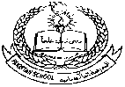**Pakistan School, Kingdom of Bahrain**

**E- Support and Learning Material / Session 2020-2021**

**Subject: Islamiat Grade: 3**

**Book: Islamiat for primary classes (FIRST TERM)**

**Pg. No: 19 (Reading of the lesson)** Unit 4: -

The Holy

Prophet(SAW)

**Difficult words.**

n-e-p-h-e-w

nephew

c-o-u-n-t-r-y-s-i-d-e

countryside

M-a-k-k-a-h

Makkah

C-h-r-i-s-t-i-a-n

Christian

K-h-a-na-e-k-a-a-b-a

Khana-e-kaaba

p-r-i-e-s-t-

priest

g-r-a-n-d-f-a-t-h-e-r

grandfather

M-u-t-t-a--l-i-b

Muttalib

k-i-n-d-h-e-a-r-t-e-d

kind-hearted

**Answer these questions**

** Book page -22**

**Answer the following questions.**

**a- When and where was our Prophet Muhammad**

**(S.A.W) born?**

Ans- Our Prophet Muhammad (S.A.W) was born in 570 ce

Makkah.

**b- Who named him Muhammad (S.A.W)?**

Ans- He was named Muhammad by his grandfather

Abdul Muttalib.

**c- What was the name that His mother gave him?**

Ans- His mother gave him the name Ahmed.

**d- Why was Hazrat Muhammad (S.A.W) sent to the countryside as a child?**

Ans- Hazrat Muhammad (S.A.W) sent to the countryside to be nursed and looked after in open and healthy air.

**e- Where did his mother Bibi Aaminah take him with her?**

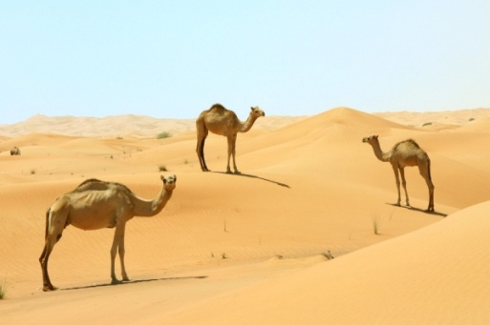Ans- His mother Bibi Aaminah took him to Madina to meet her family.

**f- What did he learn there?**

Ans- He learned there how to swim.

**g- What happened on the way back?**

Ans- On their way back his mother fell sick and died.

**h- Who brought Him back to his grandfather?**

Ans- His mother’s servant Barka, brought him back to his grandfather.

**i- Which country did he go to with his uncle for business?**

Ans- He went to Yemen and Syria with his uncle for business.

**j- What was the Prophet (S.A.W) father’s name?**

Ans- Prophet Muhammad (S.A.W) father’s name was Abdullah.

**k- Who was Amina?**

Ans- She was Prophet’s (SAW) mother.

**l- Write the names of the daughters of our Prophet (S.A.W).**

Ans- OurProphet (S.A.W) had four daughters:

1- Zainab (R.A) 2- Fatima (R.A) 3- Ruqayah (R.A) 4- Umm-e-Kulsoom (R.A)

Write T for True and F for False statements:

1- Our dear Prophet (S.A.W) life is an ideal life. **(True)**

2-Our dear Prophet Muhammad (SAW) was born in Syria**. (False)**

3- The Prophet Muhammad’s (S.A.W) father died before his birth. **(True)**

4- Prophet Muhammad (S.A.W) was honest, truthful and had the finest manners. **(True)**

**Use these words to fill in the blanks. Book page13**

**Halima Saadia, Buhira, grandfather, Bibi Aminah, Abu Talib, Abdullah**

1- The name of the Prophet’s(SAW) mother was **Bibi Aminah.**

2- Abdul Muttalib was the name of his **grandfather.**

3- His father’s name was **Abdullah.**

4- His uncle, **Abu Talib,** loved him like his own son.

5- **Halima Saadia** was the nurse who looked after Harat Muhammad (S.A.W) as a young child.

6- **Buhira** saw signs of a prophet in the young Harat Muhammad (S.A.W).

**Match COLUMN A with COLUMN B:**

|  |  |  |  |
| --- | --- | --- | --- |
| **SN** | **Column A** | **Column B** |  |
| **1** | **Abu Talib** | **His (SAW) mother’s servant** | **4** |
| **2** | **Abdul Mutallib** | **His (SAW) nurse** | **5** |
| **3** | **Amina was** | **His (SAW) uncle** | **1** |
| **4** | **Halima was** | **His (SAW) grandfather** | **2** |
| **5** | **Barka was** | **His (SAW) mother** | **3** |

**Subject: Islamiat Worksheet GRADE : 4**

**The Holy Prophet (SAW)**

Activity-1

**Tic Tac Toe**

|  |  |  |
| --- | --- | --- |
| What is the name of our Holy Prophet’s grandfather? | When and where did our Holy Prophet die? | Who named the Prophet (S.A.W)? |
| What did the Holy Prophet’s mother name him? | How old was the Holy Prophet when his mother died? | Who took care of the Holy Prophet (S.A.W) after his mother’s death? |
| How was Abdul Mutallib’s behavior with Hazrat Muhammad (S.A.W)? | Name any two Prophets whose name starts with “M”? | In which city is the Hira cave? |

Activity-2

**Put a Tick (Image result for tick mark) next to the good qualities of the Prophet (S.A.W) that you have learnt.**

Always telling the truth. Doing one’s own work.

Being kind to animals. Helping others.

Being respectful to your parents and elders.

Homework:

**Search and Answer (ANY 1):**

Q1: Who accompanied The Holy Prophet (S.A.W) on his migration to Madina?

Q2: What was the name of Prophet Muhammad’s first wife?

|  |  |  |  |  |
| --- | --- | --- | --- | --- |
| **Rubric:** | **Ex.** | **Go.** | **Sat.** | **NI** |
| **Content Accuracy** | **1** | **2** | **3** | **4** |
| **Creativity** | **1** | **2** | **3** | **4** |
| **Completeness** | **1** | **2** | **3** | **4** |
| **Neatness** | **1** | **2** | **3** | **4** |
| **1-Excellent 2- Good 3- Satisfactory**  **4- Needs improvement** | | | | |