**Pakistan School, Kingdom of Bahrain**

**E- Support and Learning Material / Session 2020-2021**

**Subject: Islamiyat Grade: 4**

**Book: Islamiyat for Primary Classes Second Edition FIRST TERM**

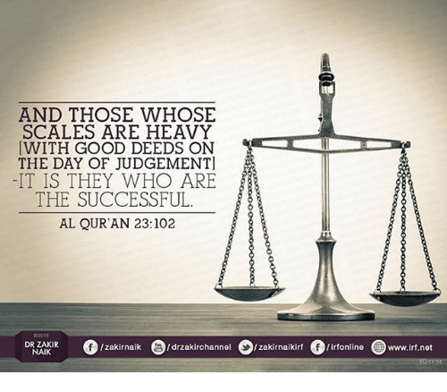 **Unit 5: Articles of Faith, Akhirat**

|  |  |  |
| --- | --- | --- |
|  | **Words** | **Meanings** |
| 1 | refuge | shelter |
| 2 | dazzled | blind |
| 3 | vision | image |
| 4 | indications | hints |
| 5 | cruel | painful/harsh |
| 6 | justice | honesty |

**Detailed Q/A**

**Q.1 Name the seven articles of faith?**

Ans. The seven articles of faith are Belief in:

1. Allah
2. His Angels
3. The Books of Allah
4. The Prophets of Allah
5. The Day of Judgement
6. Life after death
7. Destiny or Qadr

**Q.2 What is Akhirat?**

Ans. The Day of Judgement is called Akhirat. It means the last day when the whole world will come to an end. Allah will then bring everyone back to life once again. On this day everyone will be judged for what they done in this world.

**Q.3 What is the task assigned to four important angels?**

Ans.

1. Hazrat Jibraeel: The angel who brings messages from Allah to His prophets.
2. Hazrat Izraeel: The angel who takes out the soul from living things.
3. Hazrat Israfeel: The angel who will blow the horn when the day of judgement is upon us.
4. Hazrat Mikaeel: The angel who brings rains and provision for Allah’s creatures on His command.

**Short Q/A**

**Q.1 List some indications of Qayamat?**

Ans. **1**. People will be cruel to their parents.

**2**. There will be more music and dance.

**Q.2 What is Tauheed?**

Ans. The belief in the Oneness of Allah is called Tauheed. It is the first pillar of Islam.

**Q.3 How do Muslims declare their faith in the Oneness of Allah?**

Ans. Muslims declare their faith in the Oneness of Allah by reciting the Kalima Tayyaba.

**Q.4 What is the most important article of faith in Islam?**

Ans. Tauheed is the most important article of faith in Islam.

* **Exercise: FIB Book Pg. 18**
* **Complete these sentences using suitable words given.**

|  |  |  |  |  |
| --- | --- | --- | --- | --- |
| **judged** | **Hell** | **Day of Judgement** | **paradise** | **Tauheed** |

1. The belief in Allah’s Oneness is called Tauheed.
2. The Day of Judgement is another name of Akhirat.
3. Everyone will be judged on Akhirat.
4. People with good deeds will enter paradise and people with bad deeds will enter hell.

**Homework:** Read Book Page. 16 and list some indications of Qayamat given in the translation of Surah Al-Qayamat 7:29.

**Subject: Islamiyat Worksheet # 1 Grade: 4**

**Unit 5: Articles of Faith, Akhirat**

**Name: __________________________ Date: _______________**

**Note: Write answers of any 2 of the following questions.**

**Q.1 Complete these sentences using suitable words given.**

|  |  |  |  |
| --- | --- | --- | --- |
| **four** | **prophets** | **Iman** | **Allah** |

1. ____________ means strong faith.
2. No one can be a Muslim without believing in ________________.
3. There were ______________ books of Allah.
4. The message of Allah’s Oneness was given by His ____________________.

**Q.2 Match the duties assigned to four famous angels to their names.**

|  |  |  |  |
| --- | --- | --- | --- |
|  | **Column A** | **Column B** | **Answers** |
| **1.** | **Hazrat Jibraeel** | The angel who brings rains and provision for Allah’s creatures on His command. |  |
| **2.** | **Hazrat Izraeel** | The angel who will blow the horn when the day of judgement is upon us. |  |
| **3.** | **Hazrat Israfeel** | The angel who takes out the soul from living things. |  |
| **4.** | **Hazrat Mikaeel** | The angel who brings messages from Allah to His prophets. |  |

**Q.3 Name the seven articles of faith.**

**Ans.**_____________________________________________________________________________________________________________________________________________________________________________________________

|  |  |  |  |  |
| --- | --- | --- | --- | --- |
| **Rubric:** | **Ex.** | **Go.** | **Sat.** | **NI** |
| **Content Accuracy** | **1** | **2** | **3** | **4** |
| **Creativity** | **1** | **2** | **3** | **4** |
| **Completeness** | **1** | **2** | **3** | **4** |
| **Neatness** | **1** | **2** | **3** | **4** |
| **1-Excellent 2- Good 3- Satisfactory**  **4- Needs improvement** | | | | |

**Subject: Islamiyat Worksheet # 2 Grade: 4**

**Unit 5: Articles of Faith, Akhirat**

**Name: __________________________ Date: _______________**

**Note: Write answers of any 2 of the following questions.**

**Q.1 Write True for the true statements and False for the wrong ones.**

1. We must be good to get a place in Jannat. ______
2. We know when the Day of Judgement will come._______
3. Allah will bring everyone back to life once again.______
4. The Day of Judgement is also called Qayamat. _______

**Q.2 Complete these sentences using suitable words given.**

|  |  |  |  |
| --- | --- | --- | --- |
| **punished** | **Akhirat** | **rewarded** | **test** |

1. Our life on Earth is like a ____________________.
2. The Day of Judgement is also called _____________________.
3. Those who obey the laws of Allah will be ___________________.
4. Those who disobey Allah will be ___________________.

**Q.3 List 2 indications of Qayamat.**

**Ans.**_____________________________________________________________________________________________________________________________

________________________________________________________________________________________________________________________________

|  |  |  |  |  |
| --- | --- | --- | --- | --- |
| **Rubric:** | **Ex.** | **Go.** | **Sat.** | **NI** |
| **Content Accuracy** | **1** | **2** | **3** | **4** |
| **Creativity** | **1** | **2** | **3** | **4** |
| **Completeness** | **1** | **2** | **3** | **4** |
| **Neatness** | **1** | **2** | **3** | **4** |
| **1-Excellent 2- Good 3- Satisfactory**  **4- Needs improvement** | | | | |