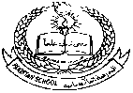**Pakistan School , Kingdom of Bahrain**

**E- Support and Learning Material / Session 2020-2021**

**Subject: Islamiyat Grade : H.K.G Sec: _____**

**Name : ___________________________ Isa Town / Manama**

***Topic no:4 The Holy Quran***

**Activity no:1**

**Colour the given picture.**

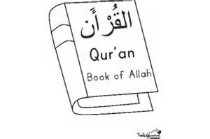

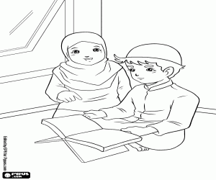

**Activity no:2**

**Questions and answers (oral).**

**Q1. Which is the last book of Allah?**

**Ans. The Holy Quran is the last book of Allah.**

**Q2. What is the language of Quran?**

**Ans. Arabic is the language of Quran.**

**Q3. How many surahs are there in Quran?**

**Ans. There are 114 surahs in Quran.**

**Q4. What is Quran?**

**Ans. Quran is the Holy book of Allah.**

**Q5.Which is the first surah of Quran?**

**Ans. Surah Al-Fatiha is the first surah of Quran.**

**Q6. What is the last surah of Quran?**

**Ans. Surah Al-Naas is the last surah of Quran.**