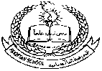**Pakistan School , Kingdom of Bahrain**

**E- Support and Learning Material / Session 2020-2021**

**Subject: Islamiyat Grade : L.K.G Sec: ______**

**Name : ________________________ Isa Town / Manama**

Surah Al Kawther

Memorize with Tajweed:

<https://youtu.be/EgfaxRpUQ58>

