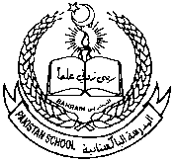**PAKISTAN SCHOOL, KINGDOM OF BAHRAIN**

**E-Support and Learning Material**

**Subjects: MATHS Class LKG ( )**

**TOPIC: NUMBER 8**

**Student Name: _________________________________________________**

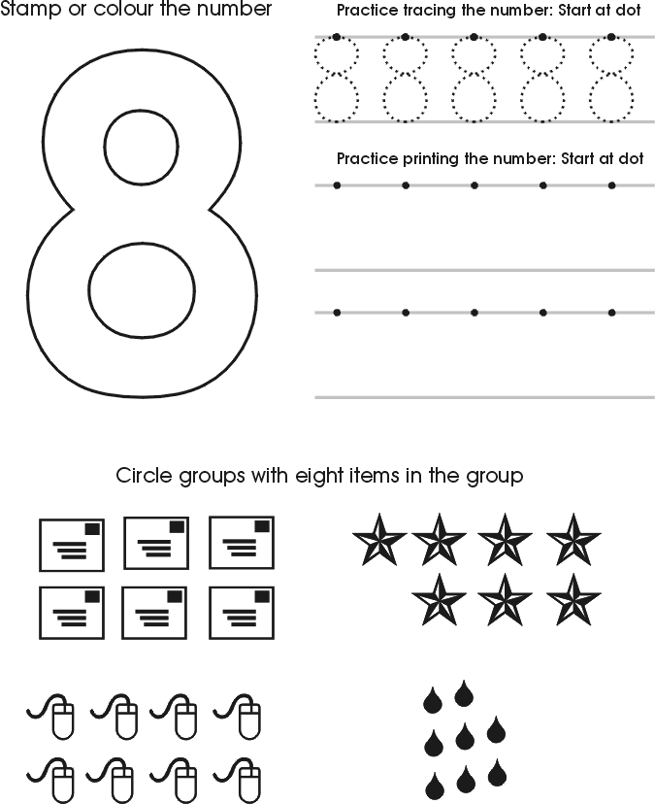

**PAKISTAN SCHOOL, KINGDOM OF BAHRAIN**

**E-Support and Learning Material**

**Subjects: MATHS Class LKG ( )**

**TOPIC: NUMBER 9**

**Student Name: _________________________________________________**

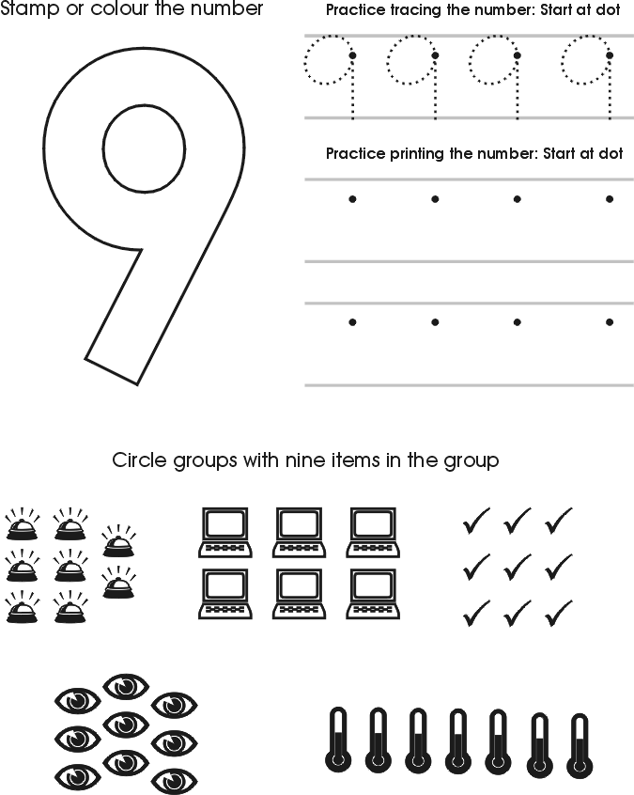

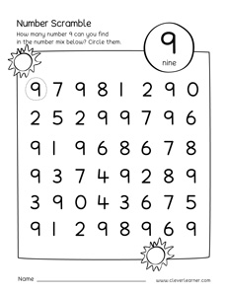Circle the number 9

**PAKISTAN SCHOOL, KINGDOM OF BAHRAIN**

**E-Support and Learning Material**

**Subjects: MATHS Class LKG ( )**

**TOPIC: Number 10**

**Student Name: _________________________________________________**

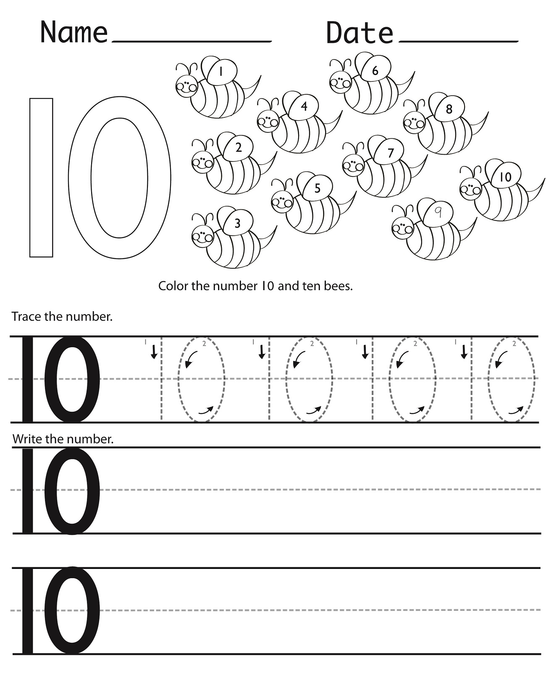

Link; <https://youtu.be/lrA-GV1ThtI>

 **PAKISTAN SCHOOL, KINGDOM OF BAHRAIN**

** E-Support and Learning Material**

**Subjects: MATHS Class LKG ( )**

**TOPIC: Revision (6- 10 )**

**Student Name: _________________________________________________**

Count the number of objects in each group. Circle the correct numeral.

