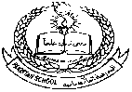**Pakistan School , Kingdom of Bahrain**

**E- Support and Learning Material / Session 2020-2021**

**Subject: G.Science Grade : 4**

**Book: Simply Science FIRST TERM**

**Unit 3: Changing sounds Pg. No: ____3**

**Topic: How Sound travel. (Week 4)**

**Activity 1 :**

**Write true or false:**

**1. Sound travel in the form of sound waves. T/F**

**2. There is no air in space. T/F**

**3. Sound can travel without medium. T/F**

**Activity 2:**

**F ill in the blanks.**

**1. Sound waves travel …………………. Through solids.**

**2. The speed of sound waves are ……………..in liquids as compared to solids.**

**3. …………..can hear sounds well underwater.**

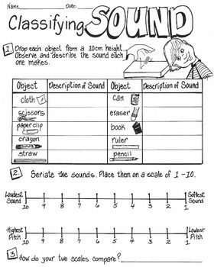

**Activity 3**

**Activity 4**

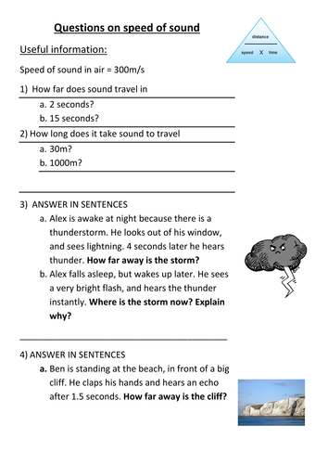

** Pakistan School , Kingdom of Bahrain**

**E- Support and Learning Material / Session 2020-2021**

**Subject: G.Science Grade : 4**

**Book: Simply Science FIRST TERM**

**Unit 3: Changing sounds Pg. No: ____30__**

**Topic: How Sound travel AND how we speak and hear.**

**Activity 1 :**

**Write true or false:**

**1. Each eardrum is a very thin skin T/F**

**2. There are four main parts of ear. T/F**

**3. Voice box also called Adam’s apple. T/F**

**Activity 2:**

**F ill in the blanks.**

**1. The part of the ear you can see is called …………**

**2. There are…………..main bones in middle ear.**

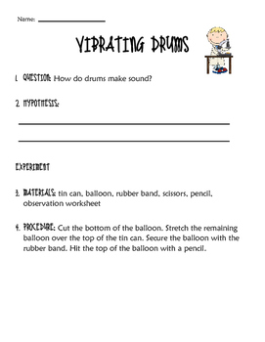**3. When the…………vibrate they make sounds.**

**Activity 3:**

**Activity 4:**

**Label the parts of ear:**

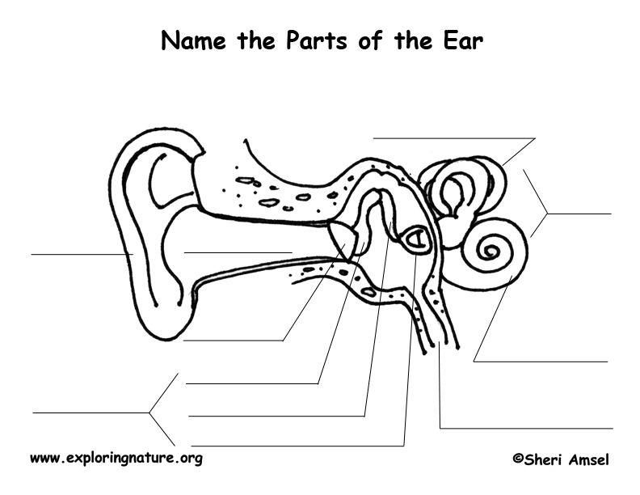

**Pakistan School , Kingdom of Bahrain**

**E- Support and Learning Material / Session 2020-2021**

**Subject: G.Science Grade : 4**

**Book: Simply Science FIRST TERM**

**Unit 3: Changing sounds Pg. No: ____3**

**Topic: How Sound travel.**

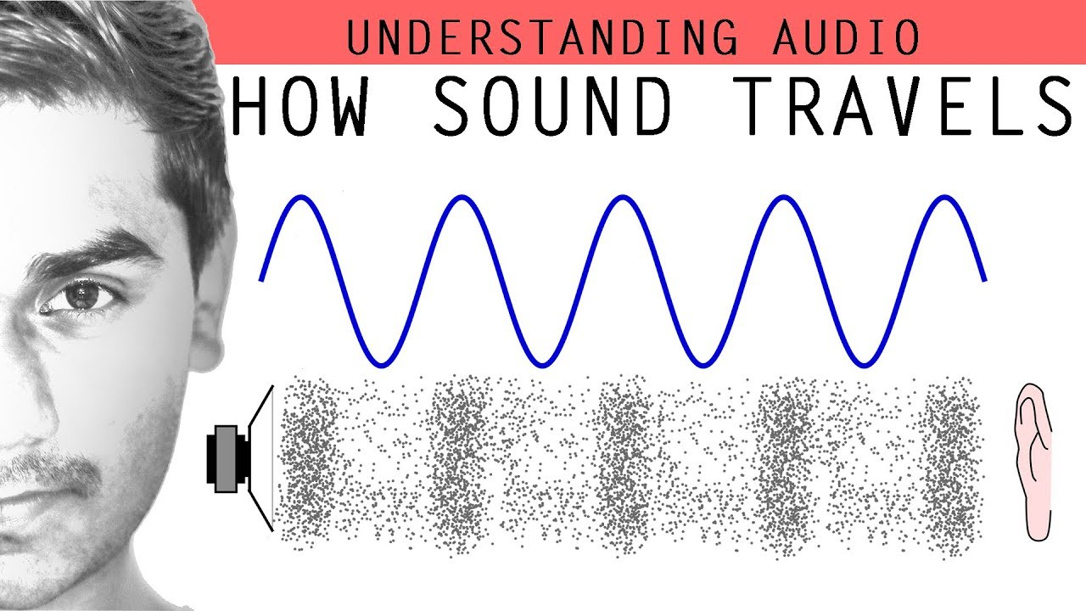

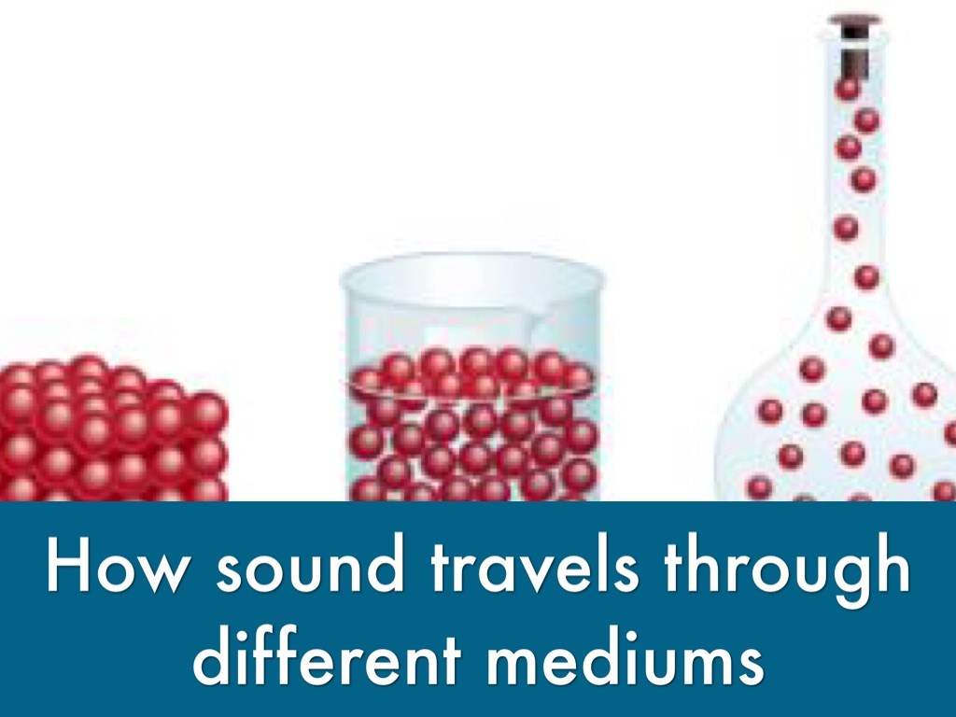**Short question answer.**

**Q. 1 How sounds travel?**

**Ans.. Sounds travel in the form of sound waves. Sound waves are produced by vibration. Sound can move through the air, water and solids.**

**Q.2. How sound waves are produced?**

**Ans. When something vibrates, sound waves are produced.**

**Q.3.Why sound cannot travel in space?**

**Ans**. **Sound needs something for travel.** **Because, there is no air in space so we cannot hear a sound** **there.**

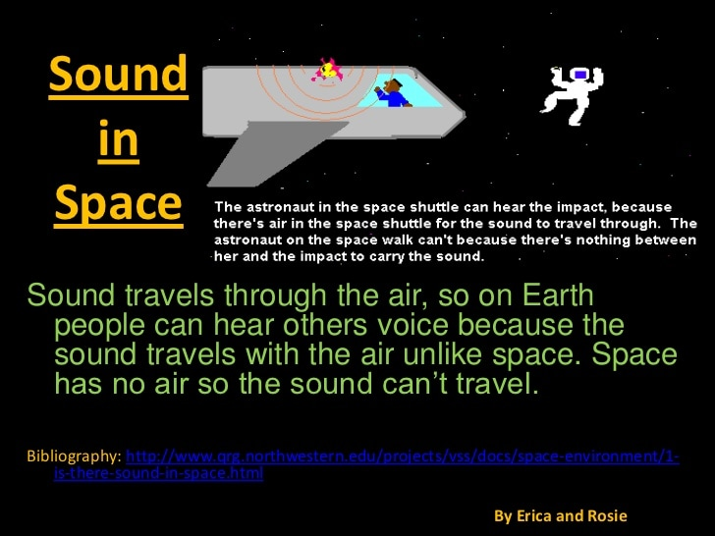

**Q.4.Through which medium sound waves can travel fast? Give reason.**

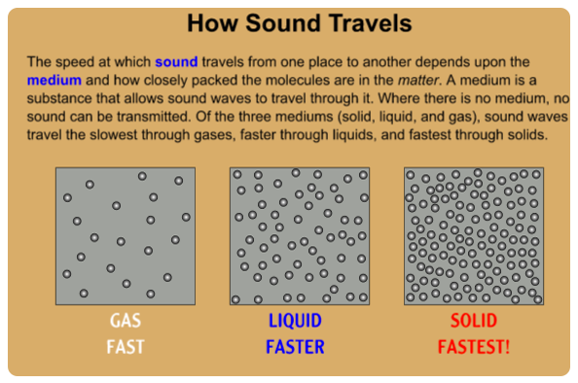**Ans. Sound can travel faster through solid medium because solid molecules are very closed to each other.**

**Q. 5.Does sound need a medium to travel? Why.**

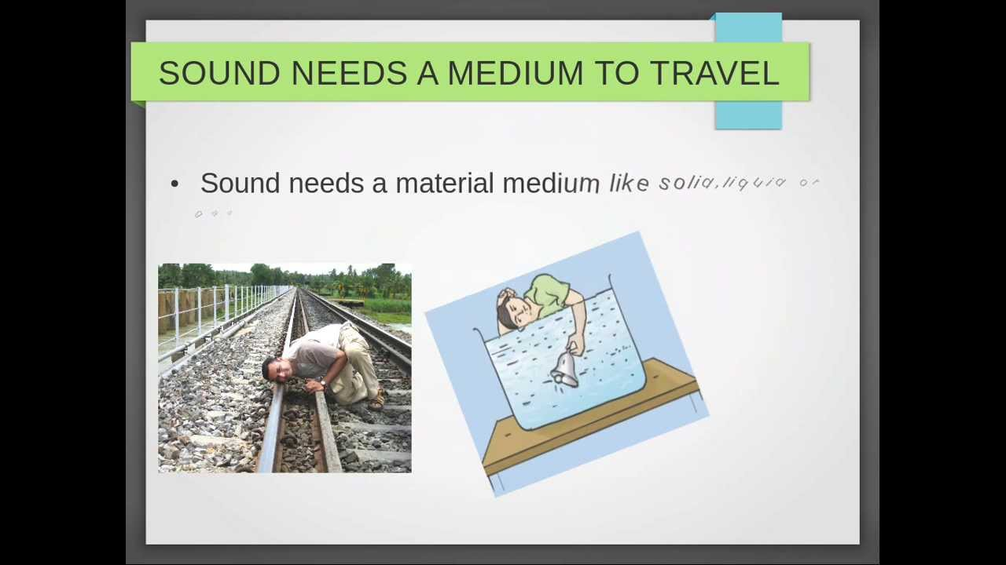 **Ans.. Yes sound need a medium to travel. Because the molecules of solid, liquid and gas carry sound waves from one point to another.**

**(A) MCQS**

**Choose the correct answer from the given option.**

**1. Sound takes ……………………………. to travel one kilometer through the air.**

**(a) three sec (b) four sec (c) five sec**

**2. The speed of sound in space is …………**

**(a) very fast (b) slow (c) cannot pass through space.**

**3. Sound can travel faster through…….. ………………………….**

**(a) Liquid (b) solid (c) space**

**4. Astronauts have to speak to each other by……….**

**(a) Internet (b) radio (c) telescope**

**ANS;**

**Mcq 1……., Three sec**

**Mcq 2………Cannot pass through space.**

**Mcq 3……….. Solid.**

**Mcq 4………..Telescope**

**Pakistan School , Kingdom of Bahrain**

**E- Support and Learning Material / Session 2020-2021**

**Subject: G.Science Grade : 4**

**Book: Simply Science FIRST TERM**

**Unit 3: Changing sounds Pg. No: ____32__**

**Topic: How we speak and hear.**

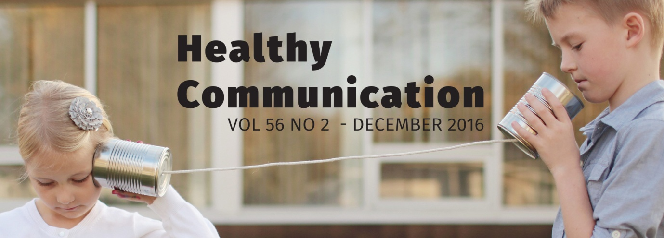

**(A) Short questions answers**

**Q.1.By which part of our body we are able to speak?**

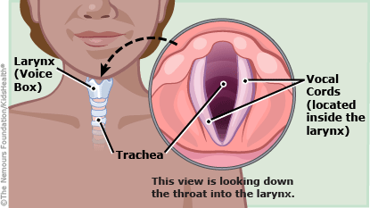**Ans: we are able to speak due to presence of voice box in our throat. Voice box is fold of muscle called vocal cords**

**Q.2. What are the main parts of ear? Write their names?**

**Ans; Human ear have three main parts:**

1. **Outer ear**
2. **Middle ear**
3. **Inner ear**

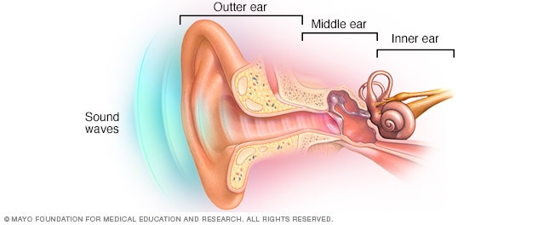

**Q.3. What is the function of vocal cords?**

**Ans: The thin muscles across the voice box which vibrate when air is passed over them and produce sound.**

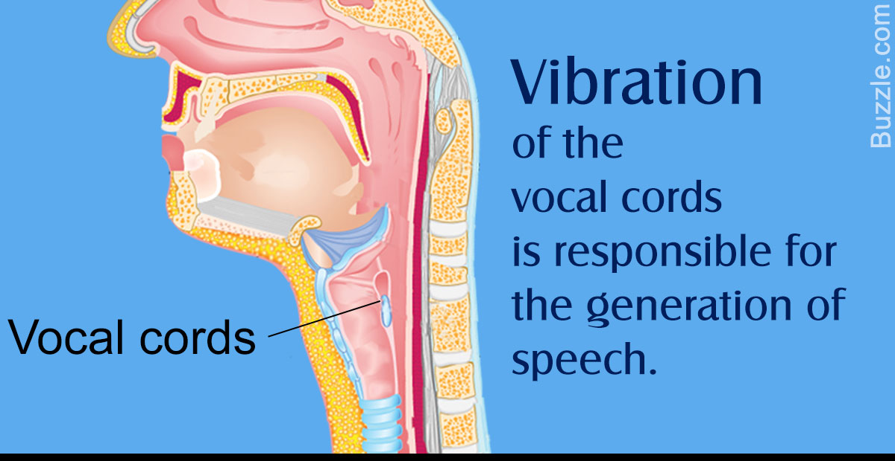

**Q.4.How do you heal damaged vocal cord naturally?**

**Ans: (1) Talking and singing too loudly or for too long time can damage our vocal cords.**

**(2).If you do not clean your teeth the germs can also damage your throat.**

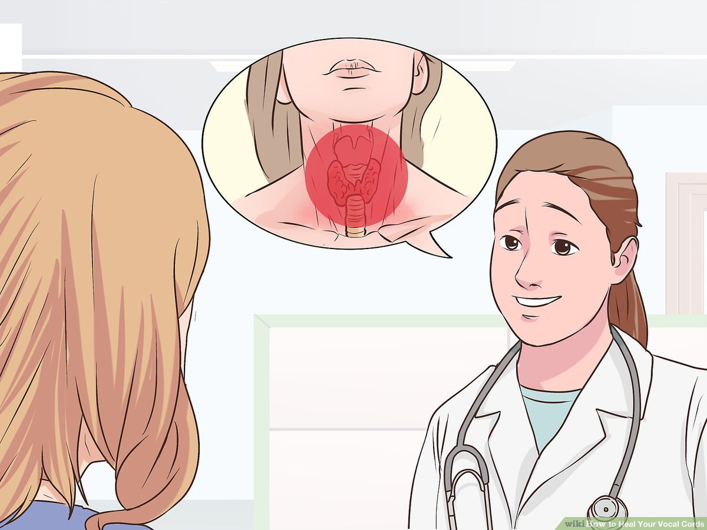 **(3).Eating to much sweets can also damage your vocal cords.**

**(B) MCQS**

**Choose the correct answer from the given option.**

**1.We are able to speak because we have ……………………………. In our throat.**

**(a) Nose (b) Ear (c) Voice box (d) None**

**2. Voice box is fold of muscles called…………**

**(a) Vocal cords (b) Head (c) Eyes (d) None**

**3. ……….. Do not have ears.**

**(a) Fish (b) Man (c) Elephant (d) None**

**4. Your ………….tells you what you have heard.**

**(a) Brain (b) Legs (c) Eyes (d) None**

**ANS;**

**Mcq 1…….voice box**

**Mcq 2………Vocal cords**

**Mcq 3………..Fish**

**Mcq 4………..Brain**