ELearning Notes computer Studies HSSC-II Pakistan School Bahrain

**Definition of Computer**

An electronic device which is capable of receiving information (data) in a particular form and of performing a sequence of operations in accordance with a predetermined but variable set of procedural instructions (program) to produce a result in the form of information or signals.

Computer is use in all Commerce Departments like shopping malls and Big Departmental stores to calculate the Sales and Purchase of the Firm. Computers are very help in the business to maintain their accounts through the Computer Example: Tally Accounting Software, MARG Software.

E-commerce (electronic commerce) describes the buying, selling, and exchanging of products, services, and information via computer network. The term e-commerce as describe transactions, conducted between business partners. There are many applications of e-commerce ,such as home banking, shopping in electronic malls, buying stocks, finding a job, conducting an auction, collaborating electronically with business partners around the globe, marketing & advertising and providing customer service. There are several types of e-commerce like collaborative commerce, Business to commerce, consumer to consumer, and Mobile commerce etc. Mobile satellite communications also promise to extend the global reach of voice, data and other services

According to functionality computer can be divided in to three types:

1.      Analog

2.      Digital

3.      Hybrid

**ANALOG COMPUTERS:**

* “An analog (spelled analogue in British English) computer is a form of computer that uses the **continuously-changeable** aspects of physical fact such as electrical, mechanical, or hydraulic quantities to model the problem being solved.”
* Analog means **continuity** of associated quantity just like an analog clock measures time by means of the distance traveled by the hand of the clock around a dial.

[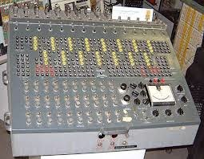](http://4.bp.blogspot.com/-i3cEWVSLGI0/U8qo4KUGVGI/AAAAAAAAAVA/z1D-ZwTX4L8/s1600/index.jpg)

**EXAMPLES:**

* Thermometer
* Analog clock
* Speedometer
* Tire pressure gauge

**ADVANTAGES:**

       Analog computer has come to refer to

* devices and media that represent
* Store images
* Sound, motion pictures, etc.

**DISADVANTAGES:**

* Analog computers can have a very wide range of complexity.
* Slide rules and monographs are the simplest, while naval gun fire control computers and large hybrid digital/analogue computers were among the most complicated.
* Very complicated for containing output for the users some time.

**DIGITAL COMPUTERS:**

* “A computer that performs calculations and logical operations with quantities represented as digits, usually in the binary number system of “0” and “1”.
* “Computer capable of solving problems by processing information expressed in discrete form. By manipulating combinations of binary digits (*“0”, “1”*), it can perform mathematical calculations, organize and analyze data, control industrial and other processes, and simulate dynamic systems such as global weather patterns. ”

[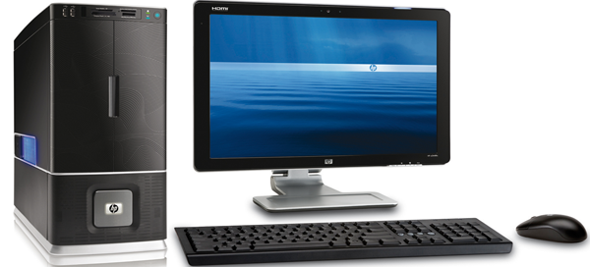](http://4.bp.blogspot.com/-GbatrmYRTKg/U8qqKYlz1oI/AAAAAAAAAVM/ReaT6lZMqm8/s1600/pf-img-pc.png)

**EXAMPLES:**

* IBM PC
* Apple Macintosh
* Calculators
* Digital watches etc

**HYBRID COMPUTERS:**

* “A computer that processes both analog and digital data”.
* “Hybrid computer is a digital computer that accepts analog signals, converts them to digital and processes them in digital form”

A hybrid computer may use or produce analog data or digital data. It accepts a continuously varying input, which is then converted into a set of discrete values for digital processing. 

**Examples:**

* Hybrid computer is the computer used in hospitals to measure the heartbeat of the patient.
* Devices used in petrol pump.
* Hybrid Machines are generally used in scientific applications or in controlling industrial processes.

[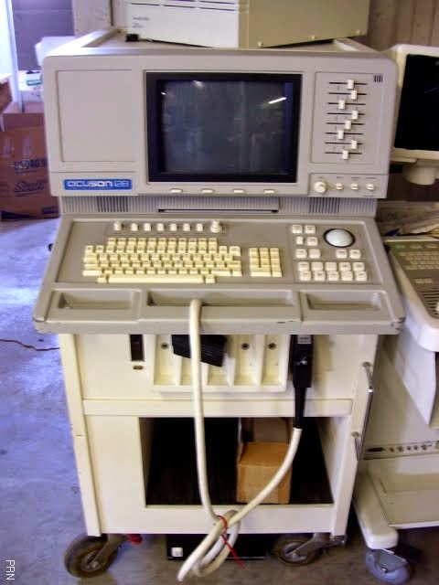](http://4.bp.blogspot.com/-dUVtMuGv_l0/U8qraXkEsjI/AAAAAAAAAVY/tH20KRpbfeM/s1600/003.jpg)

We can divide computers on the basis of size cost and speed as:

* Super Computer
* Mainframe Computer
* Mini Computer
* **Micro Computer**
  + **Personal Computer**
    - Desktop computers
    - Laptop /Note Books
  + **Mobile Computer & Devices**
    - PDA
    - Tablet PC
    - Hand Held Computer
    - Laptop/Note Books

We can divide computers on the basis of size cost and speed as:

* Super Computer
* Mainframe Computer
* Mini Computer
* **Micro Computer**
  + **Personal Computer**
    - Desktop computers
    - Laptop /Note Books
  + **Mobile Computer & Devices**
    - PDA
    - Tablet PC
    - Hand Held Computer
    - Laptop/Note Books

**SUPER** **COMPUTER**

* [Supercomputers](https://www.blogger.com/null) are the largest, fastest, most powerful, and most expensive computers made. Like other large systems, supercomputers can be accessed by many individuals at the same time. Supercomputers are used primarily for scientific applications that are mathematically intensive.

**[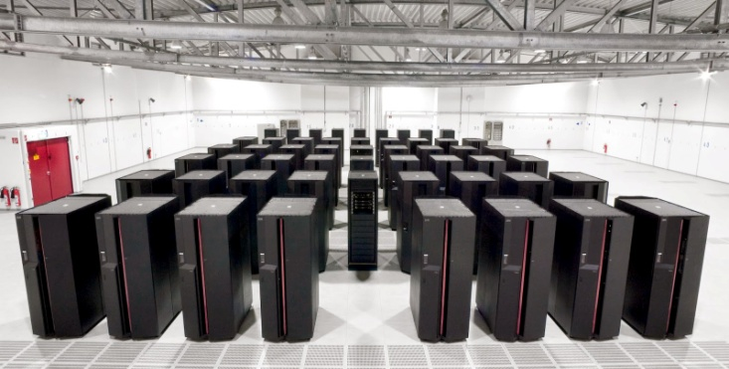](http://1.bp.blogspot.com/-XDomd-bOPpw/U8qstpXNlxI/AAAAAAAAAVk/NIda13fmfaA/s1600/ibm_supercomputer.jpg)**

EXAMPLE:

Cray-1, Cray-2, Control Data Cyber 205, ETA

**MAINFRAME COMPUTER**

Mainframe computers are the most powerful computers. A mainframe computer may contain several microprocessors. A single mainframe computer can be used by hundreds of people at once.  Each user has his own terminal that is connected to the mainframe. Mainframe computers are usually kept in a special cooled, clean computer room.

[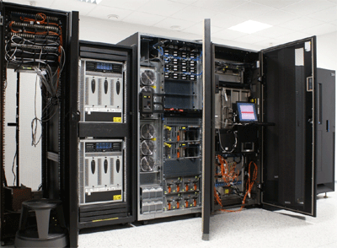](http://3.bp.blogspot.com/-vbXqrgzI-zo/U8qvA9OEAGI/AAAAAAAAAVw/uu2X7uAeSYQ/s1600/mainframe-gif.gif)

**EXAMPLE:**

IBM S/390, Amdahl 580, Control Data Cyber 176

**MINI** **COMPUTER**

The "age of the mini" started in the late 1960s. The creation of integrated circuits suitable for computers enabled designers to shrink the size of the computer. Minicomputers are frequently referred to as mid-range computers. Minicomputers are medium-sized computers which are more powerful than microcomputers but not as powerful as mainframes

[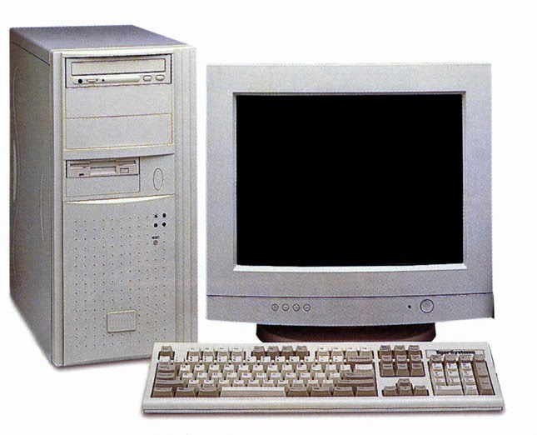](http://3.bp.blogspot.com/-A2BhvBHPVgg/U8qxwadLfTI/AAAAAAAAAV8/kQVhI3tAbtk/s1600/DesktopComputer.jpg)

**MICROCOMPUTER**

When you are working on a multiuser computer, such as a mainframe or minicomputer, you can control the input and see the output on the display, but you control nothing else.

A single-user computer gives you control over all the phases of computer processing: input, processing, output, and storage. You can select the programs you want to use, and you don't have to compete with other users to gain access to the system. A single-user system is designed to meet the computing needs of an individual.

Single-user computers fall into two categories:

* Workstations
* Microcomputers.

**WORKSTATION:**

A workstation is a powerful desktop computer designed to meet the computing needs of engineers, architects, and other professionals who need detailed graphics displays. The workstation has sometimes been called a "super micro." The workstation looks very much like a desktop microcomputer, but the chips inside make the difference

**MICROCOMPUTERS:**

The microcomputer segment of the industry is complex; there are different types of microcomputer platforms with varying capabilities. The most common type of microcomputer is a desktop computer, which is a non portable personal computer that fits on top of a desk.

[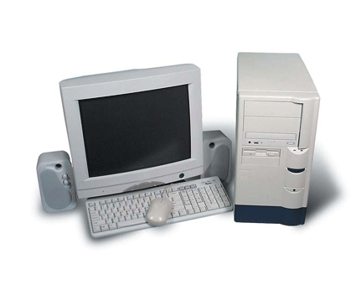](http://4.bp.blogspot.com/-fz2EzMqD9TY/U8qzSTwFNKI/AAAAAAAAAWI/CD9itYiutTE/s1600/micro-computers.gif)

**PERSONAL** **COMPUTER**

##### “A small computer intended for use by an individual. A personal computer will usually fit on a desk.”

##### PC further divided in to two types:

* Desktop Computer
* Laptop/ Note book Computer

**DESKTOP COMPUTER:**

“A computer designed for desktop use; usually comprises, at a minimum, a central processing unit (CPU), a monitor, and a keyboard as separate units, connected by special cables.

**LAPTOP /NOTE BOOK COMPUTER:**

 “A laptop is a personal computer designed for mobile use, small and light enough to sit on a person's lap while in use.”

**[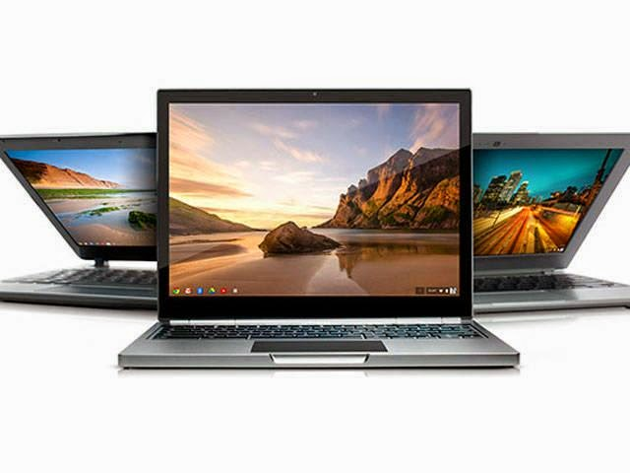](http://1.bp.blogspot.com/-1XY4lsr5214/U8q1ICVgx4I/AAAAAAAAAWU/K7yxVEi8v1c/s1600/10-features-about-googles-first-high-end-laptop-chromebook-pixel.jpg)**

**MOBILE COMPUTERS / DEVICES**

All devices which can carry in hand and portable, is said to be mobile devices  and computers.

These Devices are categorized in:

* PDA
* Tablet PC
* Hand Held Computer
* Laptop/Note Books

**PDA**

PDA stands for “Personal Digital Assistant”. A small, handheld system combining in one device multiple computing, Internet, networking, and fax/telephone features

[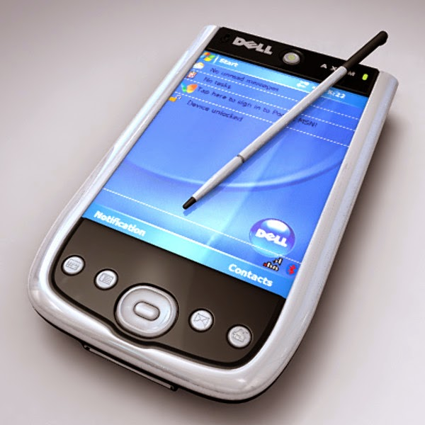](http://3.bp.blogspot.com/-BGQRAJc5jDo/U8q27eTC3tI/AAAAAAAAAWg/lt2uqHlM0Zw/s1600/axim_01.bmpdf3ed997-2f02-4e05-91e5-0c15bb84cd6cLarger.jpg)

**TABLET PC**

“A tablet PC is a wireless personal computer (PC) that allows a user to take notes using natural handwriting with a stylus or digital pen on a touch screen.”

##### **<http://4.bp.blogspot.com/-QnpYORRji5M/U8q4E1xO6uI/AAAAAAAAAWs/VGjEFWZy8m4/s1600/vizio-microsoft-windows-8-tablet-pc-amd-620x412.jpg>**

**HAND HELD COMPUTER**

Very small, lightweight device (such as the Palm Pilot) which provides functionality approaching that of a laptop computer.“

[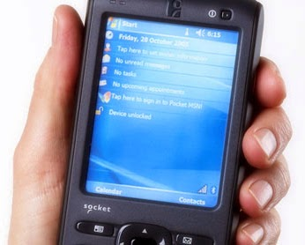](http://1.bp.blogspot.com/-5dDhA3FkBjU/U8q5AWbkWgI/AAAAAAAAAW4/-evVzZL1OPY/s1600/socket_mobile.jpg)

**LAPTOP/NOTE BOOKS COMPUTER**

“A portable computer typically weighing less than 6 pounds (3 kilograms) that has a flat-panel display and miniature hard disk drives, and is powered by rechargeable batteries.”

[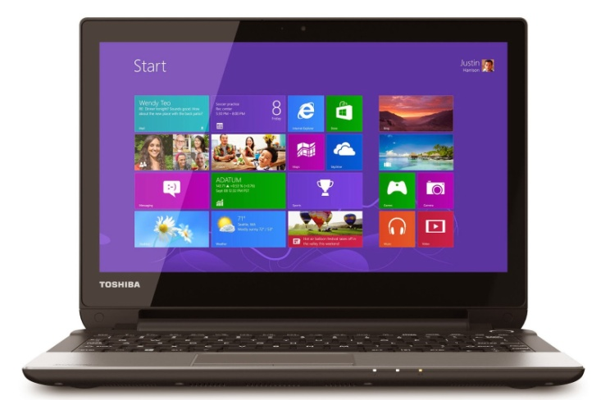](http://4.bp.blogspot.com/-YDuO6MGtkqs/U8q5lpdc4KI/AAAAAAAAAXA/gwp-OBJ7nLw/s1600/Toshiba-NB15t_ANGLE3-2.jpg)

**Data Processing**

Data processing is, generally, "the collection and manipulation of items of data to produce meaningful information." In this sense, it can be considered a subset of information processing, "the change (processing) of information in any manner detectable by an observer."

**Elements of Data Processing**

There are four basic elements of an Electronic Data Processing (EDP) system. These are:   
  
1. Hardware is a general term for the physical artifacts of a technology. It may also mean the physical components of a computer system, in the form of computer hardware.   
  
2. Software is a general term for the various kinds of programs used to operate computers and related devices. (The term hardware describes the physical aspects of computers and related devices.)   
  
3. Data/Procedure. Computer data processing is any process that a computer program does to enter data and summaries, analyze or otherwise convert data into usable information. It involves recording, analyzing, sorting, summarizing, calculating, disseminating and storing data. Because data is most useful when well-presented and actually informative, data-processing systems are often referred to as information systems.

4. Personnel. The final aspect of Electronic Data Processing is the people who create, administer, and feed the EDP system. This includes:

* Programmers
* Technicians
* Data Entry Specialists

**Hardware**

Computer hardware is the physical parts or components of a computer, such as monitor, keyboard, computer data storage, hard disk drive (HDD), graphic card, sound card, memory (RAM), motherboard, and so on, all of which are tangible physical objects.

**Software**

Computer software (often called just software) is a set of instructions and associated documentation that tells a computer what to do or how to perform a task or it can mean all the software on a computer, including the [applications](https://simple.wikipedia.org/wiki/Computer_program) and the [operating system](https://simple.wikipedia.org/wiki/Operating_system).

1. **System Software:** is a type of computer program that is designed to run a computer's hardware and application programs. If we think of the computer system as a layered model, the system software is the interface between the hardware and user applications. E.g. MS Windows, Apple IOS, Linux, DOS, Translators (Compiler, Interpreter etc)
2. **Application Software:** An application program (app or application for short) is a [computer program](https://en.wikipedia.org/wiki/Computer_program) designed to perform a group of coordinated functions, tasks, or activities for the benefit of the user. Examples of an application include a [word processor](https://en.wikipedia.org/wiki/Word_processor), a [spreadsheet](https://en.wikipedia.org/wiki/Spreadsheet), an [accounting application](https://en.wikipedia.org/wiki/Accounting_software), a [web browser](https://en.wikipedia.org/wiki/Web_browser), a [media player](https://en.wikipedia.org/wiki/Media_player_(application_software)), an aeronautical [flight simulator](https://en.wikipedia.org/wiki/Flight_simulator), a [console game](https://en.wikipedia.org/wiki/Console_game) or a [photo editor](https://en.wikipedia.org/wiki/Photo_editor). The [collective noun](https://en.wikipedia.org/wiki/Collective_noun) application software refers to all applications collectively.
3. **Device driver:** A device driver is a program that controls a particular type of device that is attached to your computer. There are device drivers for printers, displays, CD-ROM readers, diskette drives, and so on. When you buy an operating system, many device drivers are built into the product.

**System Analysis**

Systems Analysis is the process of studying a procedure or [business](https://en.wikipedia.org/wiki/Business) in order to identify its goals and purposes and create [systems](https://en.wikipedia.org/wiki/System) and procedures that will achieve them in an efficient way. Another view sees systems analysis as a [problem-solving](https://en.wikipedia.org/wiki/Problem-solving) technique that decomposes a system into its component pieces for the purpose of the studying how well those component parts work and interact to accomplish their purpose.

**Programming**

Computer programming is the craft of writing useful, maintainable, and extensible source code which can be interpreted or compiled by a computing system to perform a meaningful task

**II. Components of Digital Computer System and their Functions:**

Central Processing Unit:

i. Control Unit

ii. Arithmetic and Logic Unit

iii. Main Memory

*a. Input/Output Devices*

Functioning, advantages and disadvantages of various input/output devices i.e. Terminal printers, Card Readers, Diskette Readers etc.

*b. Secondary Storage Devices*

Disk drives fixed (Winchester), removable, Floppy, Magnetic Tape drive etc, Usage and suitability of various secondary storage devices according to their speed and volume should be explained.

**General purpose computer architecture**

General purpose computer containing a four basic hardware blocks which are memory unit (MU), arithmetic and logic unit (ALU), input/output unit (IOU), and control unit (CU). Input/output (I/O) devices input and output data into and out of the memory unit. In some systems, I/O devices send and receive data into and from the ALU rather than the MU. Programs reside in the memory unit. The ALU processes the data taken from the memory unit (or the ALU) and stores the processed data back in the memory unit (or the ALU). The control unit coordinates the activities of the other three units. It retrieves instructions from programs resident in the MU, decodes these instructions, and directs the ALU to perform corresponding processing steps. It also oversees I/O operations

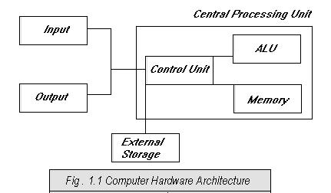

1. ***I/O Unit:*** The input unit contains the hardware devices those are used to enter thedata in to computer system, Keyboard and mouse are most common devices. The output contain the hardware devices those are use to output the data from the computer system, Monitor and printer are most common output devices. Nowadays so many other I/O devices are shown in following F*igure.*

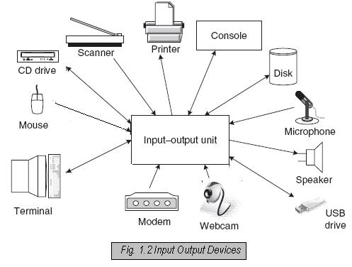

***Control Unit:*** The control unit maintains the sequence of the operation,controlling the actions of all other units it can perform the instruction which constitute the program and direct as per the operation perform by machine.

1. ***Arithmetic and logic Unit:*** The ALU unit functions are perform arithmeticaloperation, i.e. addition, subtraction, multiplication, division as well as logical operation i.e. and, or, not.

The control unit gives the instruction to the ALU which operations they have to perform and where it supplied (store purpose), it is directed to perform the operations.

1. ***Memory Unit:*** The memory unit or storage section of the computer consist thedevices used to store the data or information during the process. Memory unit is used to hold intermediate and final result of computer program. There are various types of memory which are used in computer system are as below. In this memory structure importance of the memory as per top to down approach.

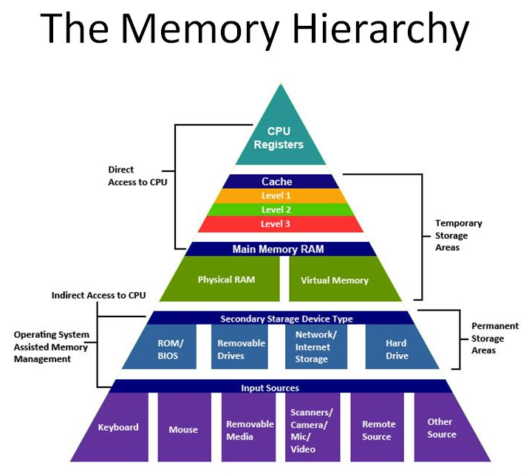

**Input Devices**

Following are few of the important input devices which are used in a computer:

* Keyboard
* Mouse
* Joy Stick
* Light pen
* Track Ball
* Scanner
* Graphic Tablet
* Microphone
* Magnetic Ink Card Reader(MICR)
* Optical Character Reader(OCR)
* Bar Code Reader
* Optical Mark Reader(OMR)

## Keyboard

Keyboard is the most common and very popular input device which helps in inputting data to the computer. The layout of the keyboard is like that of traditional typewriter, although there are some additional keys provided for performing additional functions.

Keyboards are of two sizes 84 keys or 101/102 keys, but now keyboards with 104 keys or 108 keys are also available for Windows and Internet.

The keys on the keyboard are as follows:

|  |  |  |
| --- | --- | --- |
| **Sr.No** | **Keys** | **Description** |
| 1 | Typing Keys | These keys include the letter keys (A-Z) and digit keys (0-9) which generally give same layout as that of typewriters. |
| 2 | Numeric Keypad | It is used to enter numeric data or cursor movement. Generally, it consists of a set of 17 keys that are laid out in the same configuration used by most adding machines and calculators. |
| 3 | Function Keys | The twelve function keys are present on the keyboard which are arranged in a row at the top of the keyboard. Each function key has unique meaning and is used for some specific purpose. |
| 4 | Control keys | These keys provide cursor and screen control. It includes four directional arrow keys. Control keys also include Home, End, Insert, Delete, Page Up, Page Down, Control(Ctrl), Alternate(Alt), Escape(Esc). |
| 5 | Special Purpose Keys | Keyboard also contains some special purpose keys such as Enter, Shift, Caps Lock, Num Lock, Space bar, Tab, and Print Screen. |

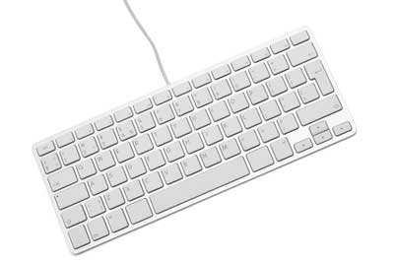

## Mouse

Mouse is most popular pointing device. It is a very famous cursor-control device having a small palm size box with a round ball at its base which senses the movement of mouse and sends corresponding signals to CPU when the mouse buttons are pressed.

Generally it has two buttons called left and right button and a wheel is present between the buttons. Mouse can be used to control the position of cursor on screen, but it cannot be used to enter text into the computer.

### Advantages

* Easy to use
* Not very expensive
* Moves the cursor faster than the arrow keys of keyboard.

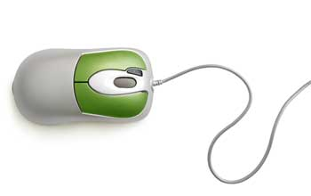

## Joystick

Joystick is also a pointing device which is used to move cursor position on a monitor screen. It is a stick having a spherical ball at its both lower and upper ends. The lower spherical ball moves in a socket. The joystick can be moved in all four directions.

The function of joystick is similar to that of a mouse. It is mainly used in Computer Aided Designing(CAD) and playing computer games.

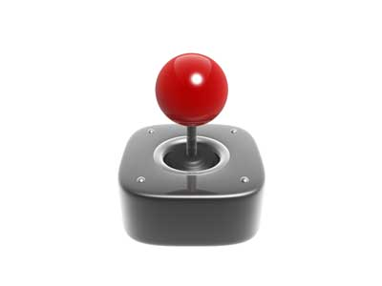

## Light Pen

Light pen is a pointing device which is similar to a pen. It is used to select a displayed menu item or draw pictures on the monitor screen. It consists of a photocell and an optical system placed in a small tube. When the tip of a light pen is moved over the monitor screen and pen button is pressed, its photocell sensing element detects the screen location and sends the corresponding signal to the CPU

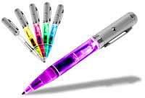

## Track Ball

Track ball is an input device that is mostly used in notebook or laptop computer, instead of a mouse. This is a ball which is half inserted and by moving fingers on ball, pointer can be moved. Since the whole device is not moved, a track ball requires less space than a mouse. A track ball comes in various shapes like a ball, a button and a square

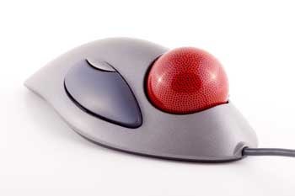

## Scanner

Scanner is an input device which works more like a photocopy machine. It is used when some information is available on a paper and it is to be transferred to the hard disc of the computer for further manipulation. Scanner captures images from the source which are then converted into the digital form that can be stored on the disc. These images can be edited before they are printed

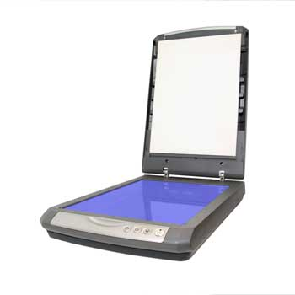

## Digitizer

Digitizer is an input device which converts analog information into digital form. Digitizer can convert a signal from the television or camera into a series of numbers that could be stored in a computer. They can be used by the computer to create a picture of whatever the camera had been pointed at. Digitizer is also known as Tablet or Graphics Tablet because it converts graphics and pictorial data into binary inputs. A graphic tablet as digitizer is used for doing fine works of drawing and image manipulation applications

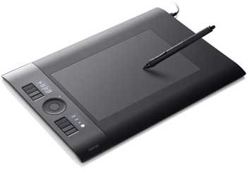

## Microphone

Microphone is an input device to input sound that is then stored in digital form. The microphone is used for various applications like adding sound to a multimedia presentation or for mixing music.

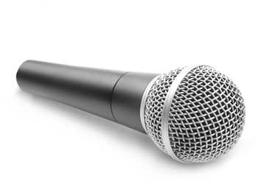

## Magnetic Ink Card Reader(MICR)

MICR input device is generally used in banks because of a large number of cheques to be processed every day. The bank's code number and cheque number are printed on the cheques with a special type of ink that contains particles of magnetic material that are machine readable. This reading process is called Magnetic Ink Character Recognition (MICR). The main advantages of MICR is that it is fast and less error prone

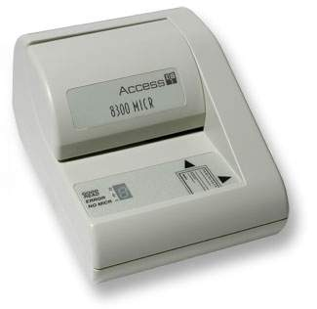

## Optical Character Reader(OCR)

OCR is an input device used to read a printed text. OCR scans text optically character by character, converts them into a machine readable code and stores the text on the system memory

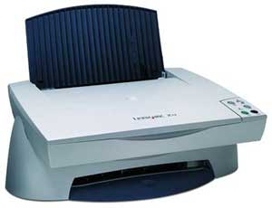

## Bar Code Readers

Bar Code Reader is a device used for reading bar coded data (data in form of light and dark lines). Bar coded data is generally used in labelling goods, numbering the books etc. It may be a hand held scanner or may be embedded in a stationary scanner. Bar Code Reader scans a bar code image, converts it into an alphanumeric value which is then fed to the computer to which bar code reader is connected.

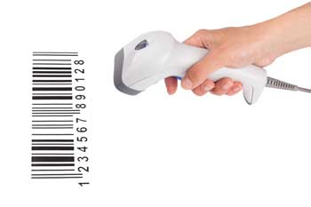

## Optical Mark Reader(OMR)

OMR is a special type of optical scanner used to recognize the type of mark made by pen or pencil. It is used where one out of a few alternatives is to be selected and marked. It is specially used for checking the answer sheets of examinations having multiple choice questions.

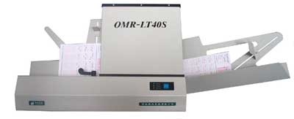

**Output Devices**

Following are few of the important output devices which are used in a computer.

* Monitors
* Graphic Plotter
* Printer

## Monitors

Monitors, commonly called as Visual Display Unit (VDU), are the main output device of a computer. It forms images from tiny dots, called pixels that are arranged in a rectangular form. The sharpness of the image depends upon the number of pixels.

There are two kinds of viewing screen used for monitors.

* Cathode-Ray Tube (CRT)
* Flat- Panel Display

### Cathode-Ray Tube (CRT) Monitor

The CRT display is made up of small picture elements called pixels. The smaller the pixels, the better the image clarity, or resolution. It takes more than one illuminated pixel to form whole character, such as the letter ‘e’ in the word help.

A finite number of characters can be displayed on a screen at once. The screen can be divided into a series of character boxes - fixed location on the screen where a standard character can be placed. Most screens are capable of displaying 80 characters of data horizontally and 25 lines vertically. There are some disadvantages of CRT:

* Large in Size
* High power consumption

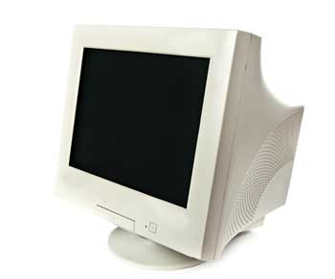

### Flat-Panel Display Monitor

The flat-panel display refers to a class of video devices that have reduced volume, weight and power requirement in comparison to the CRT. You can hang them on walls or wear them on your wrists. Current uses of flat-panel displays include calculators, video games, monitors, laptop computer, graphics display.

The flat-panel display is divided into two categories:

* **Emissive Displays -**The emissive displays are devices that convert electrical energy into light. Example are plasma panel and LED(Light-Emitting Diodes).
* **Non-Emissive Displays -**The Non-emissive displays use optical effects to convert sunlight or light from some other source into graphics patterns. Example is LCD(Liquid-Crystal Device)

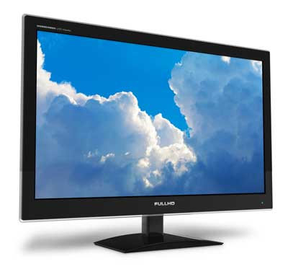

## Printers

Printer is an output device, which is used to print information on paper.

There are two types of printers:

* Impact Printers
* Non-Impact Printers

## Impact Printers

The impact printers print the characters by striking them on the ribbon which is then pressed on the paper.

Characteristics of Impact Printers are the following:

* Very low consumable costs
* Very noisy
* Useful for bulk printing due to low cost
* There is physical contact with the paper to produce an image

These printers are of two types

* Character printers
* Line printers

### Character Printers

Character printers are the printers which print one character at a time.

These are further divided into two types:

* Dot Matrix Printer(DMP)
* Daisy Wheel

#### DOT MATRIX PRINTER

In the market one of the most popular printers is Dot Matrix Printer. These printers are popular because of their ease of printing and economical price. Each character printed is in form of pattern of dots and head consists of a Matrix of Pins of size (5*7, 7*9, 9*7 or 9*9) which come out to form a character that is why it is called Dot Matrix Printer.

**Advantages**

* Inexpensive
* Widely Used
* Other language characters can be printed

**Disadvantages**

* Slow Speed
* Poor Quality

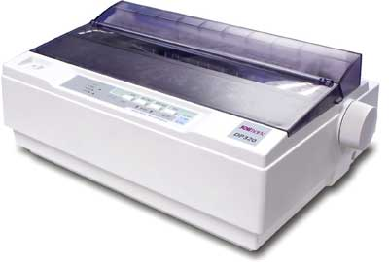

#### DAISY WHEEL

Head is lying on a wheel and pins corresponding to characters are like petals of Daisy (flower name) that is why it is called Daisy Wheel Printer. These printers are generally used for word-processing in offices which require a few letters to be sent here and there with very nice quality.

**Advantages**

* More reliable than DMP
* Better quality
* The fonts of character can be easily changed

**Disadvantages**

* Slower than DMP
* Noisy
* More expensive than DMP

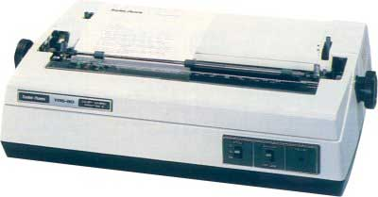

### Line Printers

Line printers are the printers which print one line at a time.

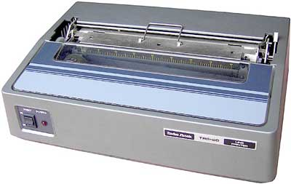

These are of further two types

* Drum Printer
* Chain Printer

#### DRUM PRINTER

This printer is like a drum in shape so it is called drum printer. The surface of drum is divided into number of tracks. Total tracks are equal to size of paper i.e. for a paper width of 132 characters, drum will have 132 tracks. A character set is embossed on track. The different character sets available in the market are 48 character set, 64 and 96 characters set. One rotation of drum prints one line. Drum printers are fast in speed and can print 300 to 2000 lines per minute.

**Advantages**

* Very high speed

**Disadvantages**

* Very expensive
* Characters fonts cannot be changed

#### CHAIN PRINTER

In this printer, chain of character sets are used so it is called Chain Printer. A standard character set may have 48, 64, or 96 characters.

**Advantages**

* Character fonts can easily be changed.
* Different languages can be used with the same printer.

**Disadvantages**

* Noisy

## Non-impact Printers

Non-impact printers print the characters without using ribbon. These printers print a complete page at a time so they are also called as Page Printers.

These printers are of two types

* Laser Printers
* Inkjet Printers

## **Characteristics of Non-impact Printers**

* Faster than impact printers.
* They are not noisy.
* High quality.
* Support many fonts and different character size.

### Laser Printers

These are non-impact page printers. They use laser lights to produce the dots needed to form the characters to be printed on a page.

#### ADVANTAGES

* Very high speed
* Very high quality output
* Give good graphics quality
* Support many fonts and different character size

#### DISADVANTAGES

* Expensive.
* Cannot be used to produce multiple copies of a document in a single printing.

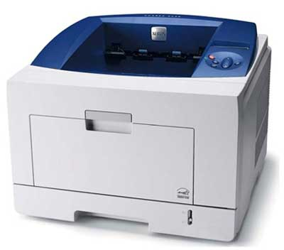

### Inkjet Printers

Inkjet printers are non-impact character printers based on a relatively new technology. They print characters by spraying small drops of ink onto paper. Inkjet printers produce high quality output with presentable features.

They make less noise because no hammering is done and these have many styles of printing modes available. Colour printing is also possible. Some models of Inkjet printers can produce multiple copies of printing also.

#### ADVANTAGES

* High quality printing
* More reliable

#### DISADVANTAGES

* Expensive as cost per page is high
* Slow as compared to laser printer

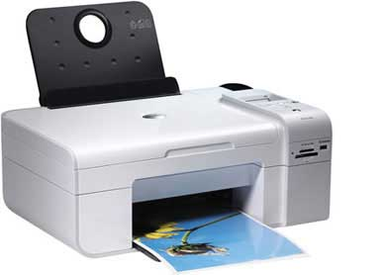

**Memory**

A memory is just like a human brain. It is used to store data and instructions. Computer memory is the storage space in computer where data is to be processed and instructions required for processing are stored. The memory is divided into large number of small parts called cells. Each location or cell has a unique address which varies from zero to memory size minus one. For example if computer has 64k words, then this memory unit has 64 * 1024=65536 memory locations. The address of these locations varies from 0 to 65535.

Memory is primarily of three types

* Cache Memory
* Primary Memory/Main Memory
* Secondary Memory

## Cache Memory

Cache memory is a very high speed semiconductor memory which can speed up CPU. It acts as a buffer between the CPU and main memory. It is used to hold those parts of data and program which are most frequently used by CPU. The parts of data and programs are transferred from disk to cache memory by operating system, from where CPU can access them.

### **Advantages**

The advantages of cache memory are as follows:

* Cache memory is faster than main memory.
* It consumes less access time as compared to main memory.
* It stores the program that can be executed within a short period of time.
* It stores data for temporary use.

### **Disadvantages**

The disadvantages of cache memory are as follows:

* Cache memory has limited capacity.
* It is very expensive.

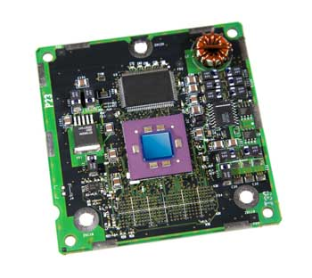

## Primary Memory (Main Memory)

Primary memory holds only those data and instructions on which computer is currently working. It has limited capacity and data is lost when power is switched off. It is generally made up of semiconductor device. These memories are not as fast as registers. The data and instruction required to be processed reside in main memory. It is divided into two subcategories RAM and ROM.

### **Characteristics of Main Memory**

* These are semiconductor memories
* It is known as main memory.
* Usually volatile memory.
* Data is lost in case power is switched off.
* It is working memory of the computer.
* Faster than secondary memories.
* A computer cannot run without primary memory.

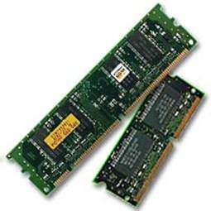

## Secondary Memory

This type of memory is also known as external memory or non-volatile. It is slower than main memory. These are used for storing data/Information permanently. CPU directly does not access these memories instead they are accessed via input-output routines. Contents of secondary memories are first transferred to main memory, and then CPU can access it. For example : disk, CD-ROM, DVD etc.

### **Characteristic of Secondary Memory**

* These are magnetic and optical memories
* It is known as backup memory.
* It is non-volatile memory.
* Data is permanently stored even if power is switched off.
* It is used for storage of data in a computer.
* Computer may run without secondary memory.
* Slower than primary memories.

Head is lying on a wheel and pins corresponding to characters are like petals of Daisy (flower name) that is why it is called Daisy Wheel Printer. These printers are generally used for word-processing in offices which require a few letters to be sent here and there with very nice quality.

**Advantages**

* More reliable than DMP
* Better quality
* The fonts of character can be easily changed

**Disadvantages**

* Slower than DMP
* Noisy
* More expensive than DMP



### Line Printers

Line printers are the printers which print one line at a time.



These are of further two types

* Drum Printer
* Chain Printer

#### DRUM PRINTER

This printer is like a drum in shape so it is called drum printer. The surface of drum is divided into number of tracks. Total tracks are equal to size of paper i.e. for a paper width of 132 characters, drum will have 132 tracks. A character set is embossed on track. The different character sets available in the market are 48 character set, 64 and 96 characters set. One rotation of drum prints one line. Drum printers are fast in speed and can print 300 to 2000 lines per minute.

**Advantages**

* Very high speed

**Disadvantages**

* Very expensive
* Characters fonts cannot be changed

#### CHAIN PRINTER

In this printer, chain of character sets are used so it is called Chain Printer. A standard character set may have 48, 64, or 96 characters.

**Advantages**

* Character fonts can easily be changed.
* Different languages can be used with the same printer.

**Disadvantages**

* Noisy

## Non-impact Printers

Non-impact printers print the characters without using ribbon. These printers print a complete page at a time so they are also called as Page Printers.

These printers are of two types

* Laser Printers
* Inkjet Printers

## **Characteristics of Non-impact Printers**

* Faster than impact printers.
* They are not noisy.
* High quality.
* Support many fonts and different character size.

### Laser Printers

These are non-impact page printers. They use laser lights to produce the dots needed to form the characters to be printed on a page.

#### ADVANTAGES

* Very high speed
* Very high quality output
* Give good graphics quality
* Support many fonts and different character size

#### DISADVANTAGES

* Expensive.
* Cannot be used to produce multiple copies of a document in a single printing.



### Inkjet Printers

Inkjet printers are non-impact character printers based on a relatively new technology. They print characters by spraying small drops of ink onto paper. Inkjet printers produce high quality output with presentable features.

They make less noise because no hammering is done and these have many styles of printing modes available. Colour printing is also possible. Some models of Inkjet printers can produce multiple copies of printing also.

#### ADVANTAGES

* High quality printing
* More reliable

#### DISADVANTAGES

* Expensive as cost per page is high
* Slow as compared to laser printer



**Memory**

A memory is just like a human brain. It is used to store data and instructions. Computer memory is the storage space in computer where data is to be processed and instructions required for processing are stored. The memory is divided into large number of small parts called cells. Each location or cell has a unique address which varies from zero to memory size minus one. For example if computer has 64k words, then this memory unit has 64 * 1024=65536 memory locations. The address of these locations varies from 0 to 65535.

Memory is primarily of three types

* Cache Memory
* Primary Memory/Main Memory
* Secondary Memory

## Cache Memory

Cache memory is a very high speed semiconductor memory which can speed up CPU. It acts as a buffer between the CPU and main memory. It is used to hold those parts of data and program which are most frequently used by CPU. The parts of data and programs are transferred from disk to cache memory by operating system, from where CPU can access them.

### **Advantages**

The advantages of cache memory are as follows:

* Cache memory is faster than main memory.
* It consumes less access time as compared to main memory.
* It stores the program that can be executed within a short period of time.
* It stores data for temporary use.

### **Disadvantages**

The disadvantages of cache memory are as follows:

* Cache memory has limited capacity.
* It is very expensive.



## Primary Memory (Main Memory)

Primary memory holds only those data and instructions on which computer is currently working. It has limited capacity and data is lost when power is switched off. It is generally made up of semiconductor device. These memories are not as fast as registers. The data and instruction required to be processed reside in main memory. It is divided into two subcategories RAM and ROM.

### **Characteristics of Main Memory**

* These are semiconductor memories
* It is known as main memory.
* Usually volatile memory.
* Data is lost in case power is switched off.
* It is working memory of the computer.
* Faster than secondary memories.
* A computer cannot run without primary memory.



## Secondary Memory

This type of memory is also known as external memory or non-volatile. It is slower than main memory. These are used for storing data/Information permanently. CPU directly does not access these memories instead they are accessed via input-output routines. Contents of secondary memories are first transferred to main memory, and then CPU can access it. For example : disk, CD-ROM, DVD etc.

### **Characteristic of Secondary Memory**

* These are magnetic and optical memories
* It is known as backup memory.
* It is non-volatile memory.
* Data is permanently stored even if power is switched off.
* It is used for storage of data in a computer.
* Computer may run without secondary memory.
* Slower than primary memories.

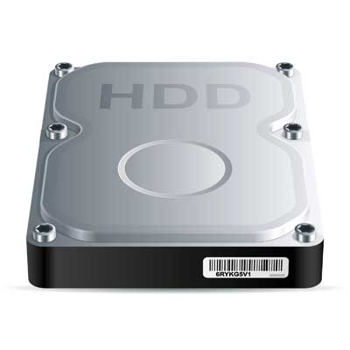

RAM(Random Access Memory) is the internal memory of the CPU for storing data, program and program result. It is read/write memory which stores data until the machine is working. As soon as the machine is switched off, data is erased.

Access time in RAM is independent of the address that is, each storage location inside the memory is as easy to reach as other locations and takes the same amount of time. Data in the RAM can be accessed randomly but it is very expensive.

RAM is volatile, i.e. data stored in it is lost when we switch off the computer or if there is a power failure. Hence a backup uninterruptible power system(UPS) is often used with computers. RAM is small, both in terms of its physical size and in the amount of data it can hold.

RAM is of two types

* Static RAM (SRAM)
* Dynamic RAM (DRAM)



## Static RAM (SRAM)

The word **static** indicates that the memory retains its contents as long as power is being supplied. However, data is lost when the power gets down due to volatile nature. SRAM chips use a matrix of 6-transistors and no capacitors. Transistors do not require power to prevent leakage, so SRAM need not have to be refreshed on a regular basis.

Because of the extra space in the matrix, SRAM uses more chips than DRAM for the same amount of storage space, thus making the manufacturing costs higher. So SRAM is used as cache memory and has very fast access.

### **Characteristic of the Static RAM**

* It has long life
* There is no need to refresh
* Faster
* Used as cache memory
* Large size
* Expensive
* High power consumption

## Dynamic RAM (DRAM)

DRAM, unlike SRAM, must be continually **refreshed** in order to maintain the data. This is done by placing the memory on a refresh circuit that rewrites the data several hundred times per second. DRAM is used for most system memory because it is cheap and small. All DRAMs are made up of memory cells which are composed of one capacitor and one transistor.

### **Characteristics of the Dynamic RAM**

* It has short data lifetime
* Need to be refreshed continuously
* Slower as compared to SRAM
* Used as RAM
* Lesser in size
* Less expensive
* Less power consumption
* **ROM**
* ROM stands for Read Only Memory. The memory from which we can only read but cannot write on it. This type of memory is non-volatile. The information is stored permanently in such memories during manufacture. A ROM, stores such instructions that are required to start a computer. This operation is referred to as bootstrap. ROM chips are not only used in the computer but also in other electronic items like washing machine and microwave oven.
* 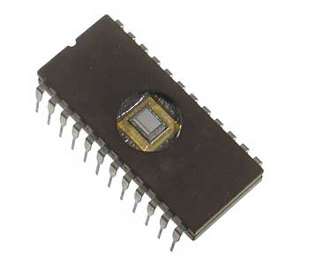



RAM(Random Access Memory) is the internal memory of the CPU for storing data, program and program result. It is read/write memory which stores data until the machine is working. As soon as the machine is switched off, data is erased.

Access time in RAM is independent of the address that is, each storage location inside the memory is as easy to reach as other locations and takes the same amount of time. Data in the RAM can be accessed randomly but it is very expensive.

RAM is volatile, i.e. data stored in it is lost when we switch off the computer or if there is a power failure. Hence a backup uninterruptible power system(UPS) is often used with computers. RAM is small, both in terms of its physical size and in the amount of data it can hold.

RAM is of two types

* Static RAM (SRAM)
* Dynamic RAM (DRAM)