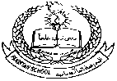**Pakistan School , Kingdom of Bahrain**

**E- Support and Learning Material / Session 2020-2021**

**Subject: Social Studies Grade: 2**

**Book: New Oxford Social Studies FIRST TERM**

**Unit 2: Lsn: 5: Rules of staying healthy and safe Pg. No: 23 ( Notes)**

**Reading/Explanation**

**Difficult Words:**

**Shower, rubbish , dirt , mosquitoes, pollution, smoke, accidents,zebracrossing.matches, electrical .**

**Q1: What do you do to keep your school clean?**

Ans: We don’t throw garbage on the ground.

**Q2: Why it is important to keep ourselves clean?**

Ans:To stay healthy we have to keep ourselves clean.

**Q3:How can we keep our home clean?**

Ans:We should not throw rubbish in the house and keep all the things back to their places after using them.

**Q4:Write 2 cause of pollution.**

Ans:1.Rubbish and dirt 2. Smoke and fumes.

**Q5: Why are bare electric wires are dangerous?**

Ans: Because an electric shock in bare wires can kill us.

**Q6: Can we play with matches?**

Ans: No, we cannot play with matches. We may burn ourselves.

**Q7:What is meaning of saying “look before you leap”?**

Ans: This tells us that we have to think carefully before doing anything.

**harmful __ every day__ zebra crossing __rubbish__ toilet __ electric**

1.We should have a bath **every day.**

2.Wash your hands after you have been to the **toilet.**

3. An **electric** shock can kill us.

4.Dirt and pollution are **harmful** for our health.

5.You must not throw **rubbish** on the roads.

6. Cross the road at **zebra crossing.**

**Write whether these statements are True or False.**

1.We should not brush our teeth every day. **( F)**

2.Cut your nails and keep them clean**. (T)**

3.Flies like clean places. **(F)**

4.Mosquitoes like lay their eggs in dirty water. **(T)**

5.Accidents not happen if we are careful. **(T)**

6.An electric shock can save us. **(F)**

1. We should cut our nails and keep them **clean.** (clean, dirty)

2. We should brush our teeth **every day**. (every month, every day)

3. Eating too much **sweets** cause tooth decay. (healthy food, sweets)

4. Flies like **dirty** places. (clean, dirty)

5. A mosquito bite can make you **ill**. (ill, healthy)

6.Medicine that are not for you may **harm** you . (Save ,harm)

7.Be careful while crossing the **road** . (road, floor)

|  |  |  |  |
| --- | --- | --- | --- |
| **1** | Shower | Hair | **3** |
| **2** | Electric shock | Itching | **4** |
| **3** | Comb | Dirty places | **5** |
| **4** | Lice | Everyday | **1** |
| **5** | Mosquitoes | Kill | **2** |

**Subject: Social Studies WORKSHEET Grade: 2**

**Unit 2: Lsn: 7: Rules for staying healthy and safe**

**Read the notes and lesson carefully and solve this worksheet.**

**Q1: Choose the Right answers:**

1. Clean people stay (healthy, unhealthy)

2. We should drink boiled (water, juice)

3. Waste papers and things throw in (dustbin, bag)

4. Allah likes people (dirty , clean)

5.Never play with (toys , matches)

6. Never leave things lying around on the (floor, plate)

**Q2: State whether these statements are True or False.**

1. We should throw things out of the window. (______ )

2. We should take bath monthly. (____ )

3. We should brush our teeth twice a day. (_____ )

4. We must comb our hair and cut our nails. ( ____ )

5.Knife is not dangerous. (______)

6.We have to look where we are going.(_________)

**Q3: Write the names of these tools:**

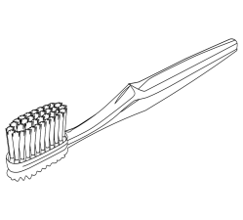 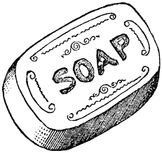 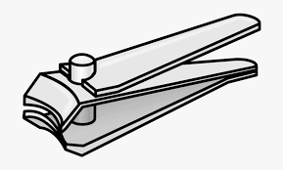 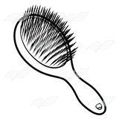

**__________ ___________ ___________ ____________**

|  |  |  |  |  |
| --- | --- | --- | --- | --- |
| **Rubric:** | **Ex.** | **Go.** | **Sat.** | **NI** |
| **Content Accuracy** | **1** | **2** | **3** | **4** |
| **Creativity** | **1** | **2** | **3** | **4** |
| **Completeness** | **1** | **2** | **3** | **4** |
| **Neatness** | **1** | **2** | **3** | **4** |
| **1-Excellent 2- Good 3- Satisfactory**  **4- Needs improvement** | | | | |