**Pakistan School , Kingdom of Bahrain**

**E- Support and Learning Material / Session 2020-2021**

**Subject: Social Studies Grade: 2**

**Book: New Oxford Social Studies FIRST TERM**

**Unit 2: Lsn: 5: Rules of staying healthy and safe Pg. No: 23 ( Notes)**

**Reading & Explanation**

**Shower, rubbish , dirt , mosquitoes, pollution, smoke, accidents,zebracrossing.matches, electrical**

**Difficult Words:**

**Q1: What do you do to keep your school clean?**

Ans: We don’t throw garbage on the ground.

**Q2: Why it is important to keep ourselves clean?**

Ans:To stay healthy we have to keep ourselves clean.

**Q3:How can we keep our home clean?**

Ans:We should not throw rubbish in the house. Keep all the things back to their places after using them.

**Q4:Write 2 causes of pollution.**

Ans:1.Rubbish and dirt 2. Smoke and fumes.

**Q5: Why are bare electric wires dangerous?**

Ans: Bare electric wires are dangerous because an electric shock in bare wires can kill us.

**Q6: Can we play with matches?**

Ans: No, we cannot play with matches. We may burn ourselves.

**Q7:What is meaning of saying “look before you leap”?**

Ans: This tells us that we have to think carefully before doing anything.

**WORKSHEET**

**Subject: Social Studies Grade: 2**

**Unit 2: Lsn: 7: Rules for staying healthy and safe Pg. No: 23**

**Read the notes and lesson carefully and solve this worksheet.**

**Q1: Choose the Right answers:**

1. Clean people stay (healthy, unhealthy)

2. We should drink boiled (water, juice)

3. Waste papers and things throw in (dustbin, bag)

4. Allah likes ________ people . (dirty , clean)

5.Never play with ___________ . (toys , matches)

6. Never leave things lying around on the (floor, bed)

**Q2: State whether these statements are True or False:**

1. We should throw things out of the window. (______ )

2. We should take bath monthly. (____ )

3. We should brush our teeth twice a day. (_____ )

4. We must comb our hair and cut our nails. ( ____ )

5.Knife is not dangerous. (______)

6.We have to look where we are going.(_________)

**Q3: Write the names of these tools:**

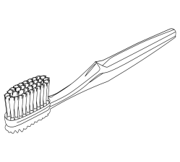 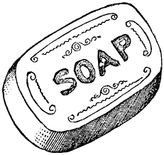 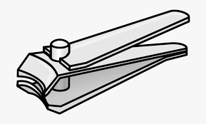 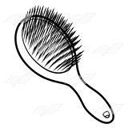

**__________ __________ ____________ ____________**

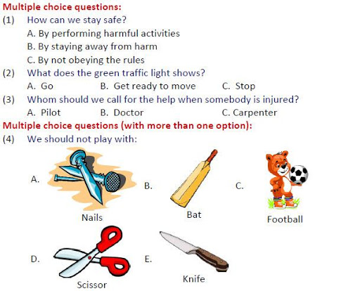

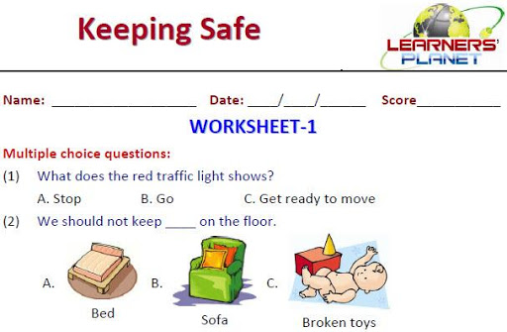

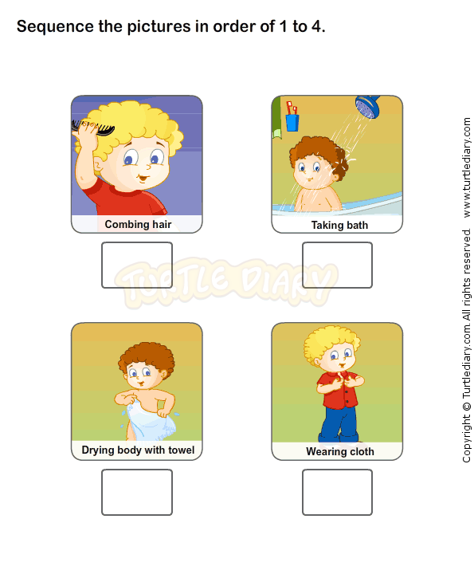

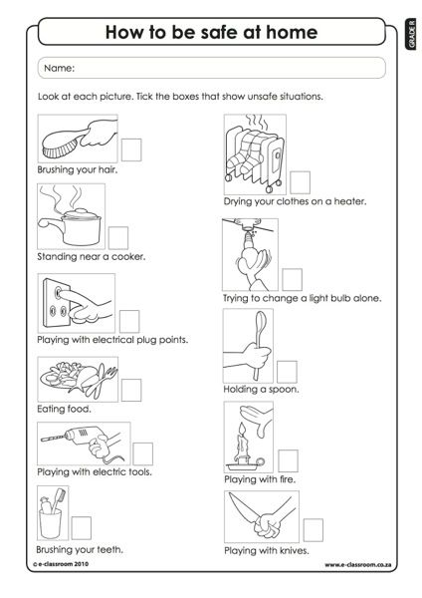

|  |  |  |  |  |
| --- | --- | --- | --- | --- |
| **Rubric:** | **Ex.** | **Go.** | **Sat.** | **NI** |
| **Content Accuracy** | **1** | **2** | **3** | **4** |
| **Creativity** | **1** | **2** | **3** | **4** |
| **Completeness** | **1** | **2** | **3** | **4** |
| **Neatness** | **1** | **2** | **3** | **4** |
| **1-Excellent 2- Good 3- Satisfactory**  **4- Needs improvement** | | | | |