 Pakistan School , Kingdom of Bahrain

E- Support and Learning Material / Session 2020-2021

Book:New Oxford Social Studies Grade : 3

FIRST TERM Lesson no 3: Climate

Reading of the lesson ‘’Climate’’

Difficult Words:

* Blowing
* Weather
* Temperature
* Mountains
* Rain gauge
* Weathervane
* Anemometer
* Barometer
* Meteorologists
* Celsius

**Answer the following questions:**

**Q.1: What is climate? How is it different from weather?**

Ans: Climate is the usual weather a place has over a period of year.

Whereas a weather changes day by day.

**Q.2: Describe the kind of climate in your area?**

Ans: The climate of my area is hot and windy.

**Q.3: Which is the coldest part of Pakistan?**

Ans: Gilgit Baltistan is the coldest part in Pakistan.

**Q.4: How can you find out the climate of a place?**

Ans: We can find out the climate of a place by measuring the daily temperature and keeping a record of the changes in the weather over a long period of time.

**Match the followings:**

|  |  |  |  |
| --- | --- | --- | --- |
| S.NO | Column A | Column B |  |
| 1 | A usual weather of a place during a year | Season | 4 |
| 2 | degree of hotness or coldness measured on a definite scale | Climate | 1 |
| 3 | The amount of rain that falls on a particular area | Temperature | 2 |
| 4 | A division of the year marked by changes in weather, | Rain fall | 3 |

Use the suitable words to fill in the blanks:

Anemometer is used to measure wind speed.

Barometer is used to measure air pressure.

Rain gauge is used to measure rainfall.

Thermometer is used to measure temperature.

Weathervane is used to find out the direction of the wind.

State whether the statements are true or false:

The weather changes day by day. (True)

The climate of a place is divided into different seasons. (True)

Spring comes after summer. (False)

People who study the weather and climate and keep records are called meteorologists. (True)

**WORKSHEET**

**Subject: Social Studies. Date: ____________**

**Student’s Name: ________________ Grade: 3**

**Q.1: Write the names of the following pictures:**

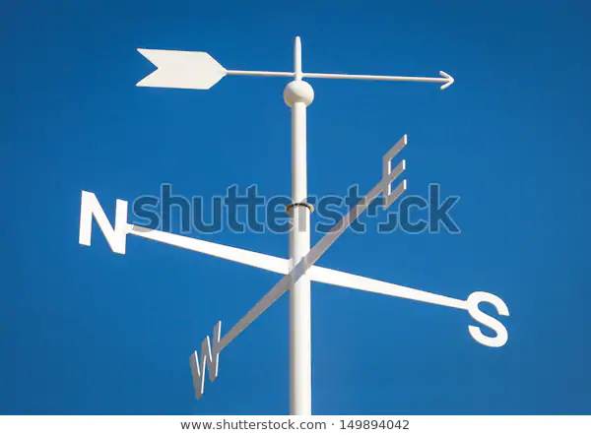 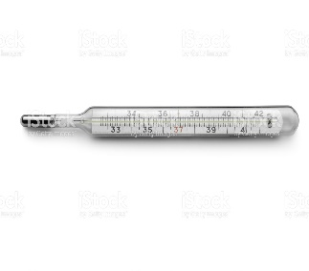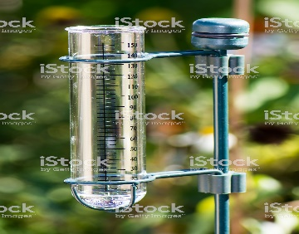

**________________ _____________________ ______________________**

**Q.2: State whether the statements are True or False:**

1. The weather changes day by day. __________

2. The climate of a place is divided into different seasons. _______

3. Spring comes after summer. ________

4. People who study the weather and climate and keep records are called meteorologists. __________

**Q.3: Answer the following questions:**

**Q.A: Write the name of your favorite season?**

Ans: ___________________________________________________________

**Q.B: Write the names of the four seasons which we have in a year?**

|  |  |  |  |  |
| --- | --- | --- | --- | --- |
| **Rubric:** | **Ex.** | **Go.** | **Sat.** | **NI** |
| **Content Accuracy** | **1** | **2** | **3** | **4** |
| **Creativity** | **1** | **2** | **3** | **4** |
| **Completeness** | **1** | **2** | **3** | **4** |
| **Neatness** | **1** | **2** | **3** | **4** |
| **1-Excellent 2- Good 3- Satisfactory**  **4- Needs improvement** | | | | |

Ans: ___________________________________________________

_________________________________________________________