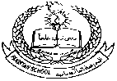**Pakistan School , Kingdom of Bahrain**

**E- Support and Learning Material / Session 2020-2021**

**Subject: Social studies Grade : 1**

**Book: New Oxford Social studies for Pakistan-1 FIRST TERM**

**Unit 2: Clean and Healthy Pg. No: 12-13**

**Lesson 3: Keeping clean**

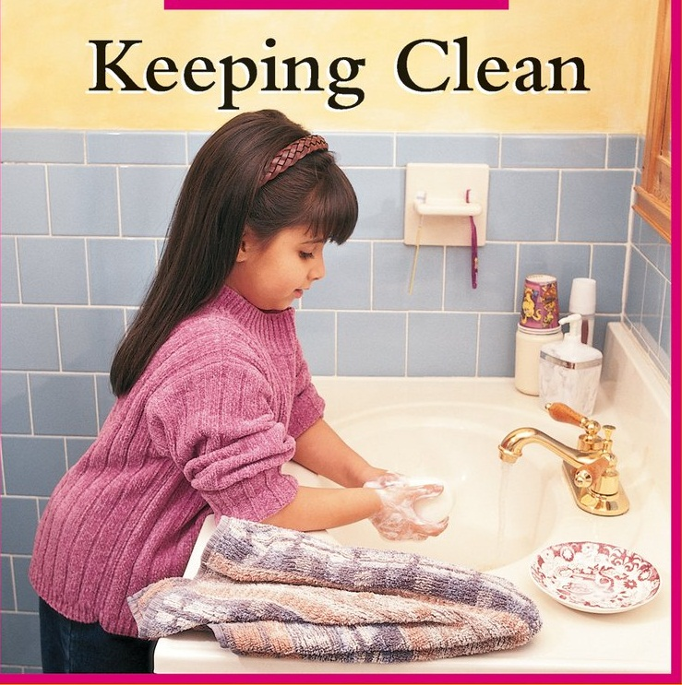

**Words to learn.**

b-r-u-s-h s-h-o-w-e-r t-o-i-l-e-t

brush shower toilet

r-e-g-u-l-a-r-l-y c-l-e-a-n

regularly clean

**Answer the following questions:**

**Q1: What other things do you do to keep clean?**

Ans: 1- I cut my nails.

2- I clean my ears.

3- I shampoo my hair.

1. I wear clean clothes.

**Q2: What time do you go to school?**

Ans: I go to school at 7: 45 am.

**Q3: How many times should we take a shower in a week ?**

Ans: We should take a shower every day.

**Choose the correct answer:**

1. Cut nails with a ( nail cutter , mouth ).
2. We keep our nose ( clean , dirty ).
3. Cleanliness is a ( good , bad ) habit.

**Write whether these statements are True or False:**

1. We use shampoo for washing hair. True
2. Brush your teeth one time in a week. False
3. Wash your hands before eating anything . True

**Subject: Social studies Grade : 1**

**Unit 2: Clean and Healthy Lesson 4: Keeping Clean**

**Worksheet** 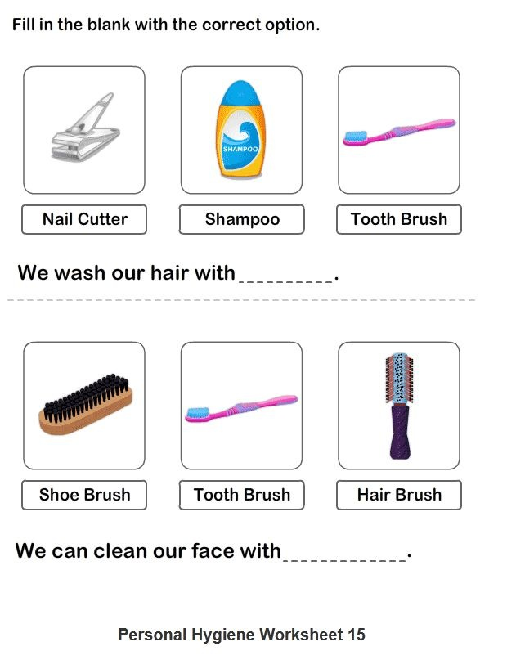

**Q1. Complete these statements using these words:**

|  |  |  |  |  |  |  |  |
| --- | --- | --- | --- | --- | --- | --- | --- |
| **hair** | **hands** | **shampoo** | **toothbrush** | **face** | **toothpaste** | **soap** | **teeth** |

