 **Pakistan School, Kingdom of Bahrain**

**E- Support and Learning Material / Session 2020-2021**

**Subject: Social Studies Grade: 3**

**Lesson no 8: Services FIRST TERM**

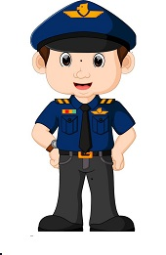 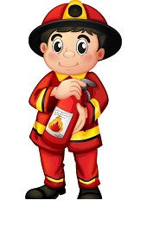 

Reading of the lesson ‘’Services’’

**Difficult Words:**

* Community
* Fire brigade
* Hospital
* Police Station
* Criminal
* Dangerous
* Helmet
* Trapped
* Building

**Answer the following questions:**

**Q.1: What work do the police do?**

Ans: Their job is to keep us and our property safe.

**Q2: What work does the fire fighter do?**

Ans: When there is a dangerous fire somewhere fire fighters are called to put it out.

**Q3: Who might you find working at the following places?**

1: Fire station Fire fighters.

2: Police station Police men and Police women.

3: A Hospital Doctors and nurses.

**Fill in the blanks:**

1: Traffic police direct the traffic on road.

2: If there is a dangerous fire in your house the fire fighter can be called to put it out.

3: People who provide free help to the poor are doing a social service.

4: A fire fighter wears a helmet to protect his head and neck.

5: People who need urgent medical attention are rushed to a hospital in an ambulance**.**

**Guess who they are :( book page no 32)**

|  |  |  |  |
| --- | --- | --- | --- |
| S.No | Column A | Column B |  |
| 1 | Keep us safe ,arrest law breakers | Firefighter | 4 |
| 2 | Clinic, looks after the patients | Doctor | 3 |
| 3 | Clinic ,sees patients | Police | 1 |
| 4 | Wears helmet, rescues trapped people | Nurse | 2 |

**Work Sheet**

**Subject: Social Studies Topic: Services Grade: 3**

**Student’s Name: ________________________________________________**

**Q.1: Look at the pictures carefully and write the names of the professions matching to the picture:**

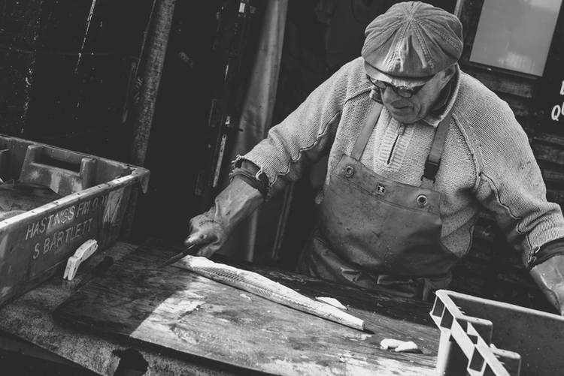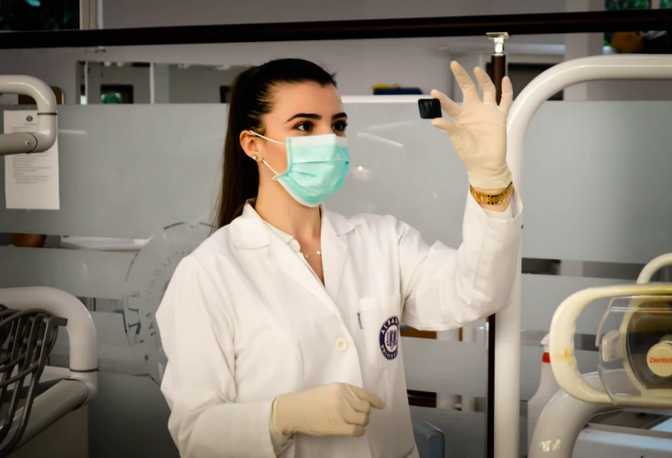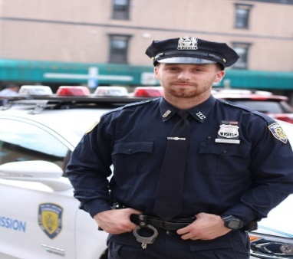

**____________________ ____________________ ____________________**

**Q.2: State whether the statements are True or False:**

1.A doctor catches the criminals. ________

2.A carpenter works with glass. ________

3.A pilot flies an airplane. ___________

4. A police man protects the people from criminals._______

5. Fire fighters travel in a red engine. _______

**Q3. Write the names of any three professions you love.**

1. ______________________

2. ______________________

3. ______________________

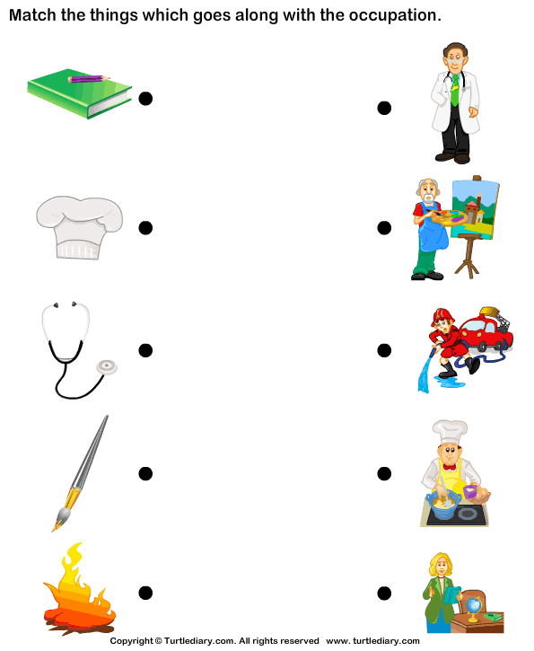

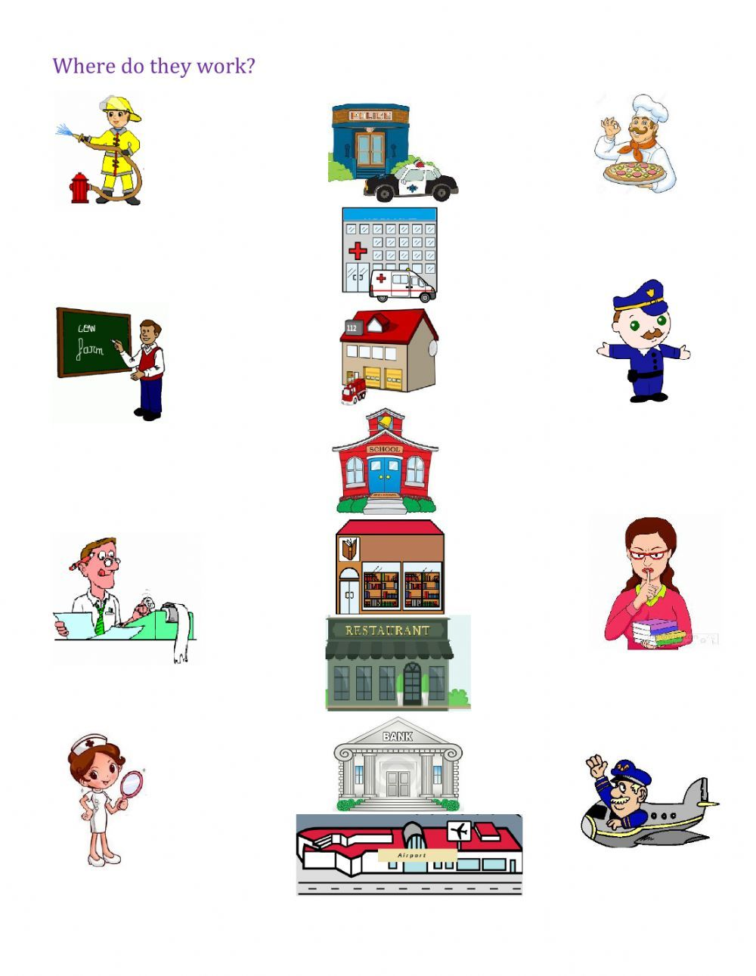

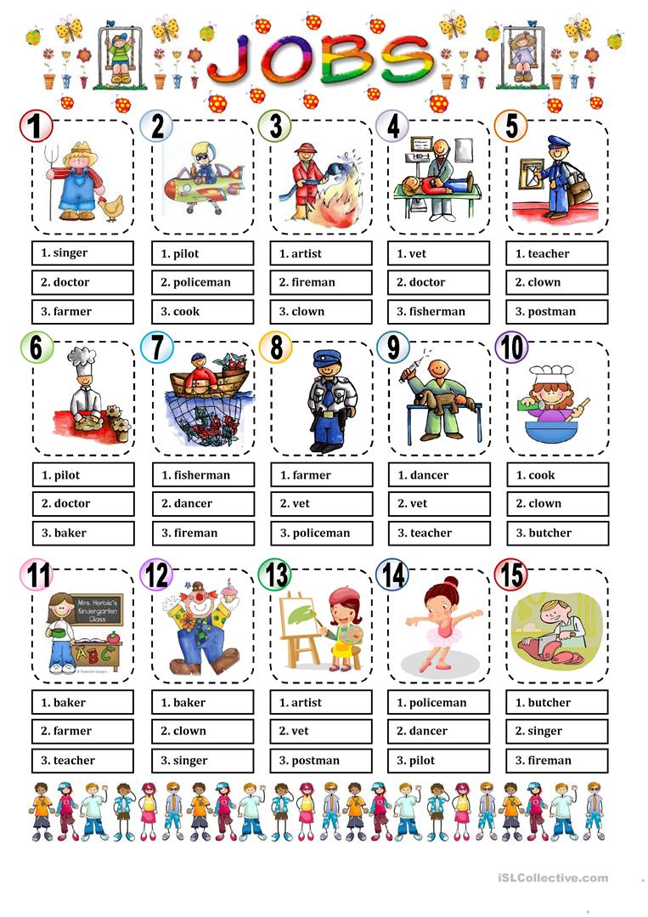

|  |  |  |  |  |
| --- | --- | --- | --- | --- |
| **Rubric:** | **Ex.** | **Go.** | **Sat.** | **NI** |
| **Content Accuracy** | **1** | **2** | **3** | **4** |
| **Creativity** | **1** | **2** | **3** | **4** |
| **Completeness** | **1** | **2** | **3** | **4** |
| **Neatness** | **1** | **2** | **3** | **4** |
| **1-Excellent 2- Good 3- Satisfactory**  **4- Needs improvement** | | | | |