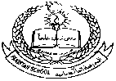**Pakistan School , Kingdom of Bahrain**

**E- Support and Learning Material / Session 2020-2021**

**Subject: Social studies Grade : 1**

**Book: New Oxford Social studies for Pakistan-1 FIRST TERM**

**Unit 1: About Myself Pg. No: 5-6**

**Lesson 3: My body**

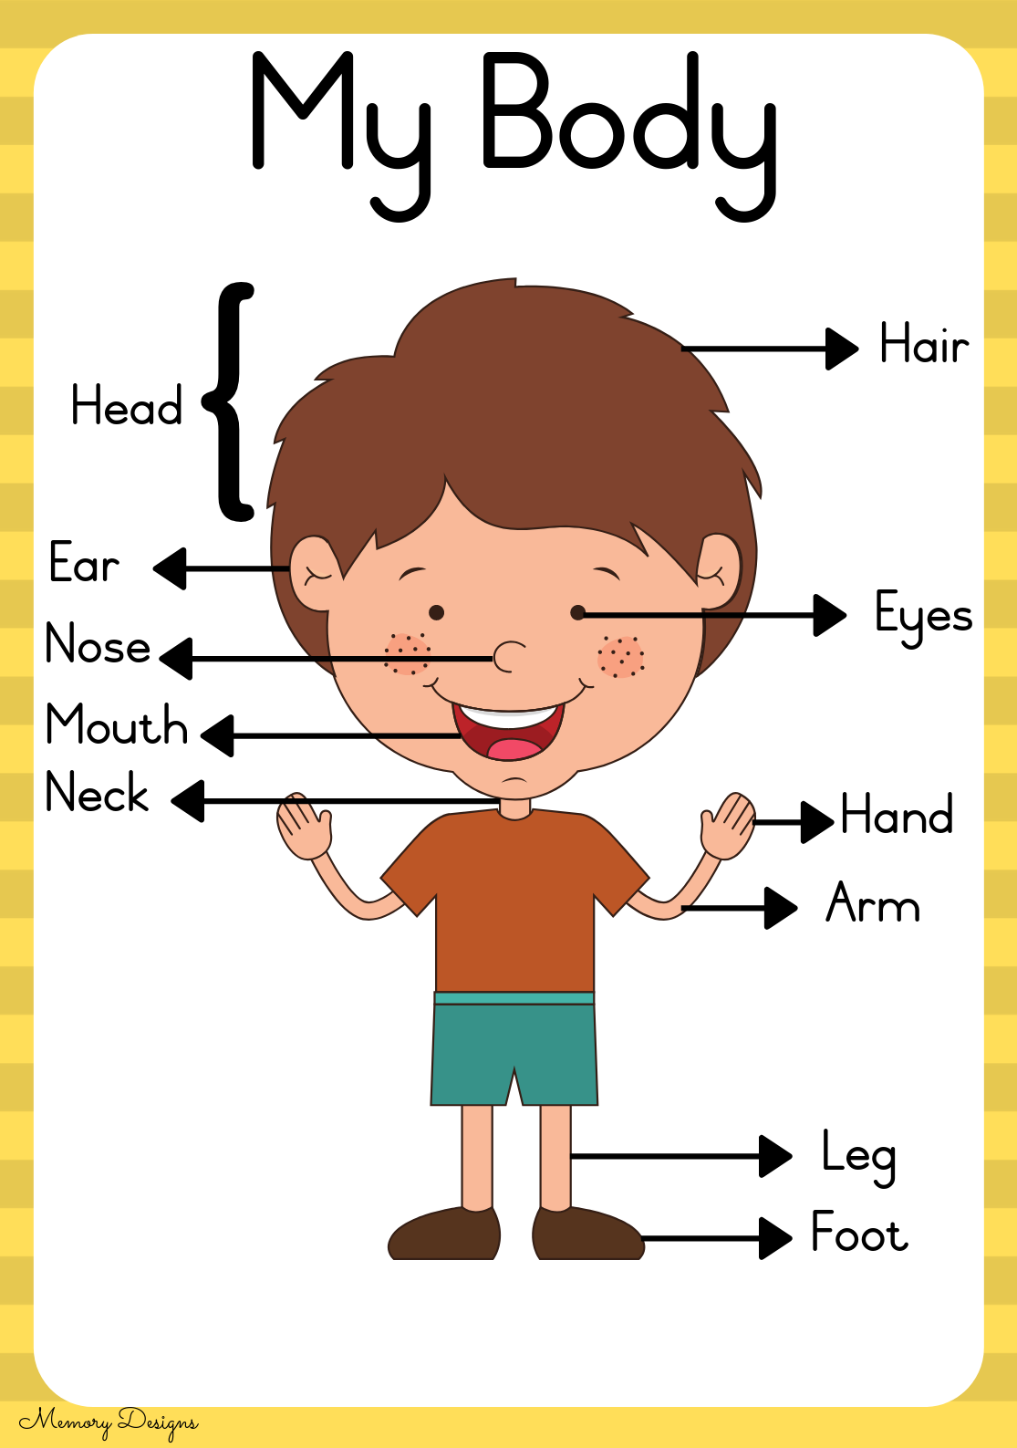

**Words to learn**

h-e-a-d r-o-u-n-d l-i-p-s

head round lips

c-h-e-e-k-s c-h-i-n

cheeks chin

**Answer the following questions.**

**Q1: What parts of your body do you use for running?**

Ans: We use our legs for running.

**Q2: What parts of your body do you use for eating?**

Ans: We use our hands for eating

**Q3: What parts of your body do you use for writing?**

Ans: We use our hands for writing.

**Fill in the blanks with the suitable words.**

|  |  |  |
| --- | --- | --- |
| ears | face | legs |

1. We use legs for running.
2. I have two ears.
3. Our face is round.

**Choose the best answer.**

1. We eat food with mouth ( mouth , nose )
2. We have ten fingers on our hand ( fingers , arms )
3. We hear with our ears ( eyes , ears )

**Work page**

**Exercise A . page ( 9 )**

**Fill in the blanks.**

1. This is my foot. 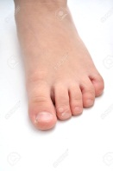
2. This is my hand . 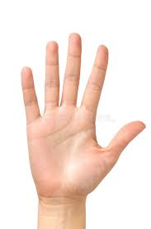
3. This is my ear. 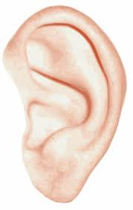
4. This is my nose. 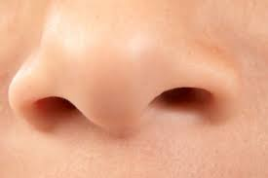

**Exercise B 1…**

This is Sara

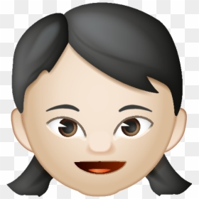

She has black hair.

Her eyes are brown.

**Exercise B 2….**

This is Tim.

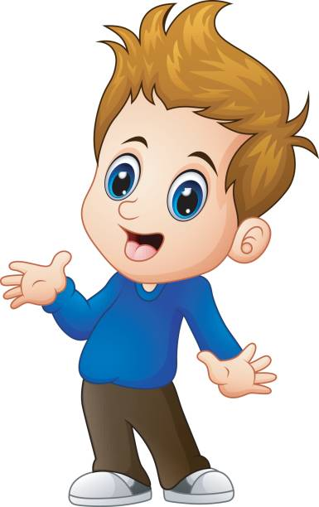

He has brown hair.

His eyes are blue.

3. My hair is _____________. My eyes are ___________.

**Page # 10**

**C. True or false?**

**This is Najeeb. Look at the picture and underline the statements as True or False.**

1. Najeeb has three arms.

True False

1. He has two ears.

True False

1. His hair is grey.

True False

1. Najeeb’s eyes are green.

True false

**Subject: Social studies Grade : 1**

**Unit 1: About Myself Lesson 3: My body**

**Worksheet**

**Q1- Fill in the missing vowel words:**

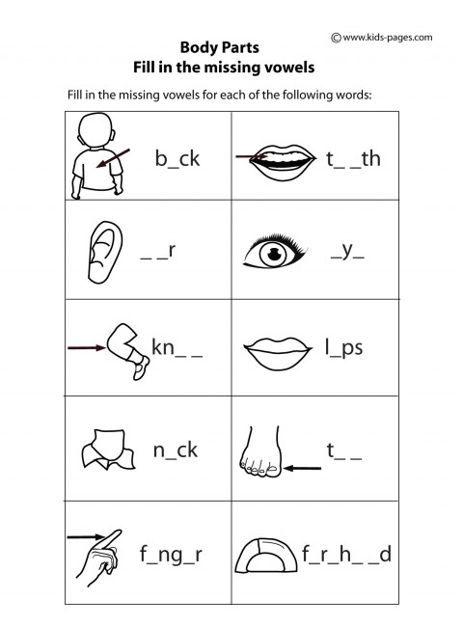

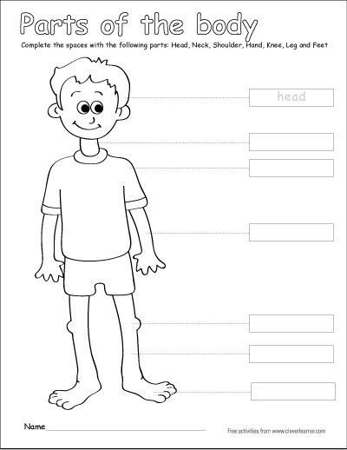

|  |  |  |  |  |
| --- | --- | --- | --- | --- |
| **Rubric:** | **Ex.** | **Go.** | **Sat.** | **NI** |
| **Content Accuracy** | **1** | **2** | **3** | **4** |
| **Creativity** | **1** | **2** | **3** | **4** |
| **Completeness** | **1** | **2** | **3** | **4** |
| **Neatness** | **1** | **2** | **3** | **4** |
| **1-Excellent 2- Good 3- Satisfactory**  **4- Needs improvement** | | | | |

**Homework:**

**Complete the table:**

|  |  |  |
| --- | --- | --- |
| **Colour** | **EYES** | **HAIR** |
| Friend 1 |  |  |
| Friend 2 |  |  |